**MODULE 4 ACTIVITY 2: SETTING UP MongoDB IN CLOUD ENVIRONMENT**

**IFT 544 MIDDLEWARE PROGRAMMING AND DATABSE SECURITY**

**AMBUK REHANI**

**Instructor – Prof.Dinesh Sthapit**

**10/01/2023**

Table of Contents

Step 1 - Start by setting up additional environment variables in "config.env".......................4Step 2 - Create the associated files in the correct folder - loanRoutes.js, loanController.jsand loanModel.js in the model folder. .................................................................................4Step 3 – Server.js file ...................................................................................................................11Step 4 – Create a folder and name it as dataBaseManager .....................................................12Step 5 – Controller file ................................................................................................................13Step 6 – App.js file .......................................................................................................................14Step 7 – The App ran displaying the PORT number and LISTEN Message.........................15Step 8 – Add a new loan (POSTMAN).......................................................................................16Step 9 – Add 5 additional loans (POSTMAN)...........................................................................17Step 10 – Get Users To get all users, enter http://localhost:<PORT-NUMBER>/loans/ as theaddress. Remember to select the verb as GET..................................................................22Step 11 – Get a Specific User (POSTMAN) Get the data of a specific user by entering thisURL: http://localhost:<PORT_NUMBER>/loans/:id ......................................................26Step 12 – Change an Existing Loan (POSTMAN) Change an existing LOan by using thePUT verb. Then change the value of the JSON object. The URL is the same as whenwe fetched the specific Loan. ..............................................................................................27Step 13 – This criterion is linked to a Learning OutcomeDelete a User (POSTMAN) Todelete a loan, you only need to change the verb to DELETE. We can verify that theuser is gone by fetching all the loans. Now Verify that you have a fully working expressbackend connected to a MongoDB database.....................................................................29Step 14 – Create a collection in POSTMAN and all your TEST there and then EXPORTPOSTMAN TEST COLLECTION to a json file. .............................................................31Step 15 – Finally, Add code to display the Connection String you used in the CONSOLE .34GitHub Repo Link .......................................................................................................................35

**Step 1:**

**Screen shot showing the config.env file with all the environment variables.**

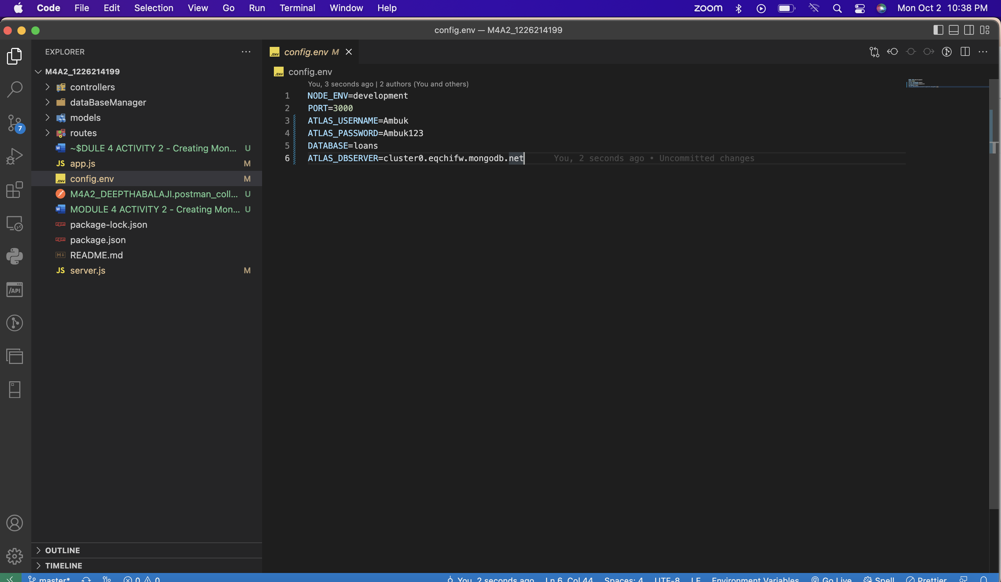

**Step 2 - Created the associated files in the correct folder - loanRoutes.js, loanController.js and loanModel.js in the model folder.**

Screenshot of the **loanRoutes.js** file

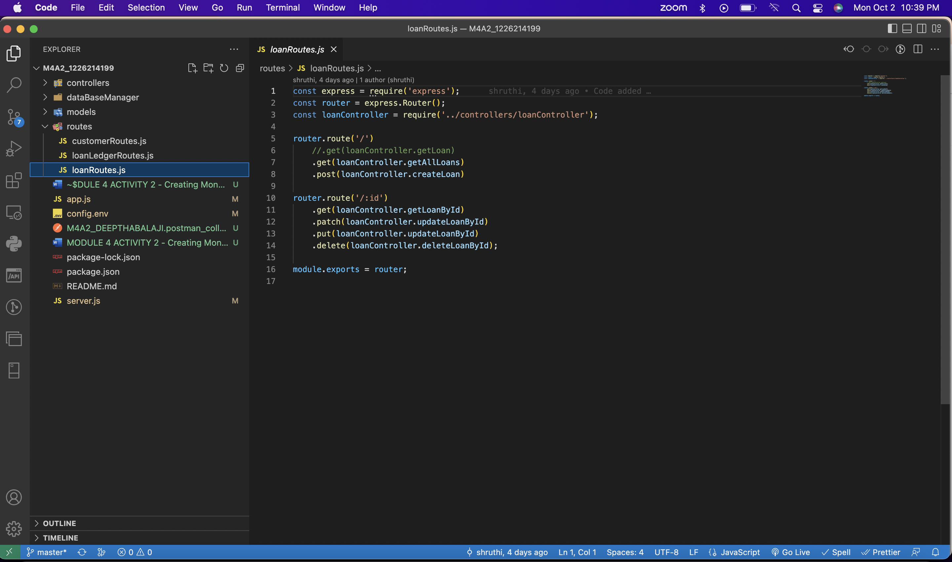

Screenshot of the **loanController.js** file

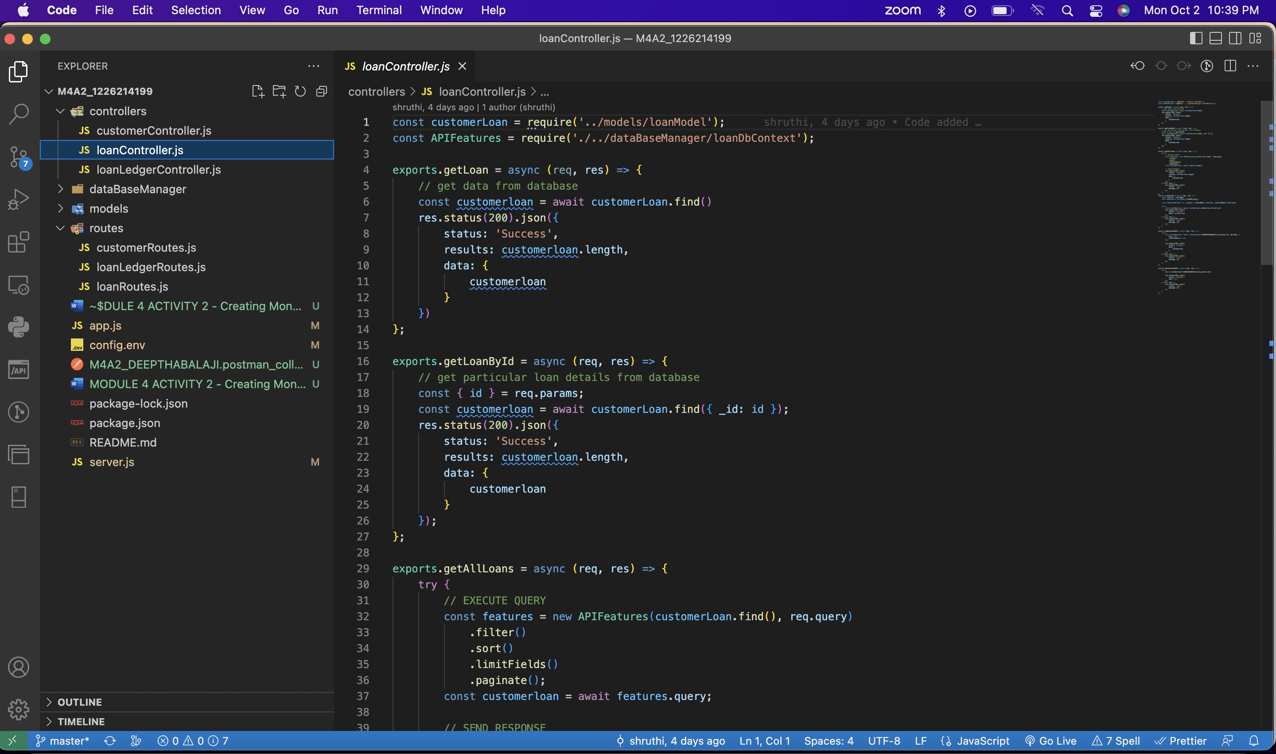

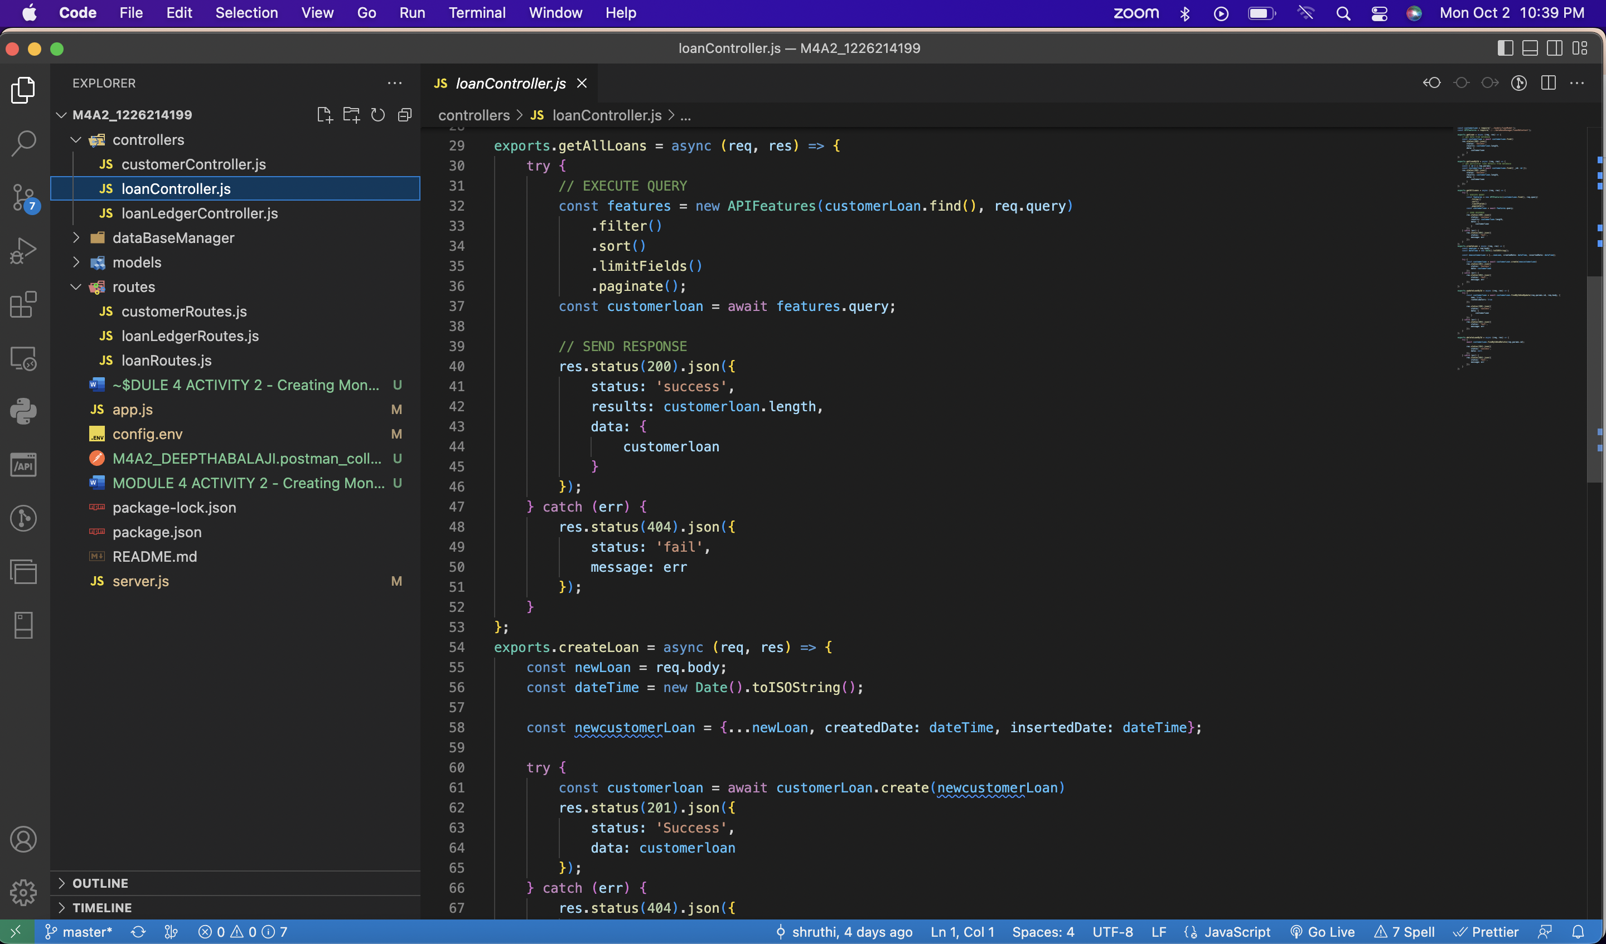

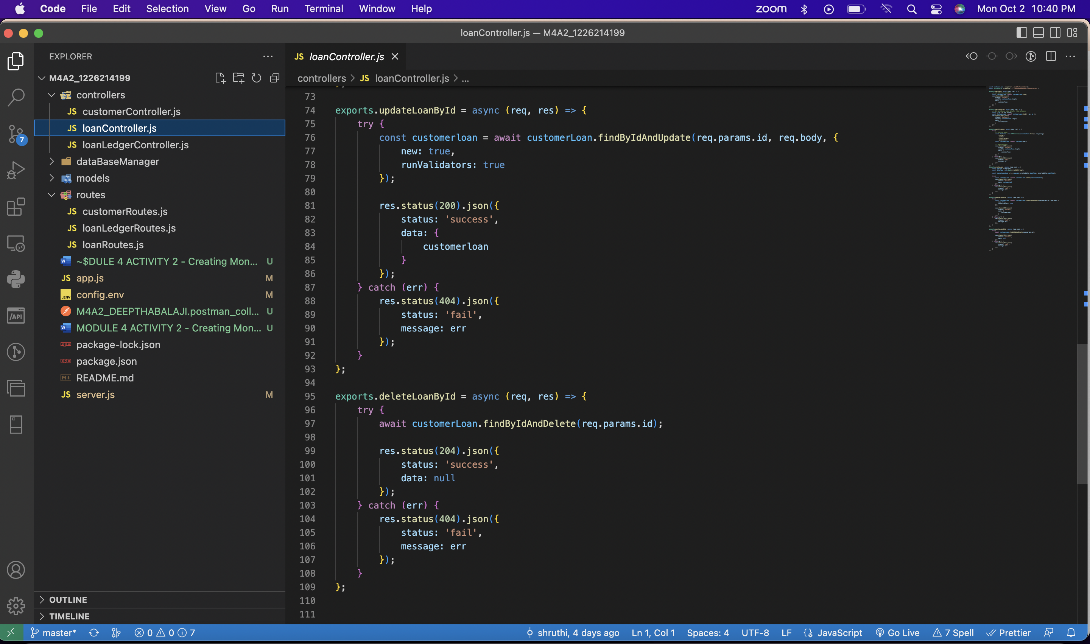

*Screenshot of the loanModel.js file*

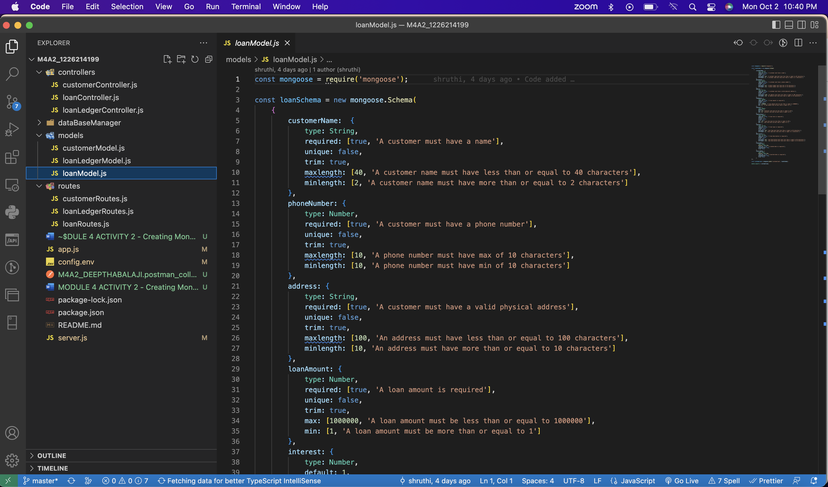

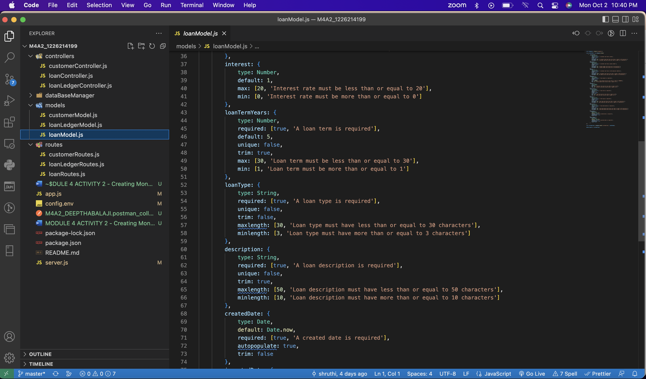

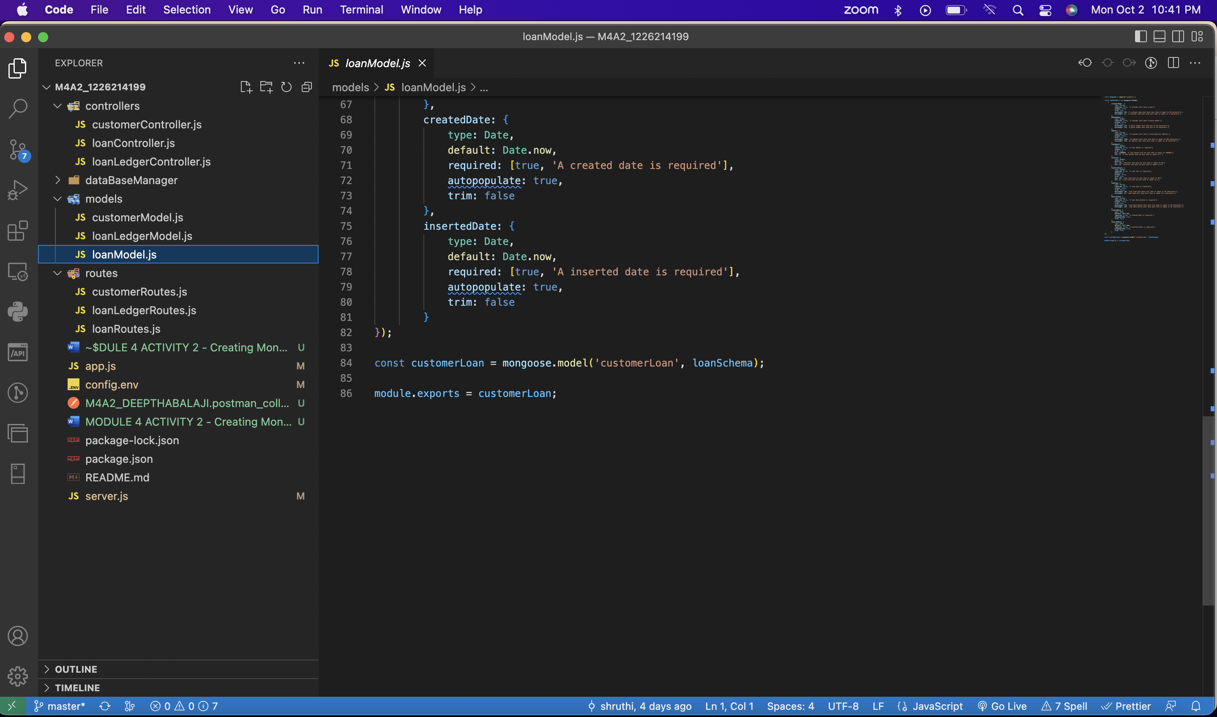

**Step 3 – Server.js file**

*Screenshot of the server.js file.*

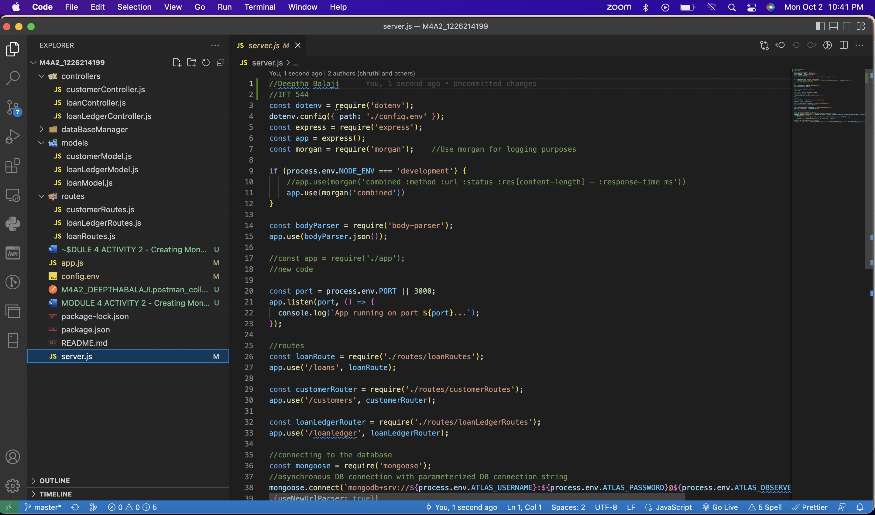

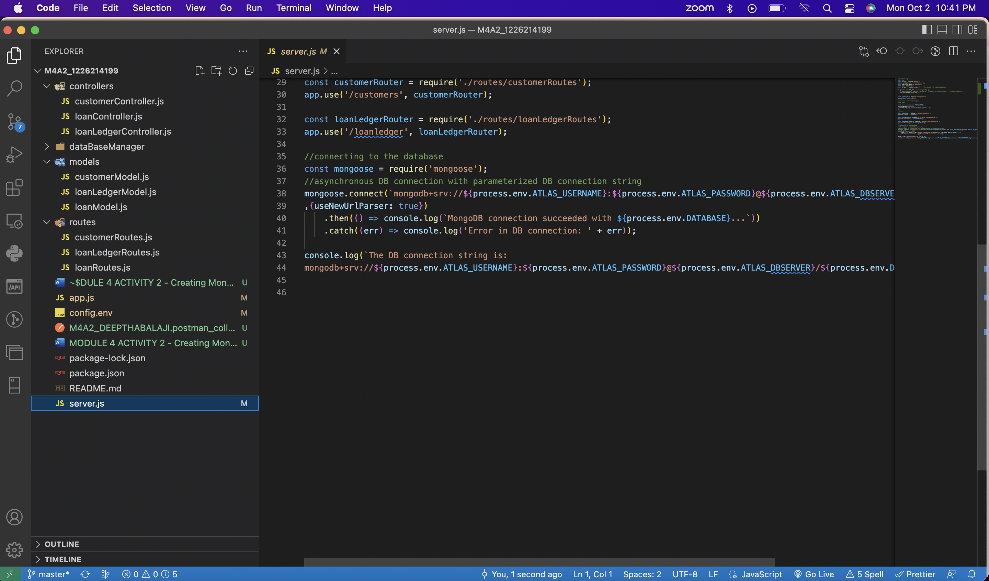

**Step 4 – Create a folder and name it as dataBaseManager**

*Screenshot of the dataBaseManager folder and the loanDbContext.js file*

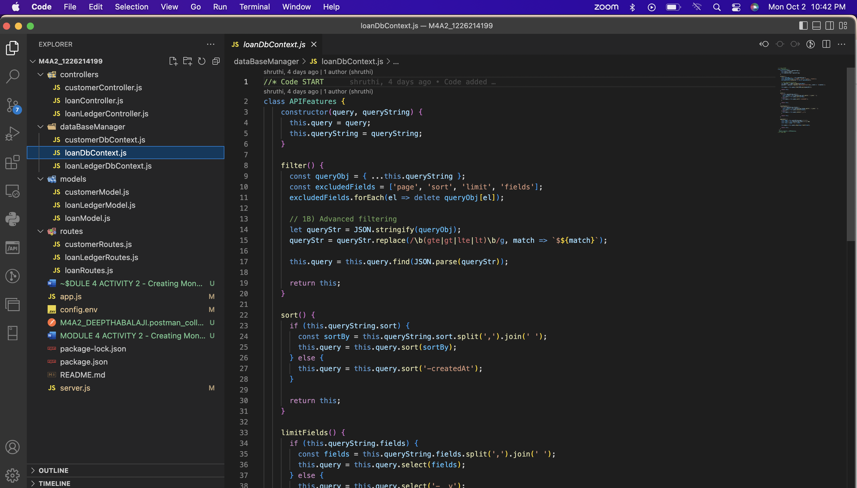

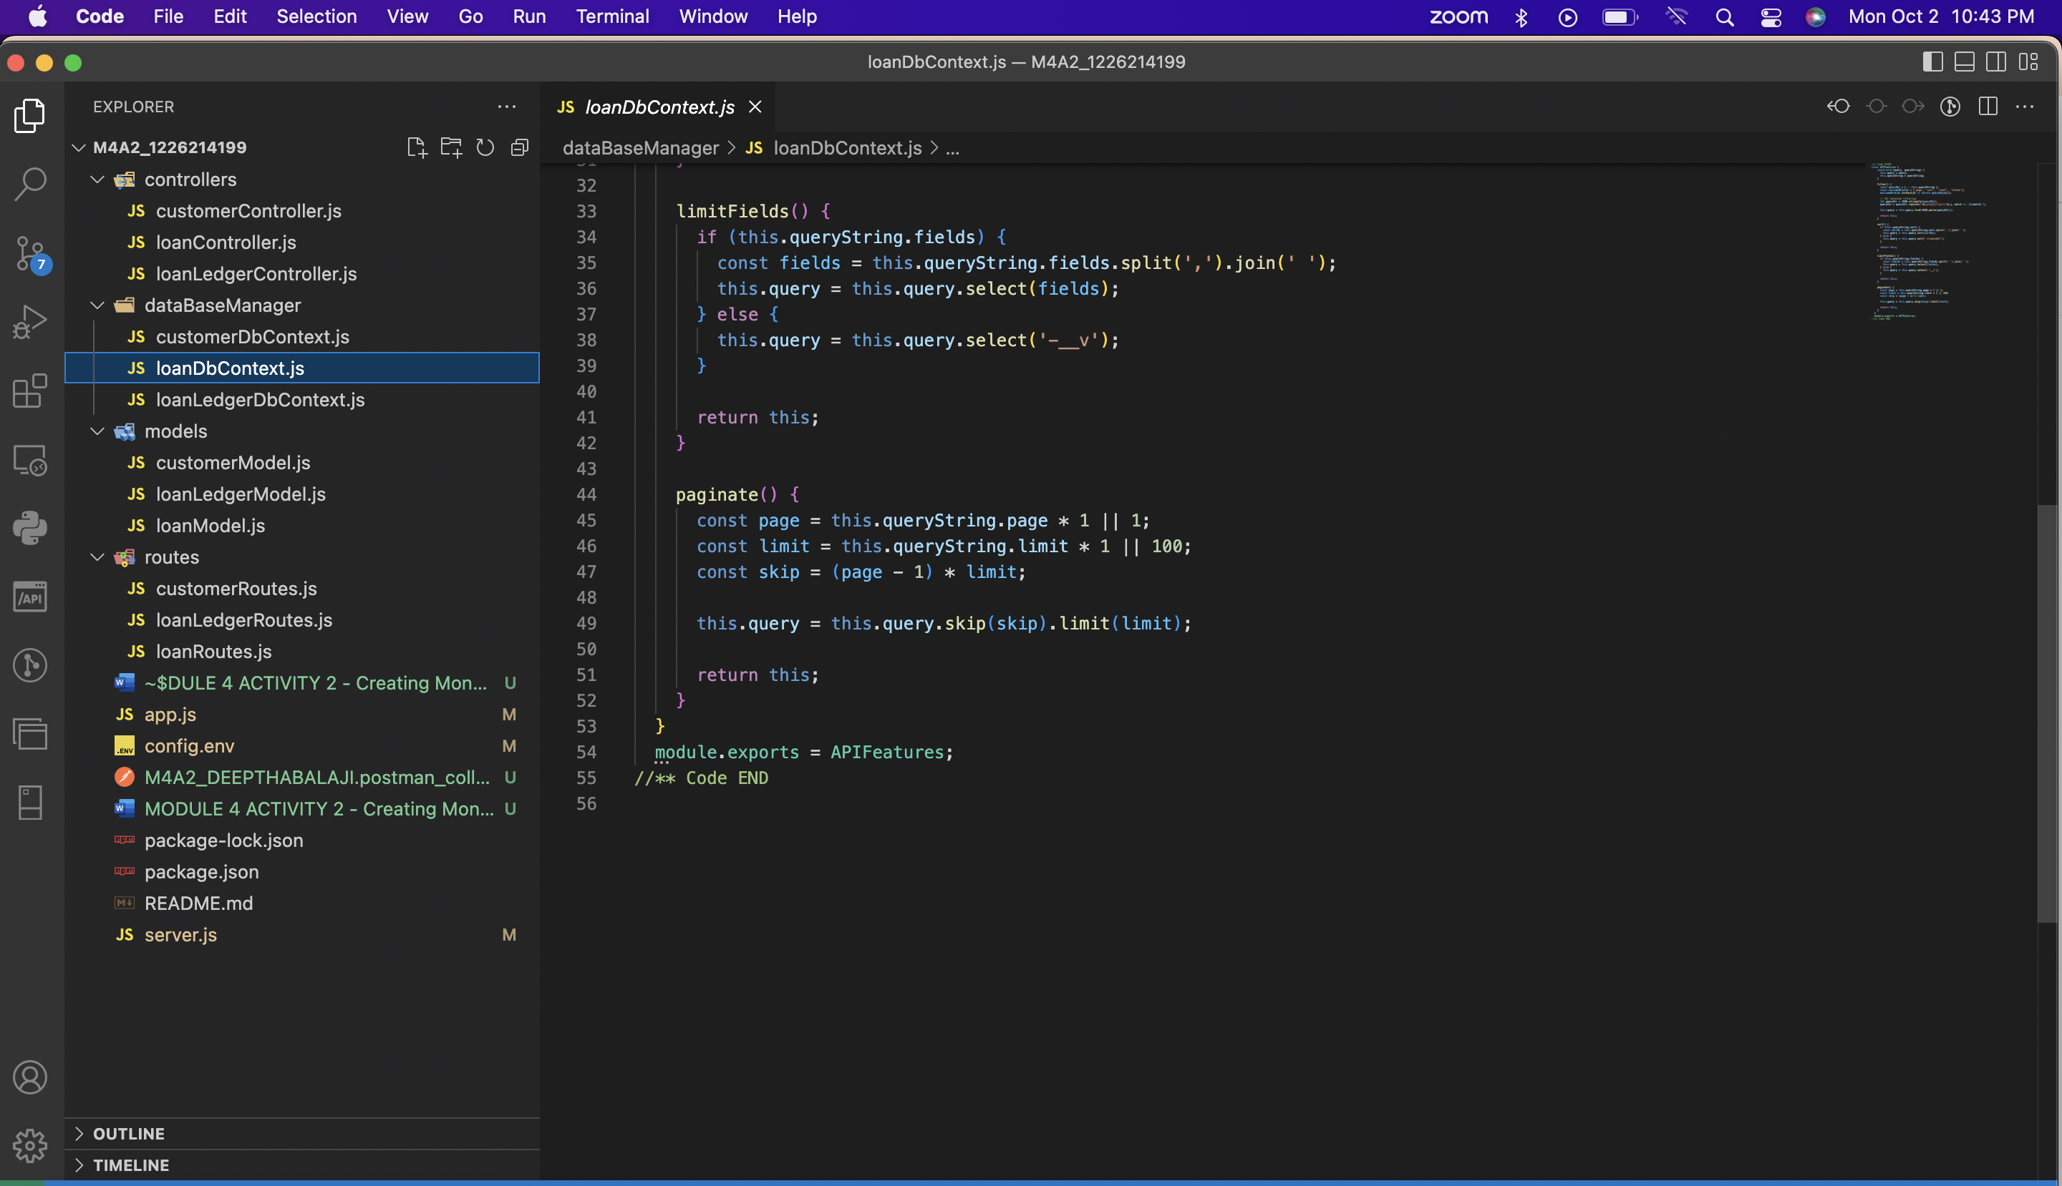

**Step 5 – Controller file**

*Screenshot of the loanController.js*

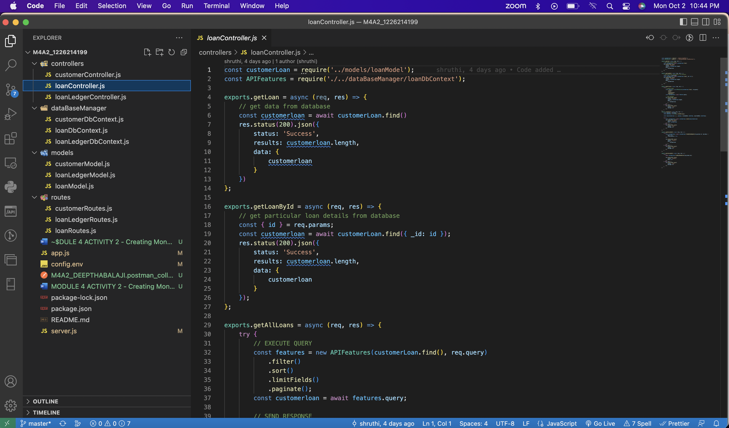

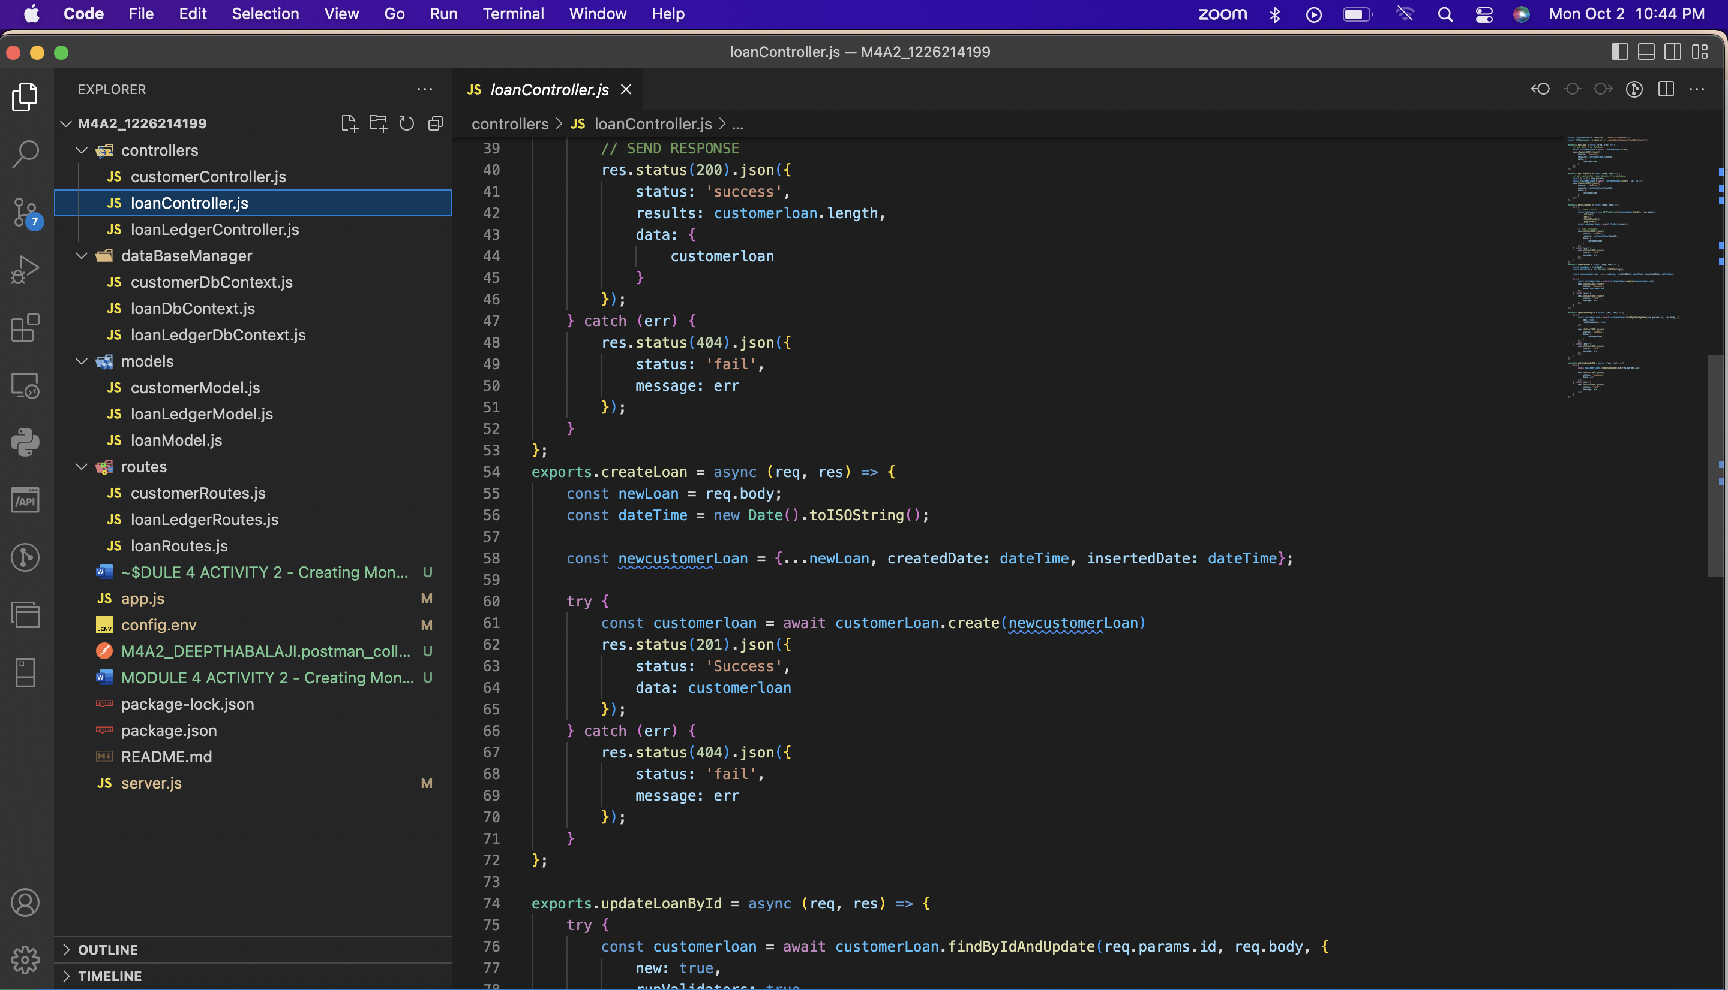

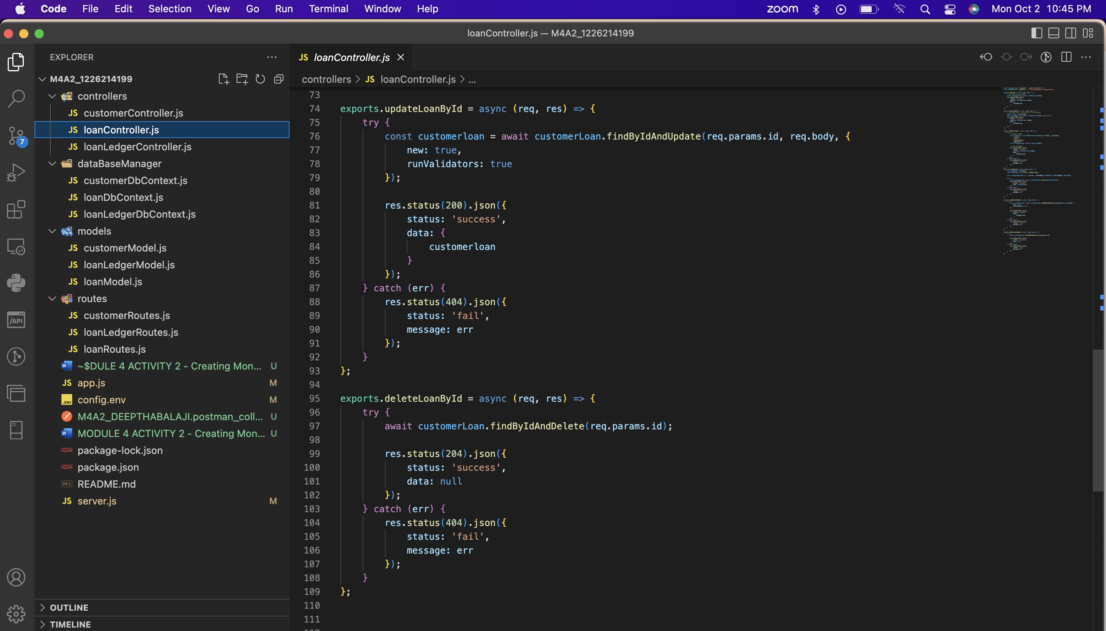

**Step 6 – App.js file**

*Screenshot of the app.js file*



**Step 7 – The App ran displaying the PORT number and LISTEN Message**

*Screenshot of the output displaying the port number and the message showing the DB connection successful*

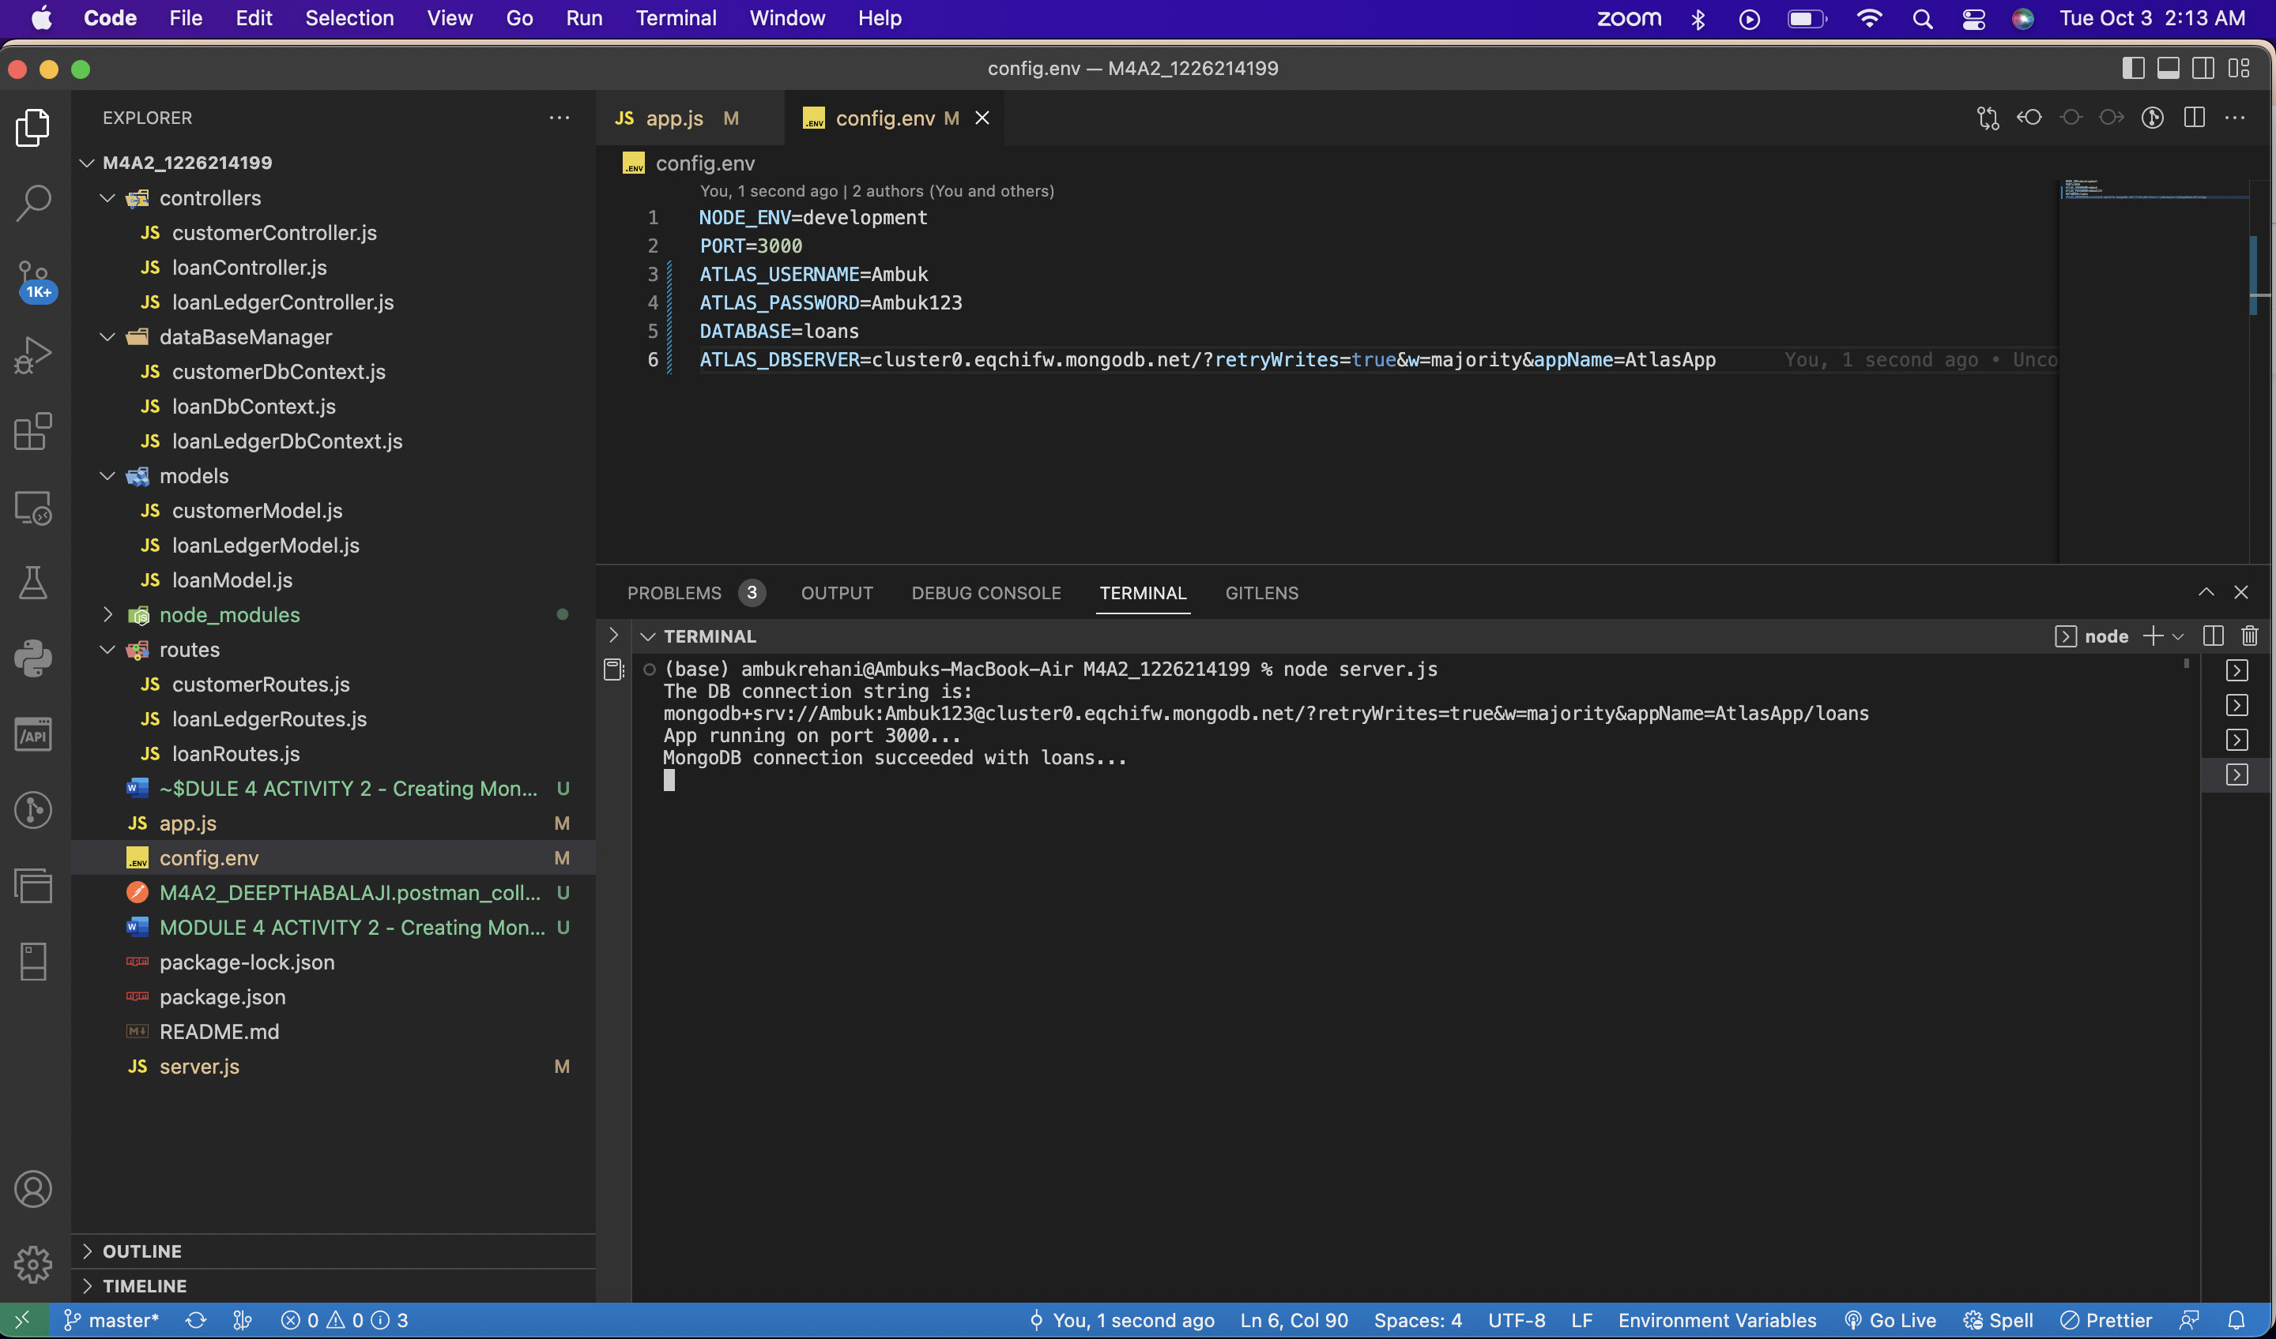a

**Step 8 – Add a new loan (POSTMAN).**

*Screenshot of the postman showing the addition of new loan successfully*

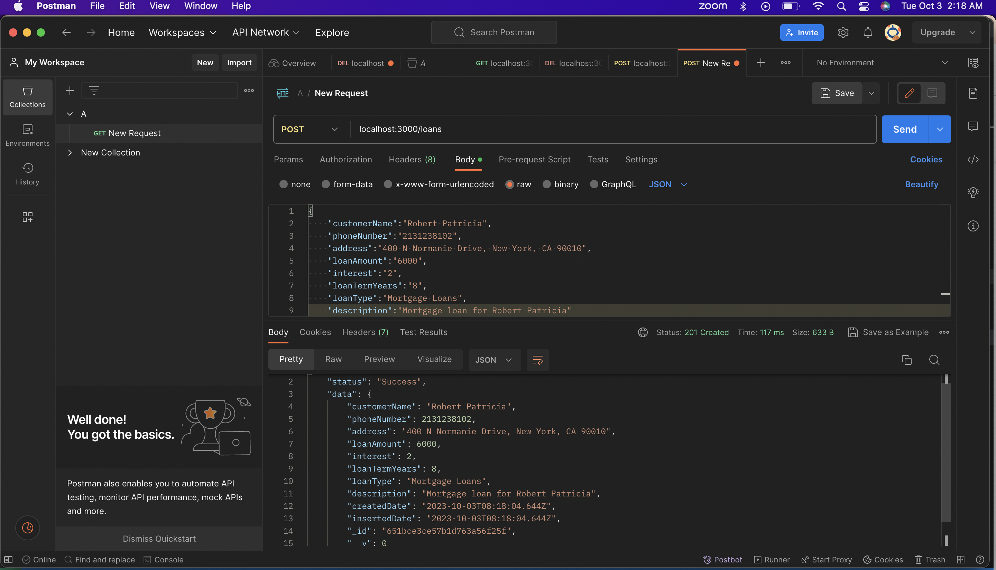

Loan document successfully added to the Mongo DB

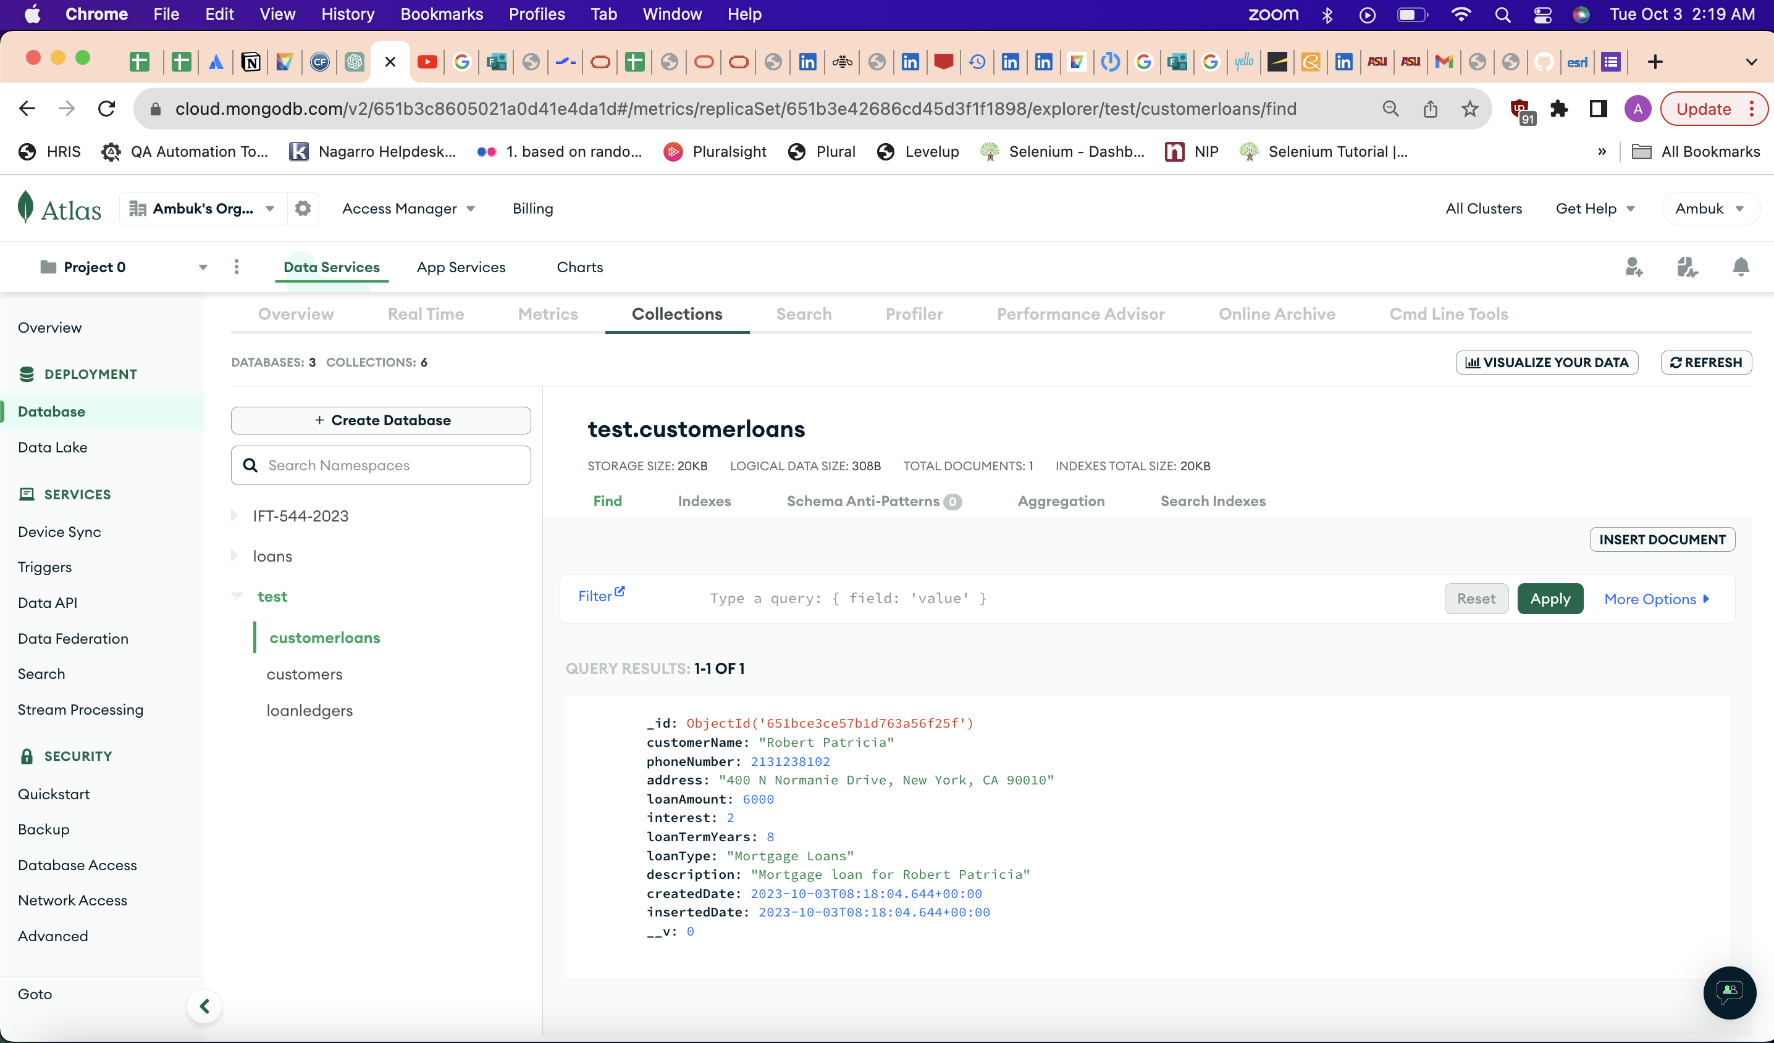

**Step 9 – Add 5 additional loans (POSTMAN).**

*Screenshot of the postman showing successful addition of 5 new loans*

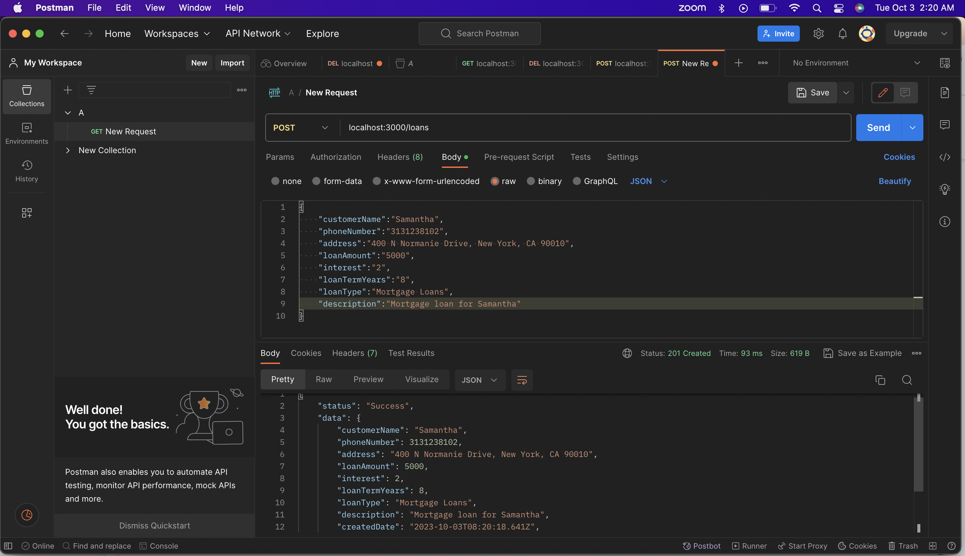

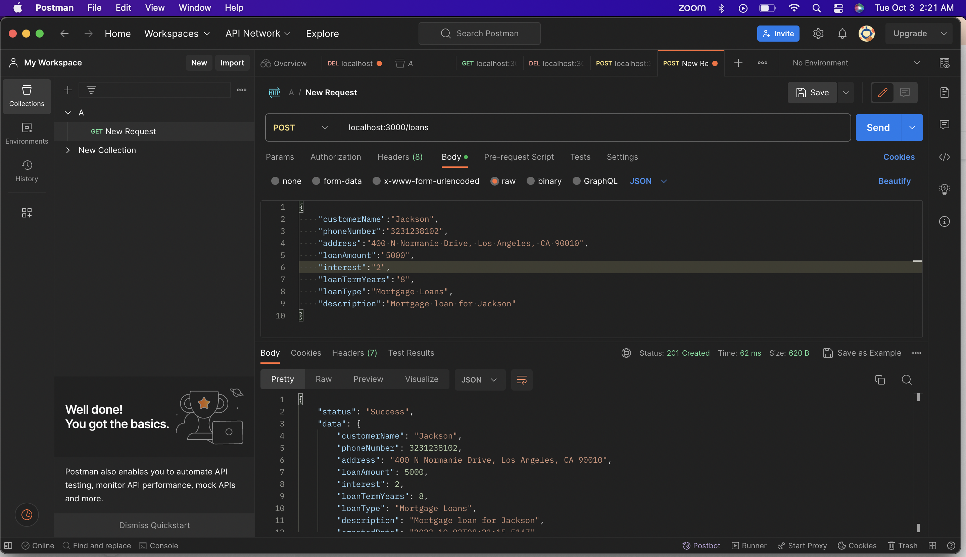

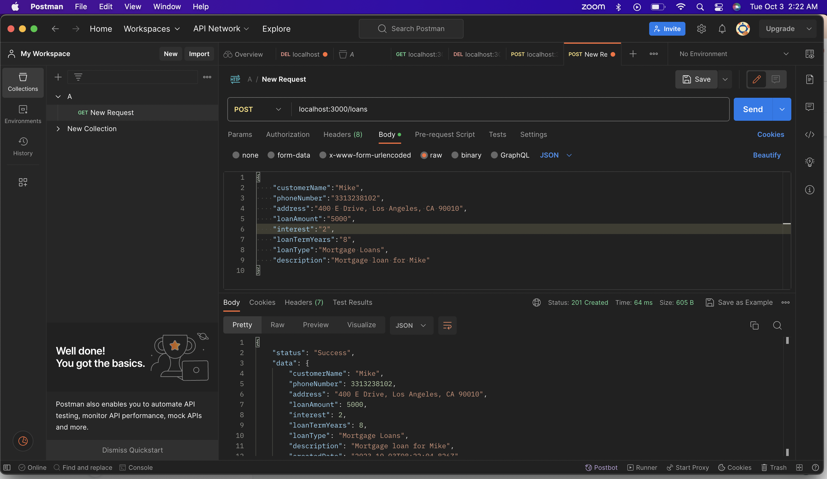

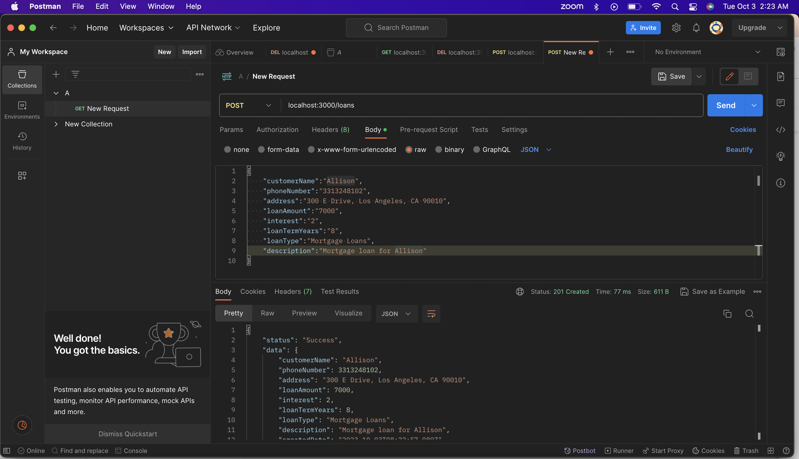

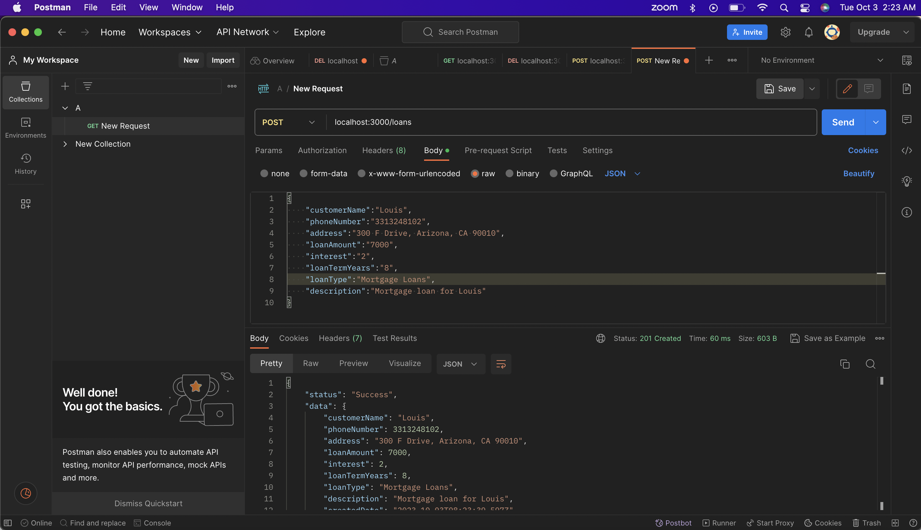

*Screenshot of the Terminal output*

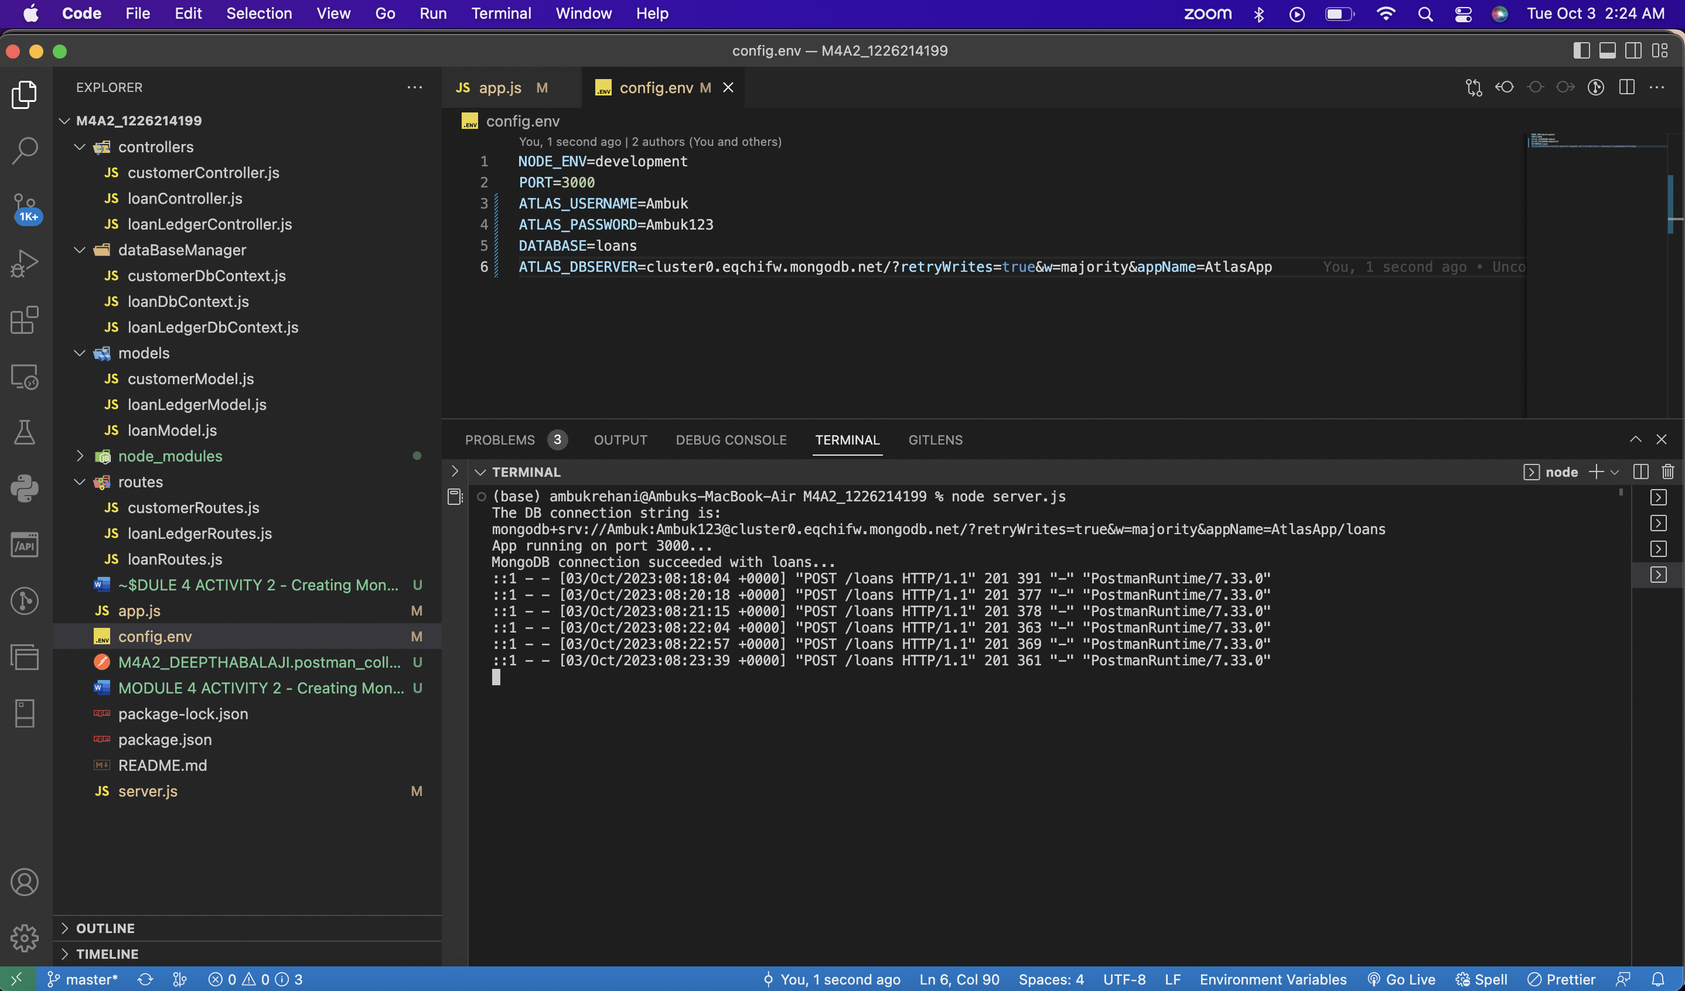

***Screenshot of the MongoDB Atlas showing successful addition of the 5 loans***

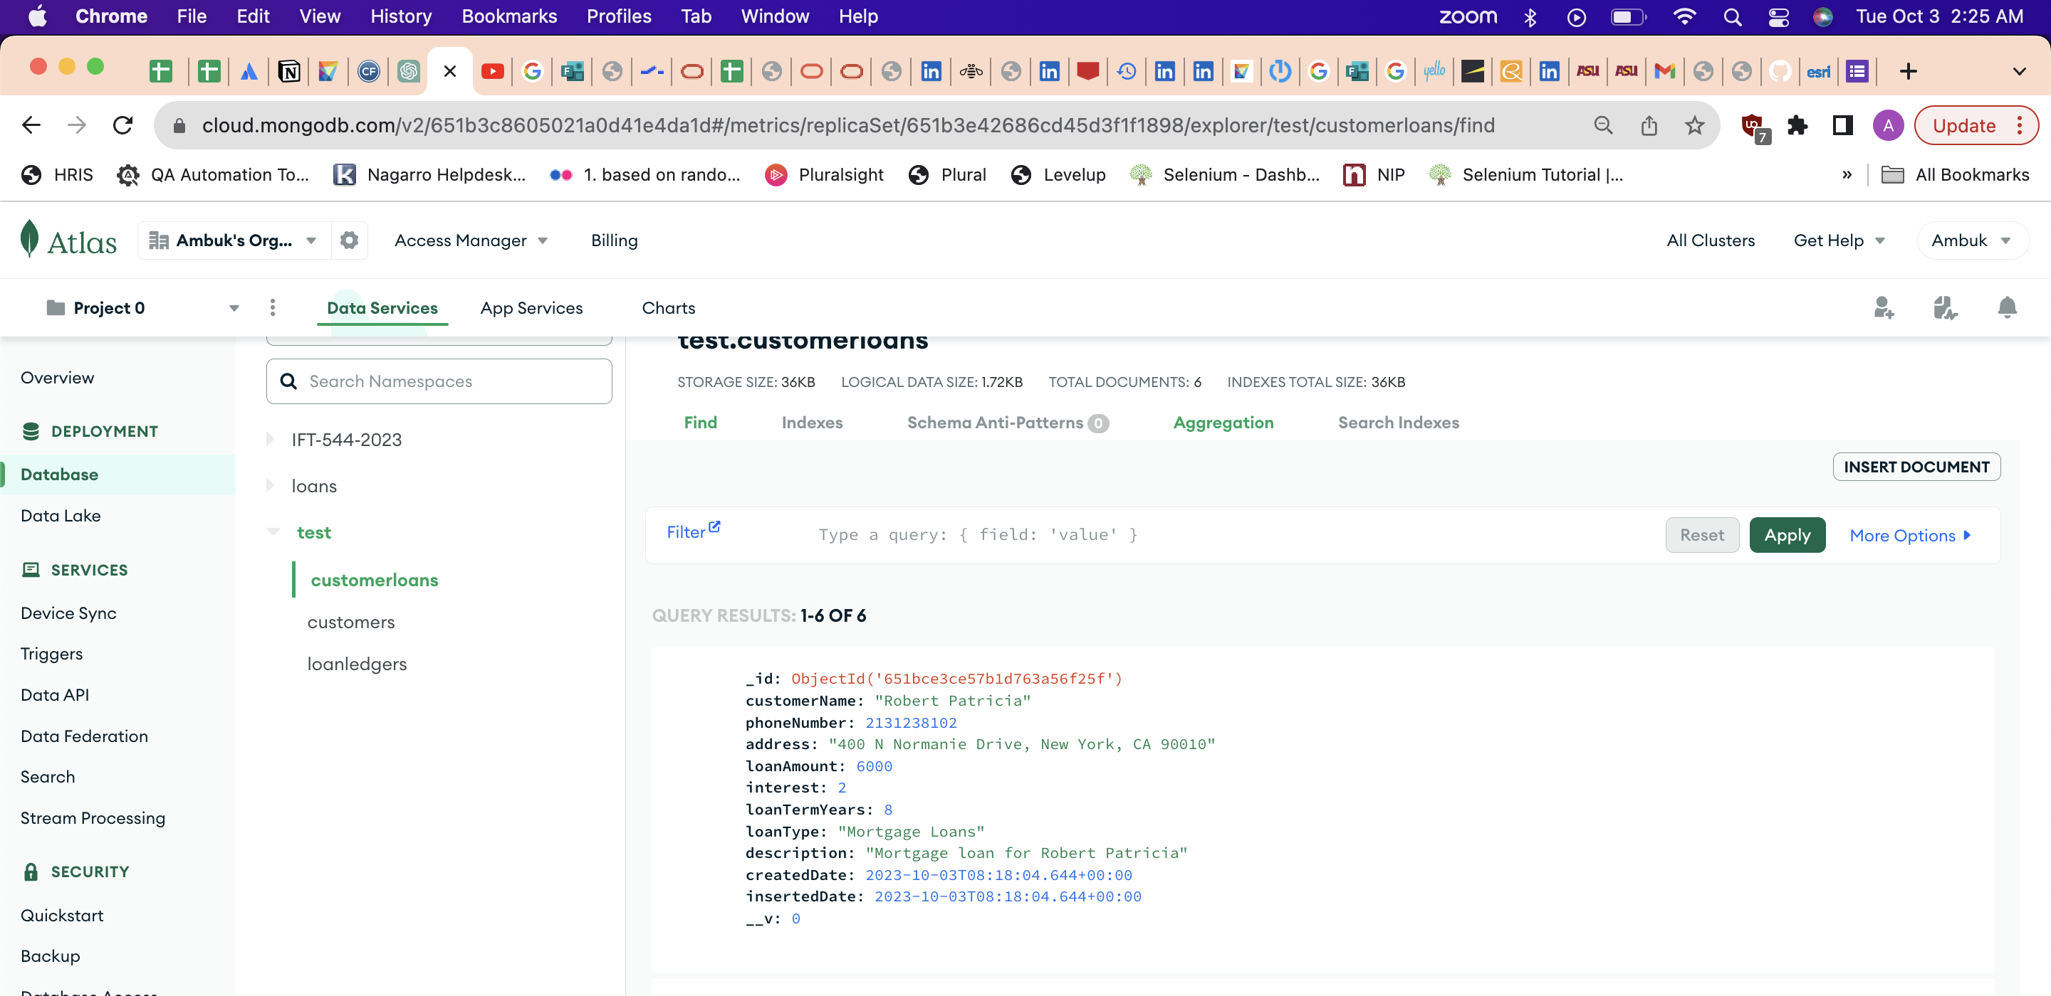

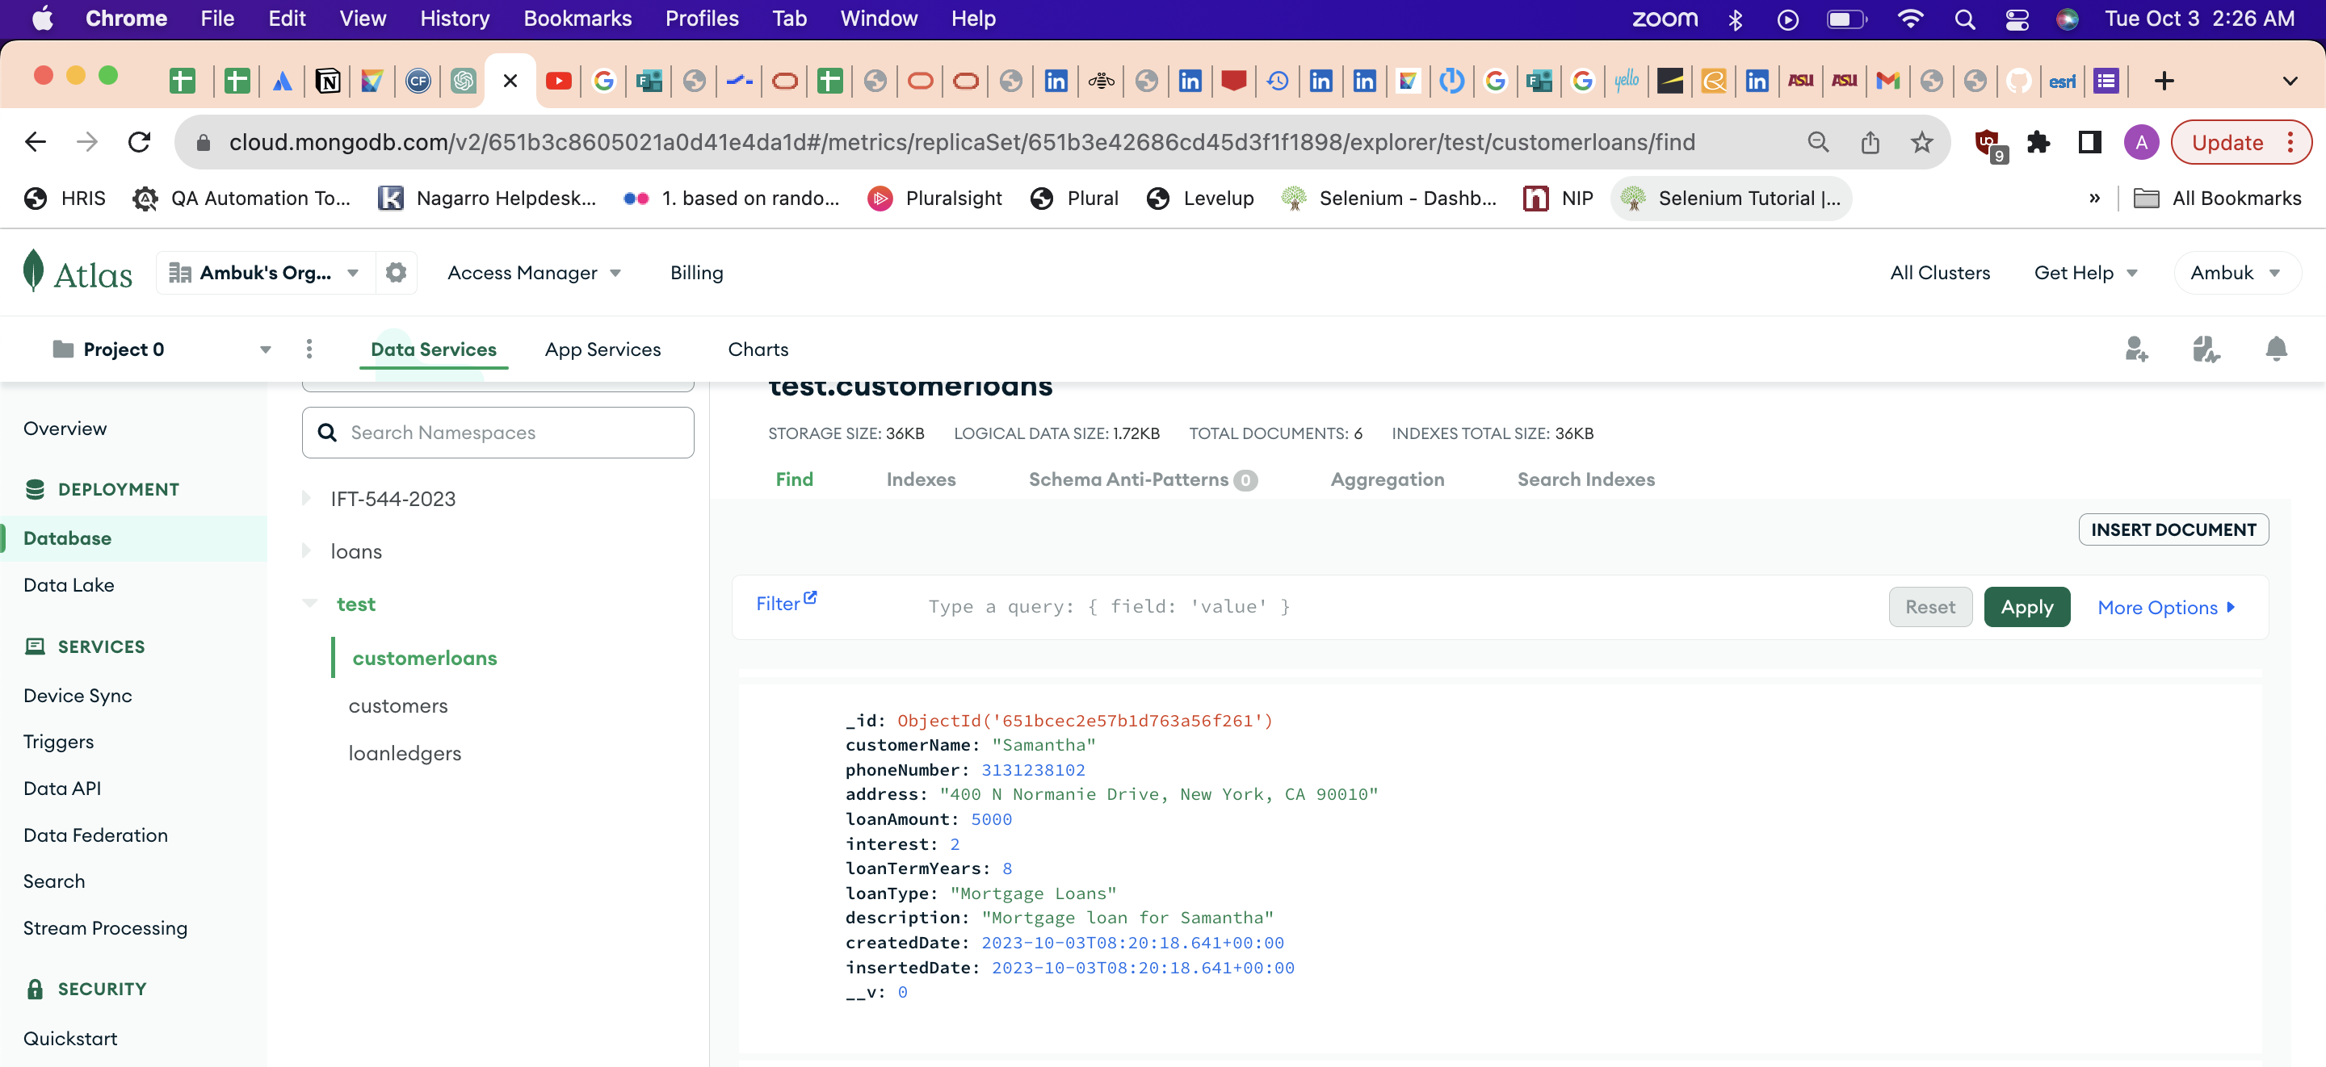

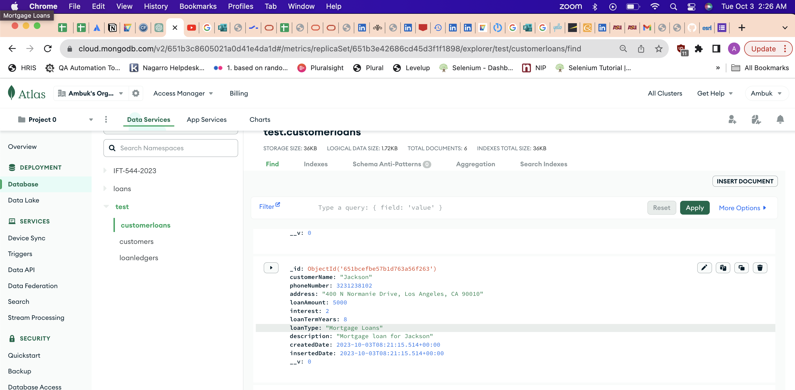

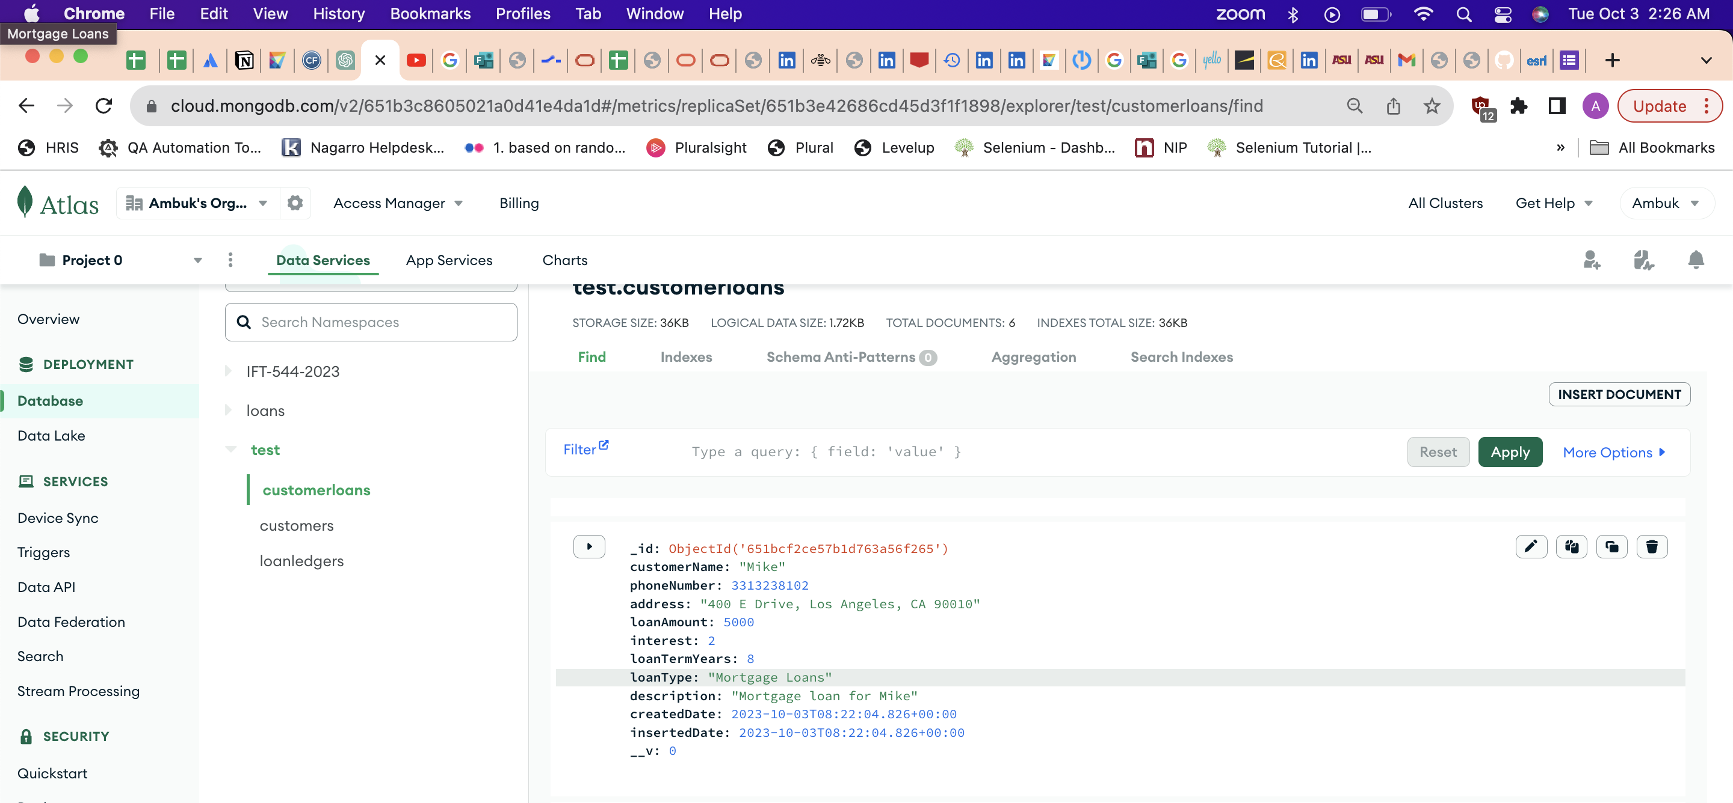

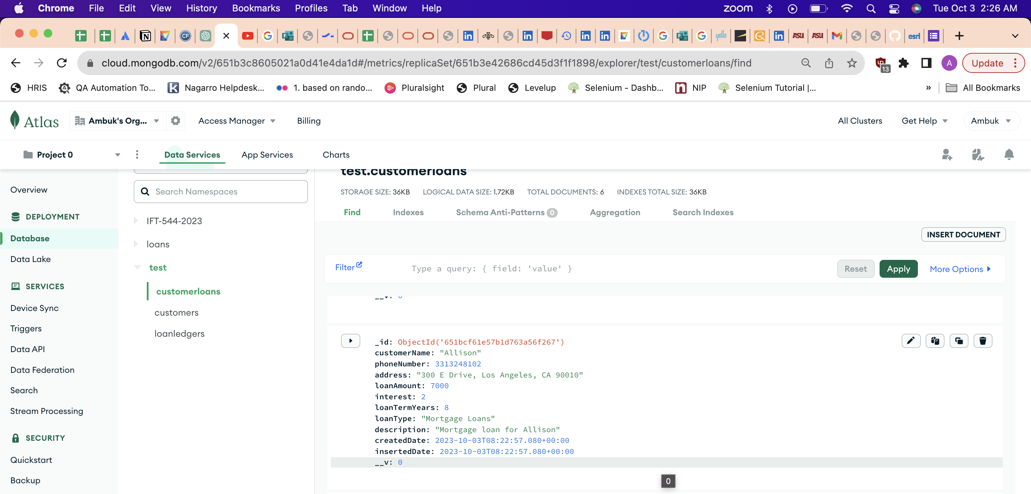

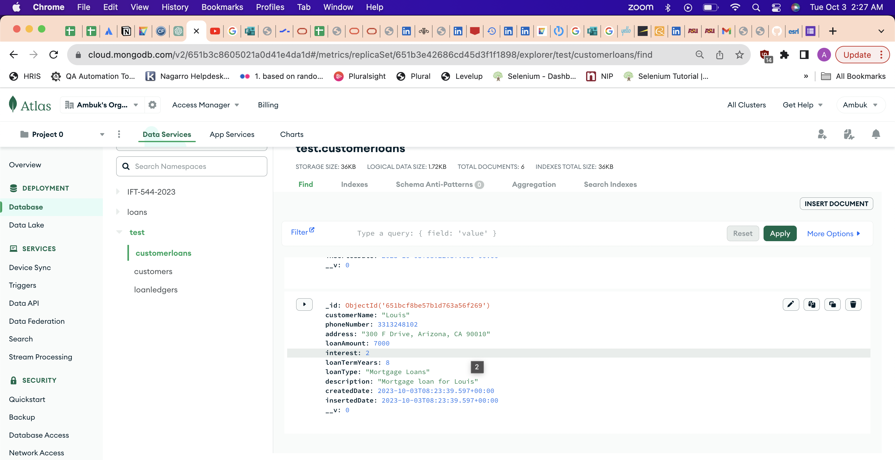

**Step 10 – Get Users To get all users, enter http://localhost:<PORT-NUMBER>/loans/ as the address.**

*Screenshot of the Postman and MongoDB Atlas showing all Customers*

*All 6 documents from the collection are successful via the /loans end point as shown below –*

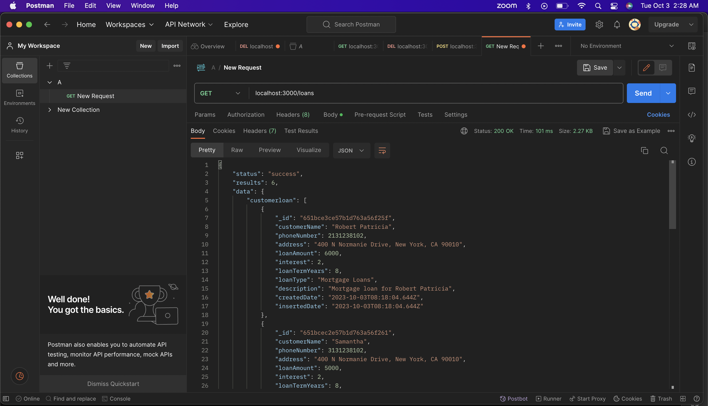

{

"status": "success",

"results": 6,

"data": {

"customerloan": [

{

"_id": "651bce3ce57b1d763a56f25f",

"customerName": "Robert Patricia",

"phoneNumber": 2131238102,

"address": "400 N Normanie Drive, New York, CA 90010",

"loanAmount": 6000,

"interest": 2,

"loanTermYears": 8,

"loanType": "Mortgage Loans",

"description": "Mortgage loan for Robert Patricia",

"createdDate": "2023-10-03T08:18:04.644Z",

"insertedDate": "2023-10-03T08:18:04.644Z"

},

{

"_id": "651bcec2e57b1d763a56f261",

"customerName": "Samantha",

"phoneNumber": 3131238102,

"address": "400 N Normanie Drive, New York, CA 90010",

"loanAmount": 5000,

"interest": 2,

"loanTermYears": 8,

"loanType": "Mortgage Loans",

"description": "Mortgage loan for Samantha",

"createdDate": "2023-10-03T08:20:18.641Z",

"insertedDate": "2023-10-03T08:20:18.641Z"

},

{

"_id": "651bcefbe57b1d763a56f263",

"customerName": "Jackson",

"phoneNumber": 3231238102,

"address": "400 N Normanie Drive, Los Angeles, CA 90010",

"loanAmount": 5000,

"interest": 2,

"loanTermYears": 8,

"loanType": "Mortgage Loans",

"description": "Mortgage loan for Jackson",

"createdDate": "2023-10-03T08:21:15.514Z",

"insertedDate": "2023-10-03T08:21:15.514Z"

},

{

"_id": "651bcf2ce57b1d763a56f265",

"customerName": "Mike",

"phoneNumber": 3313238102,

"address": "400 E Drive, Los Angeles, CA 90010",

"loanAmount": 5000,

"interest": 2,

"loanTermYears": 8,

"loanType": "Mortgage Loans",

"description": "Mortgage loan for Mike",

"createdDate": "2023-10-03T08:22:04.826Z",

"insertedDate": "2023-10-03T08:22:04.826Z"

},

{

"_id": "651bcf61e57b1d763a56f267",

"customerName": "Allison",

"phoneNumber": 3313248102,

"address": "300 E Drive, Los Angeles, CA 90010",

"loanAmount": 7000,

"interest": 2,

"loanTermYears": 8,

"loanType": "Mortgage Loans",

"description": "Mortgage loan for Allison",

"createdDate": "2023-10-03T08:22:57.080Z",

"insertedDate": "2023-10-03T08:22:57.080Z"

},

{

"_id": "651bcf8be57b1d763a56f269",

"customerName": "Louis",

"phoneNumber": 3313248102,

"address": "300 F Drive, Arizona, CA 90010",

"loanAmount": 7000,

"interest": 2,

"loanTermYears": 8,

"loanType": "Mortgage Loans",

"description": "Mortgage loan for Louis",

"createdDate": "2023-10-03T08:23:39.597Z",

"insertedDate": "2023-10-03T08:23:39.597Z"

}

]

}

}

**Step 11 – Get a Specific User (POSTMAN) Get the data of a specific user by entering this URL:** [**http://localhost:<PORT_NUMBER>/loans/:id**](http://localhost:%3cPORT_NUMBER%3e/loans/:id)

***Screenshot of the Postman request and response***

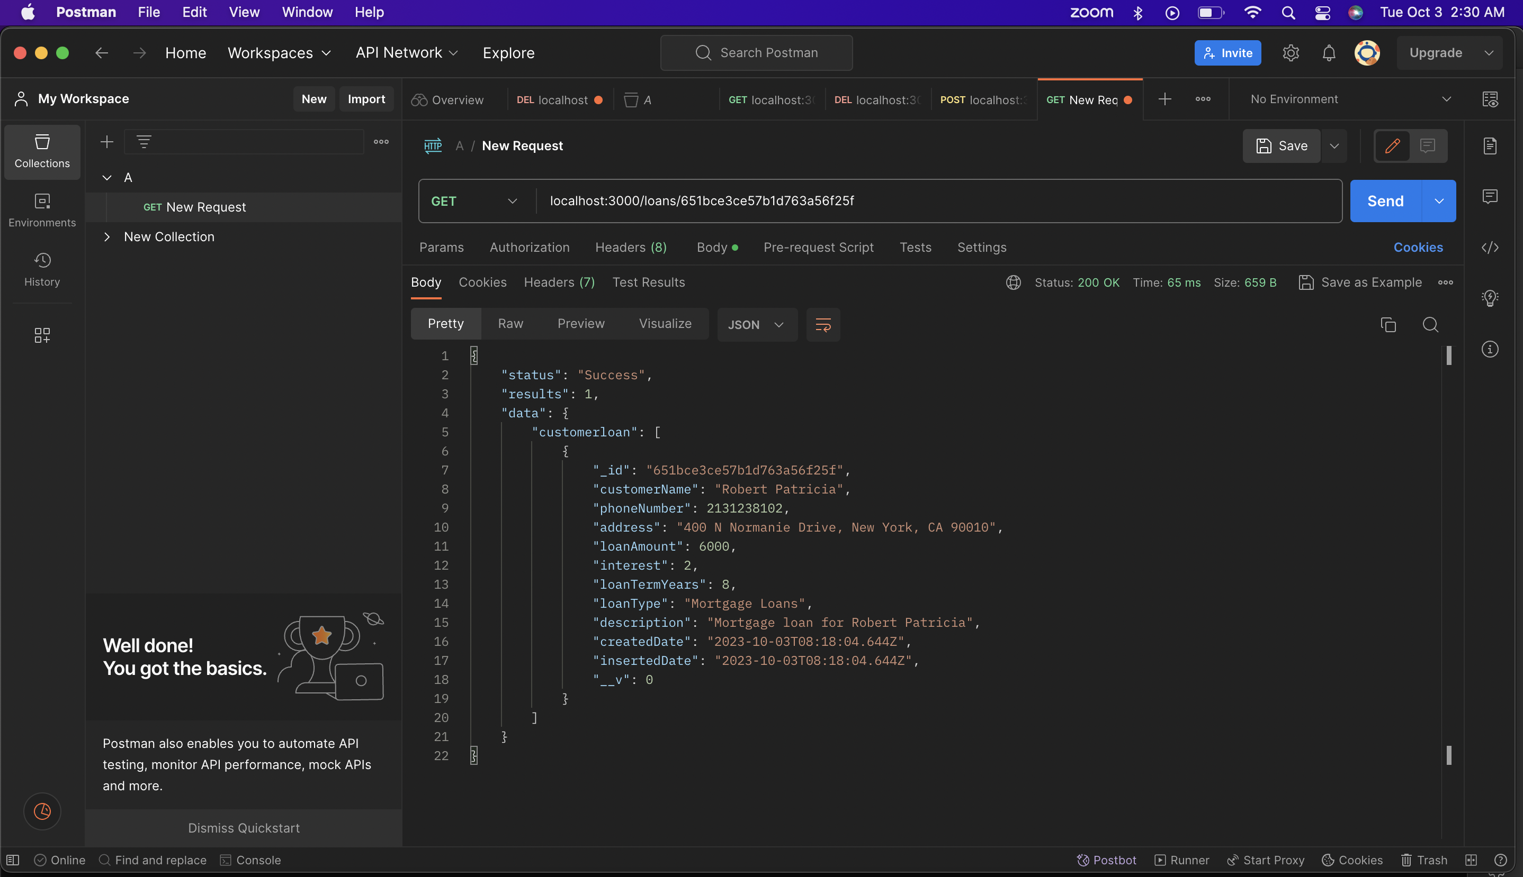

**Step 12 – Change an Existing Loan (POSTMAN) Change an existing Loan by using the PUT verb. Then change the value of the JSON object. The URL is the same as when we fetched the specific Loan.**

*Screenshots of the document before change (POSTMAN & Atlas MongoDB)* 

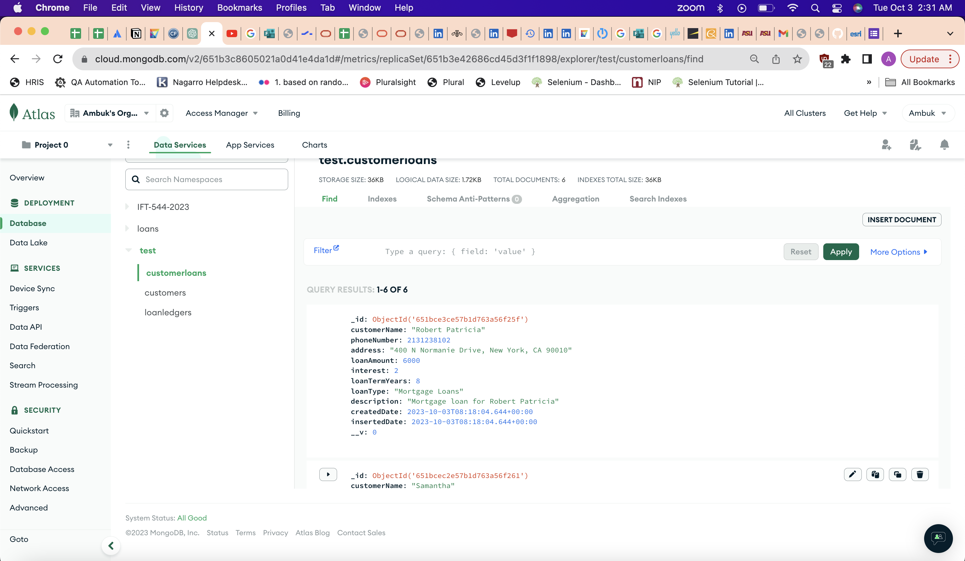

*Screenshot of the document after change (POSTMAN & Atlas MongoDB): Updated all Fields*

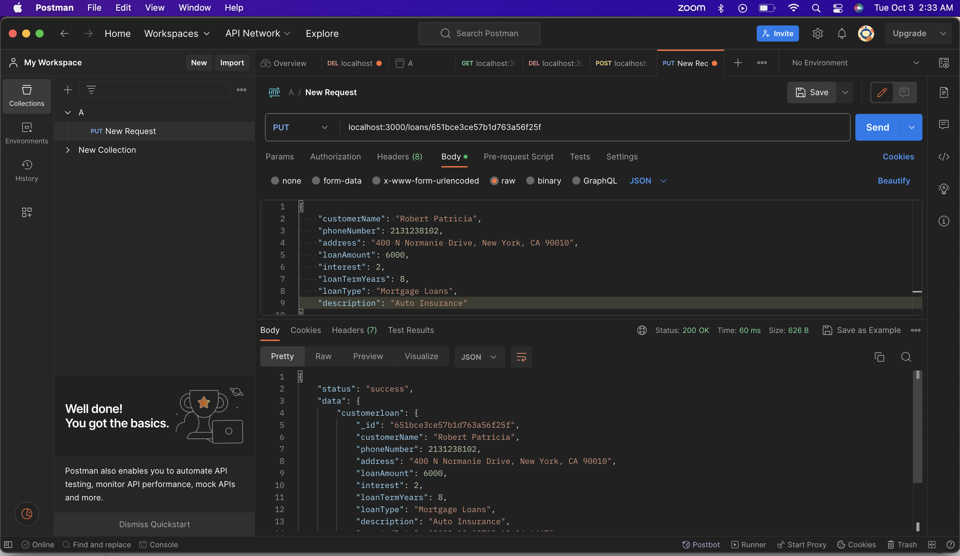

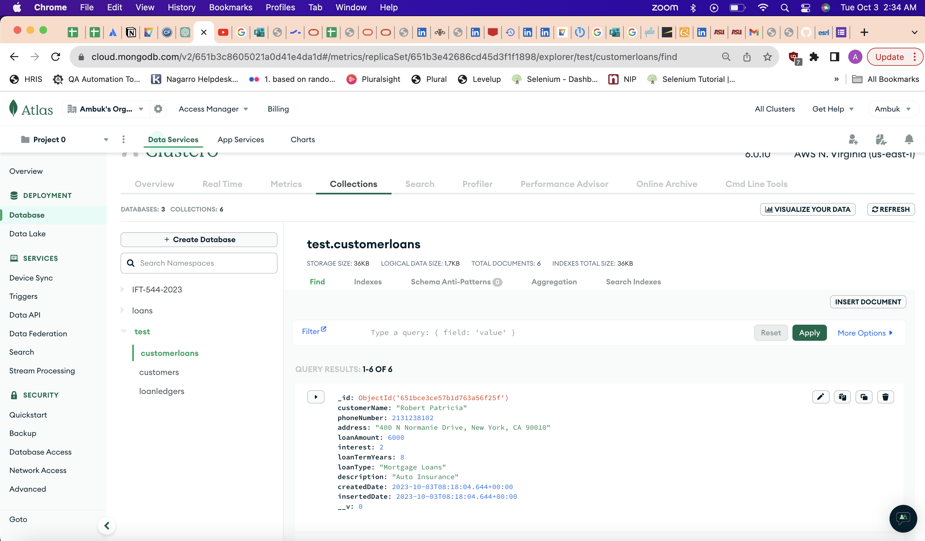

***Step 13 – To delete a loan, we only need to change the verb to DELETE. We can verify that the user is gone by fetching all the loans. Now Verify that you have a fully working express backend connected to a MongoDB database.***

*Screenshot of the Postman showing successful deletion of the document. Response 204.*

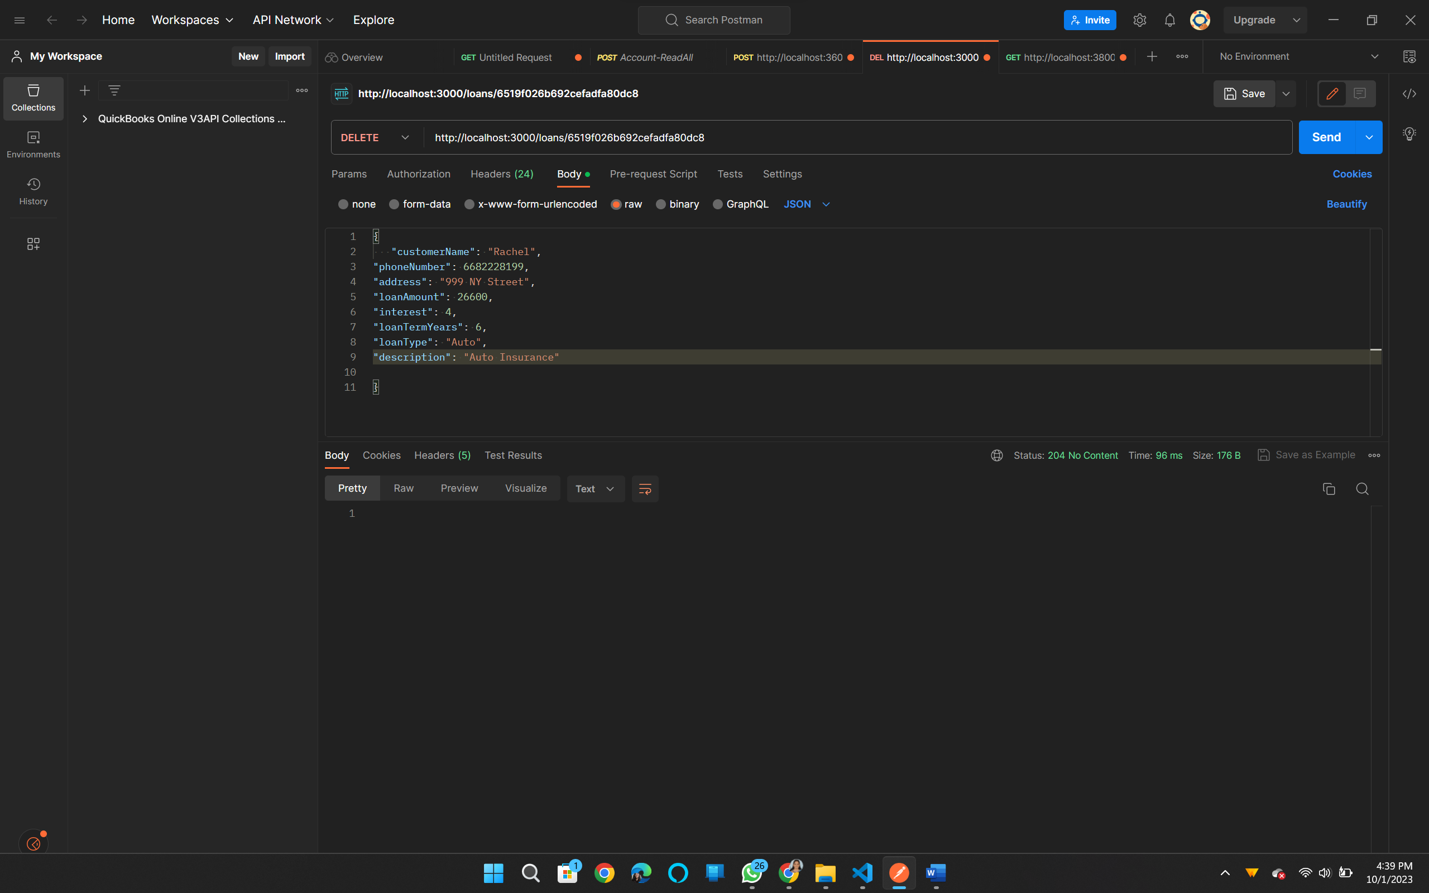

*Screenshot of the Postman verifying if a document with the id still exists or not. Output as expected. No document found.*

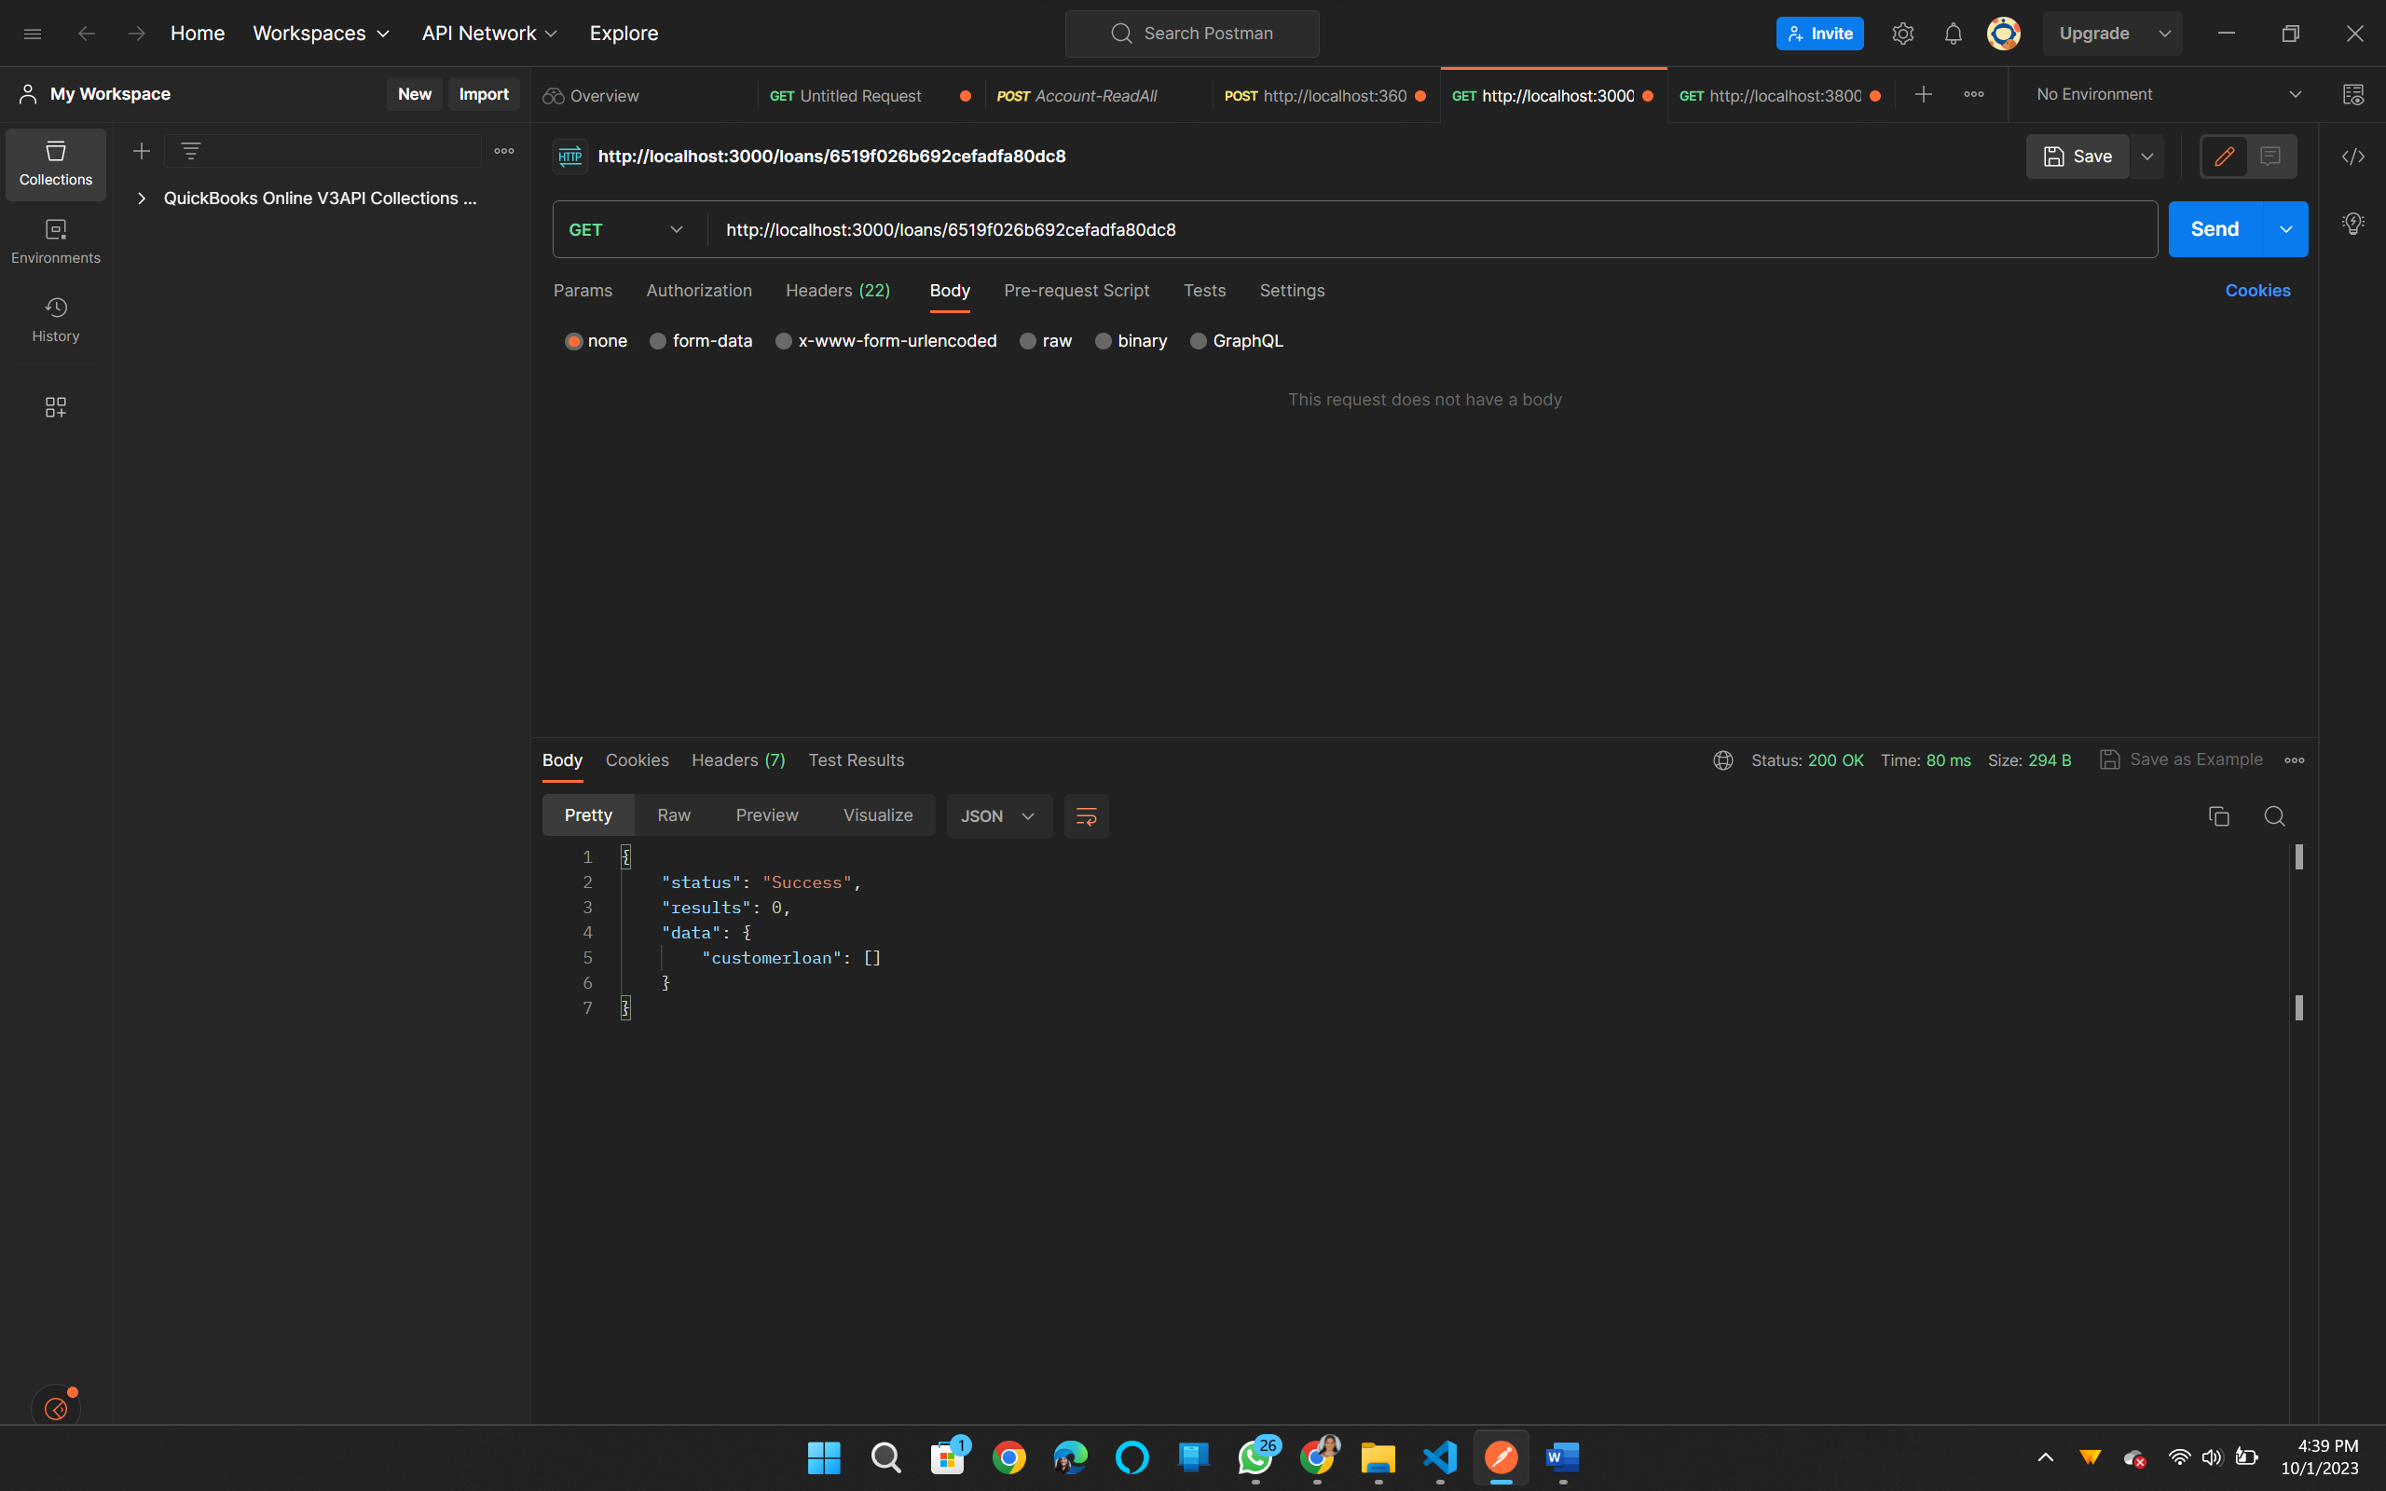

*Screenshot of the MongoDB Atlas – displaying 5 queries, previously it was 6.*

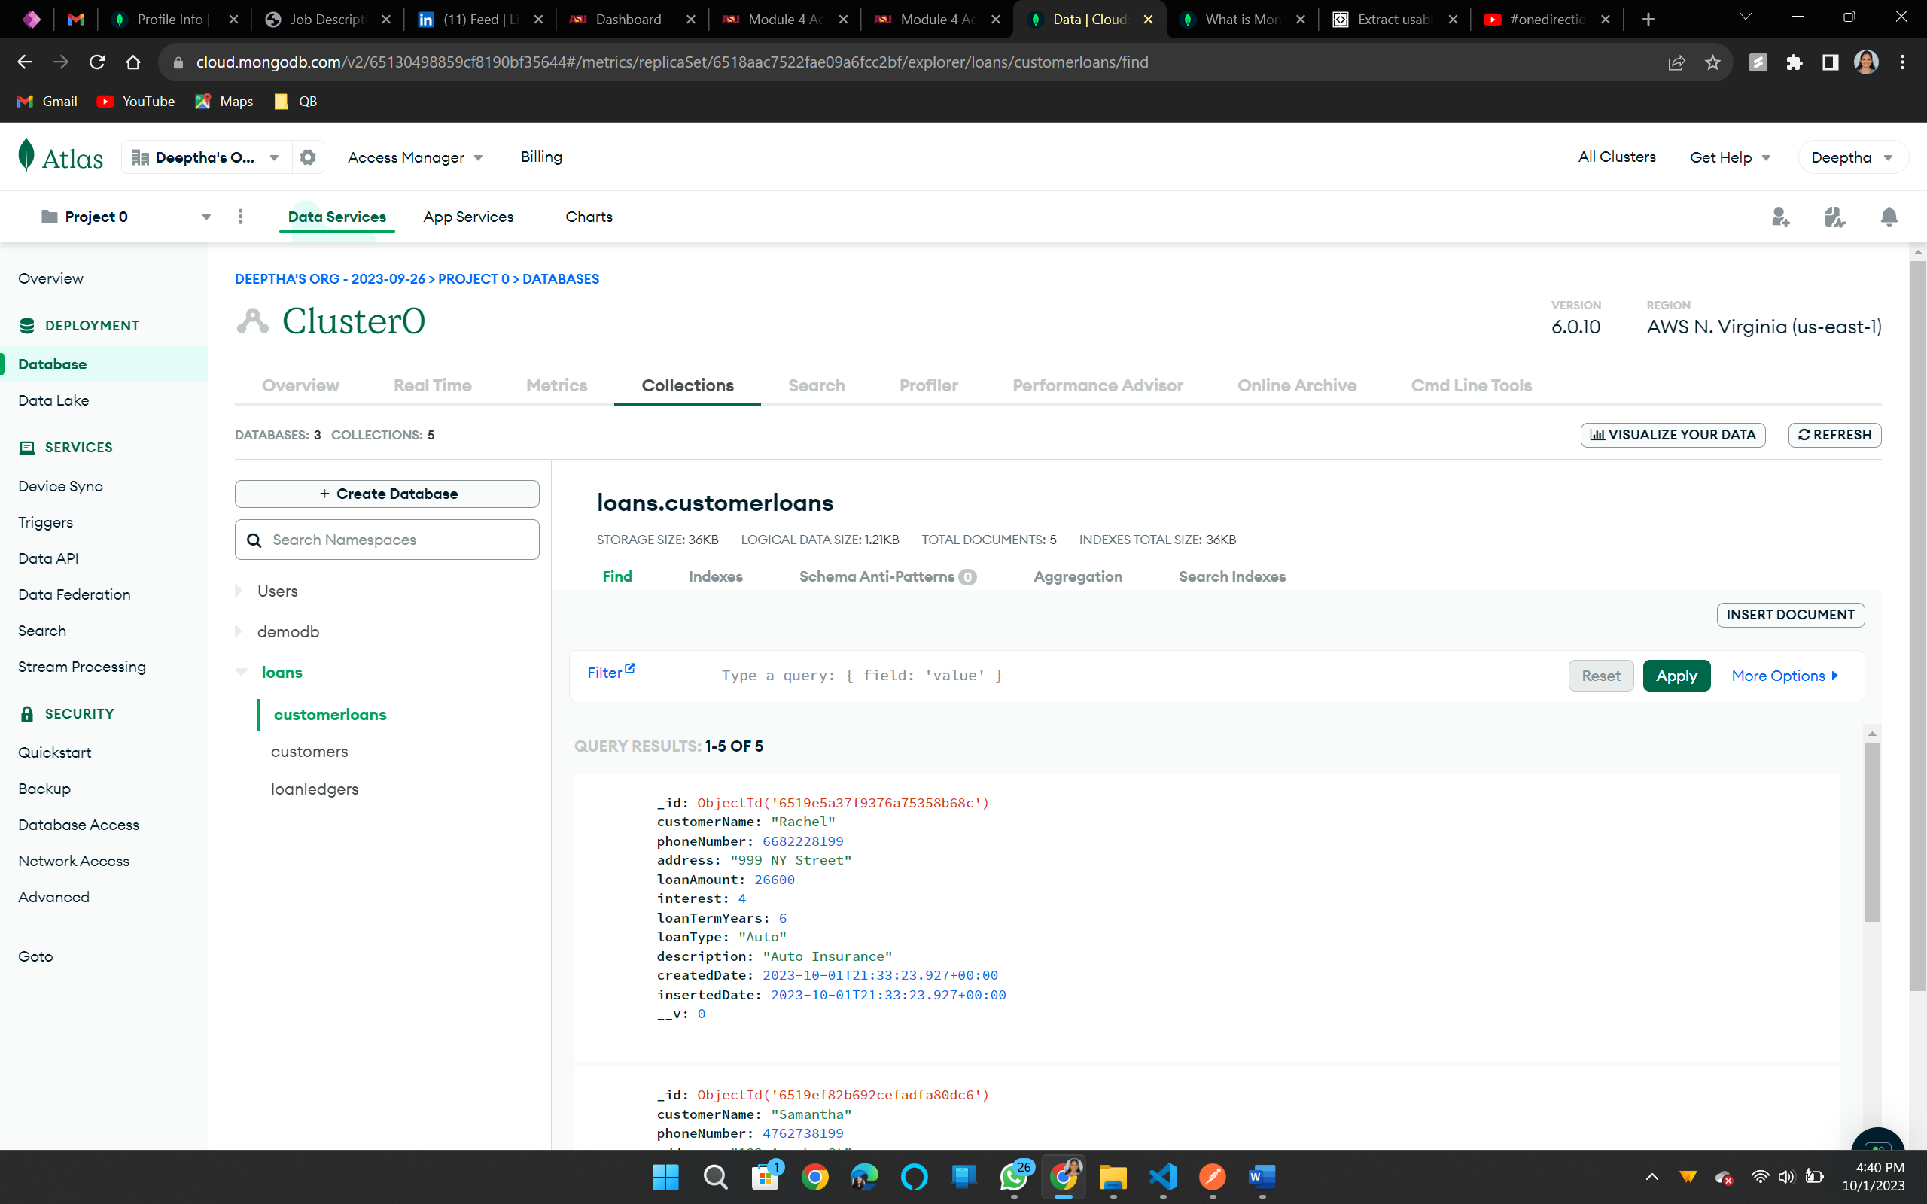

***Step 14 – Create a collection in POSTMAN and all your TEST there and then EXPORT POSTMAN TEST COLLECTION to a json file.***

*Screenshot of the collection in Postman containing all tests done so far in this assignment*

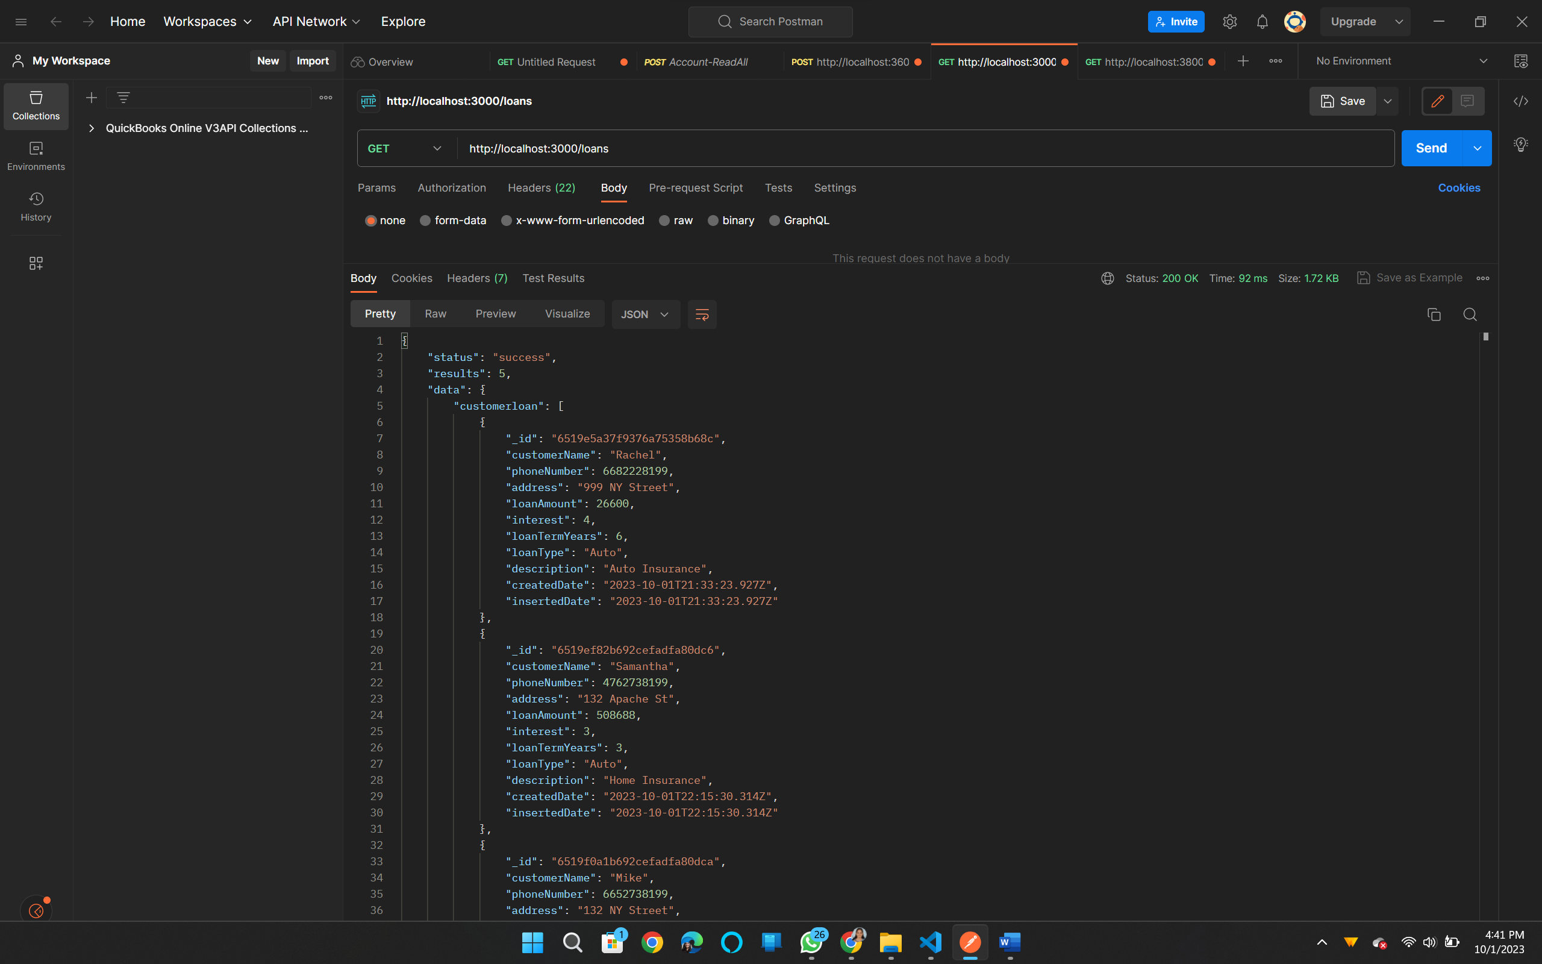

*Exporting the Postman collection as JSON file*

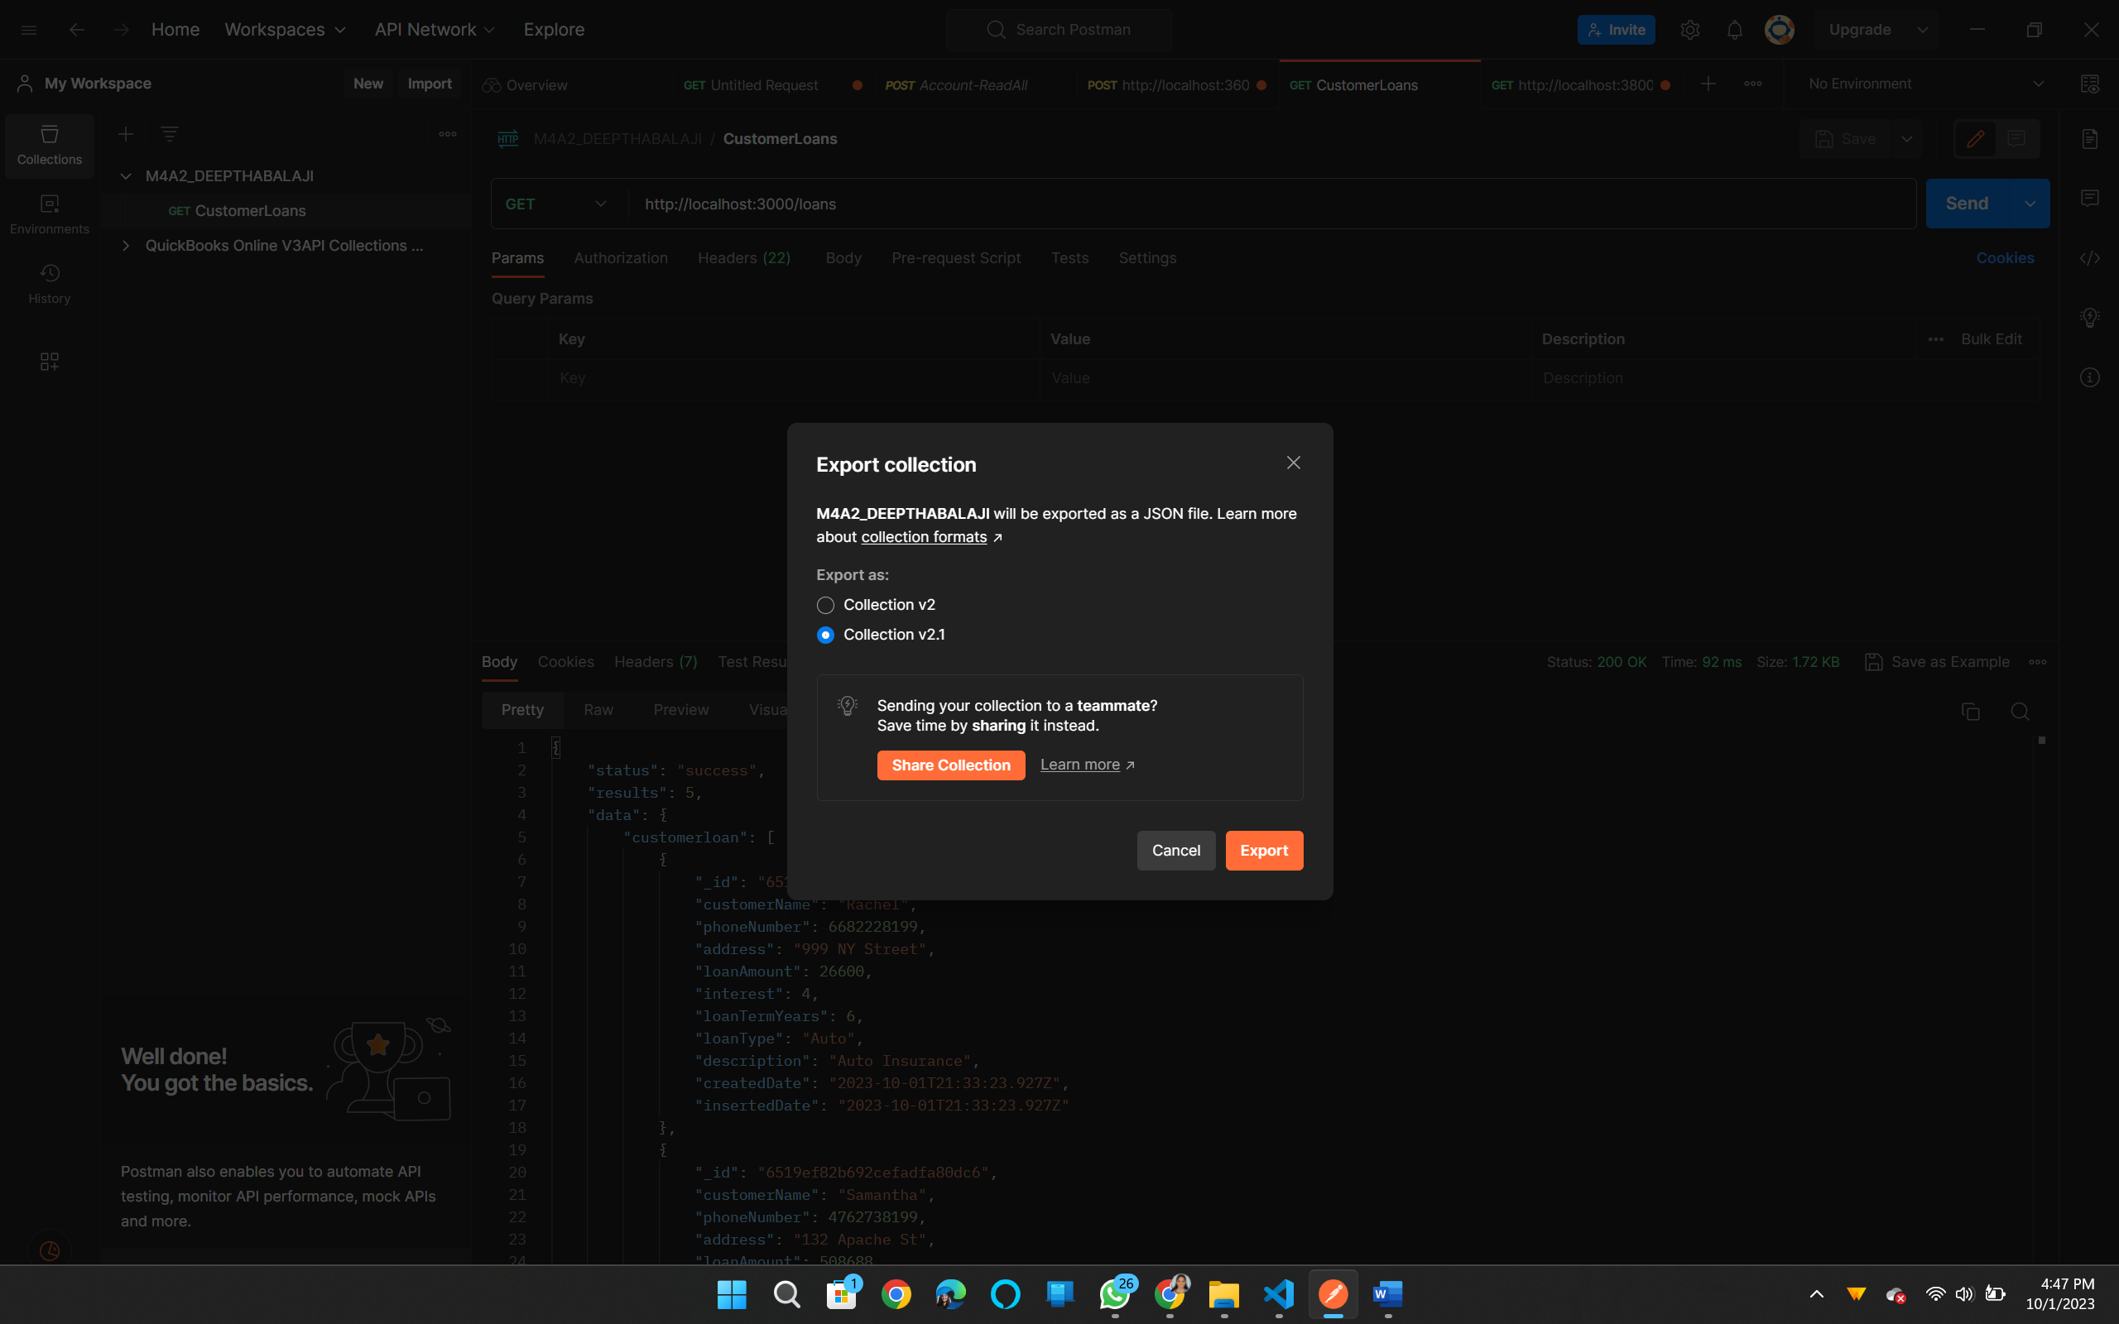

*Screenshot of the exported JSON Postman collection file*

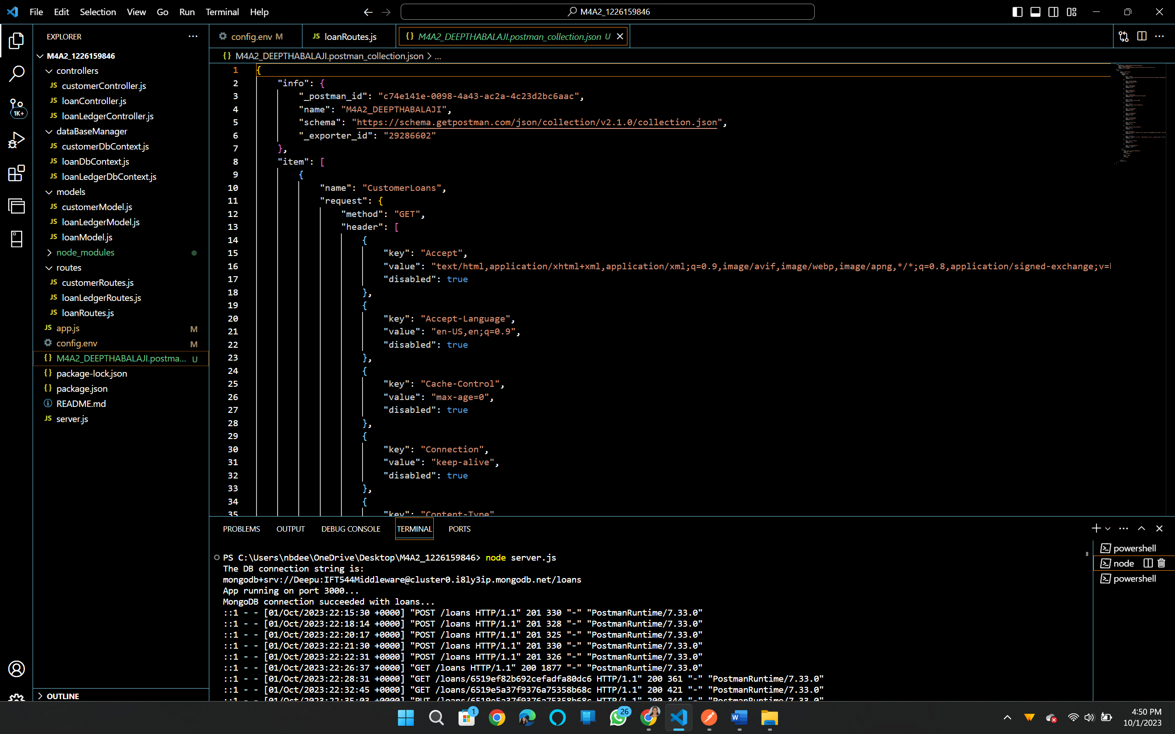

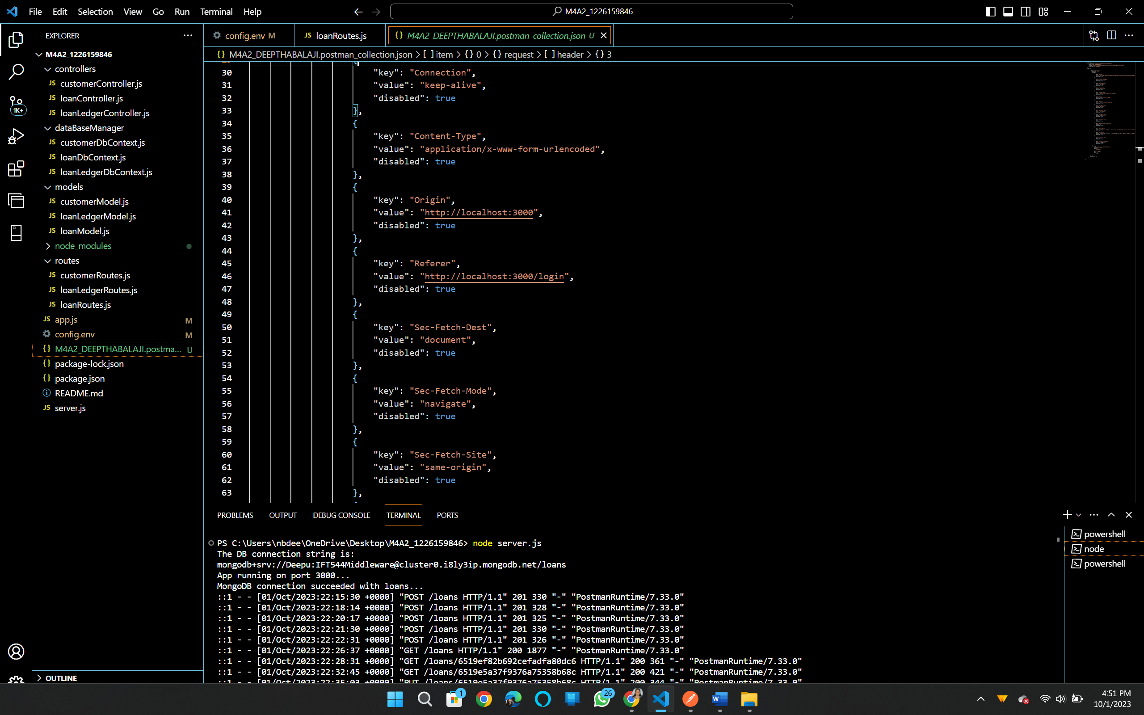

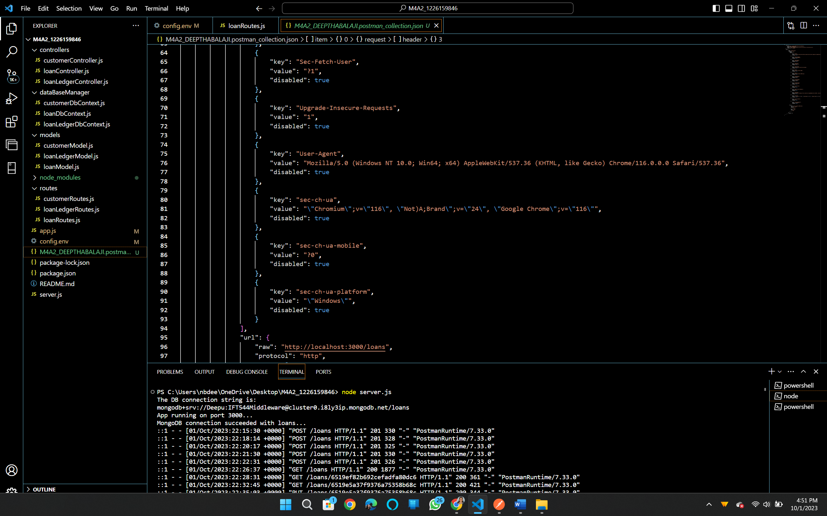

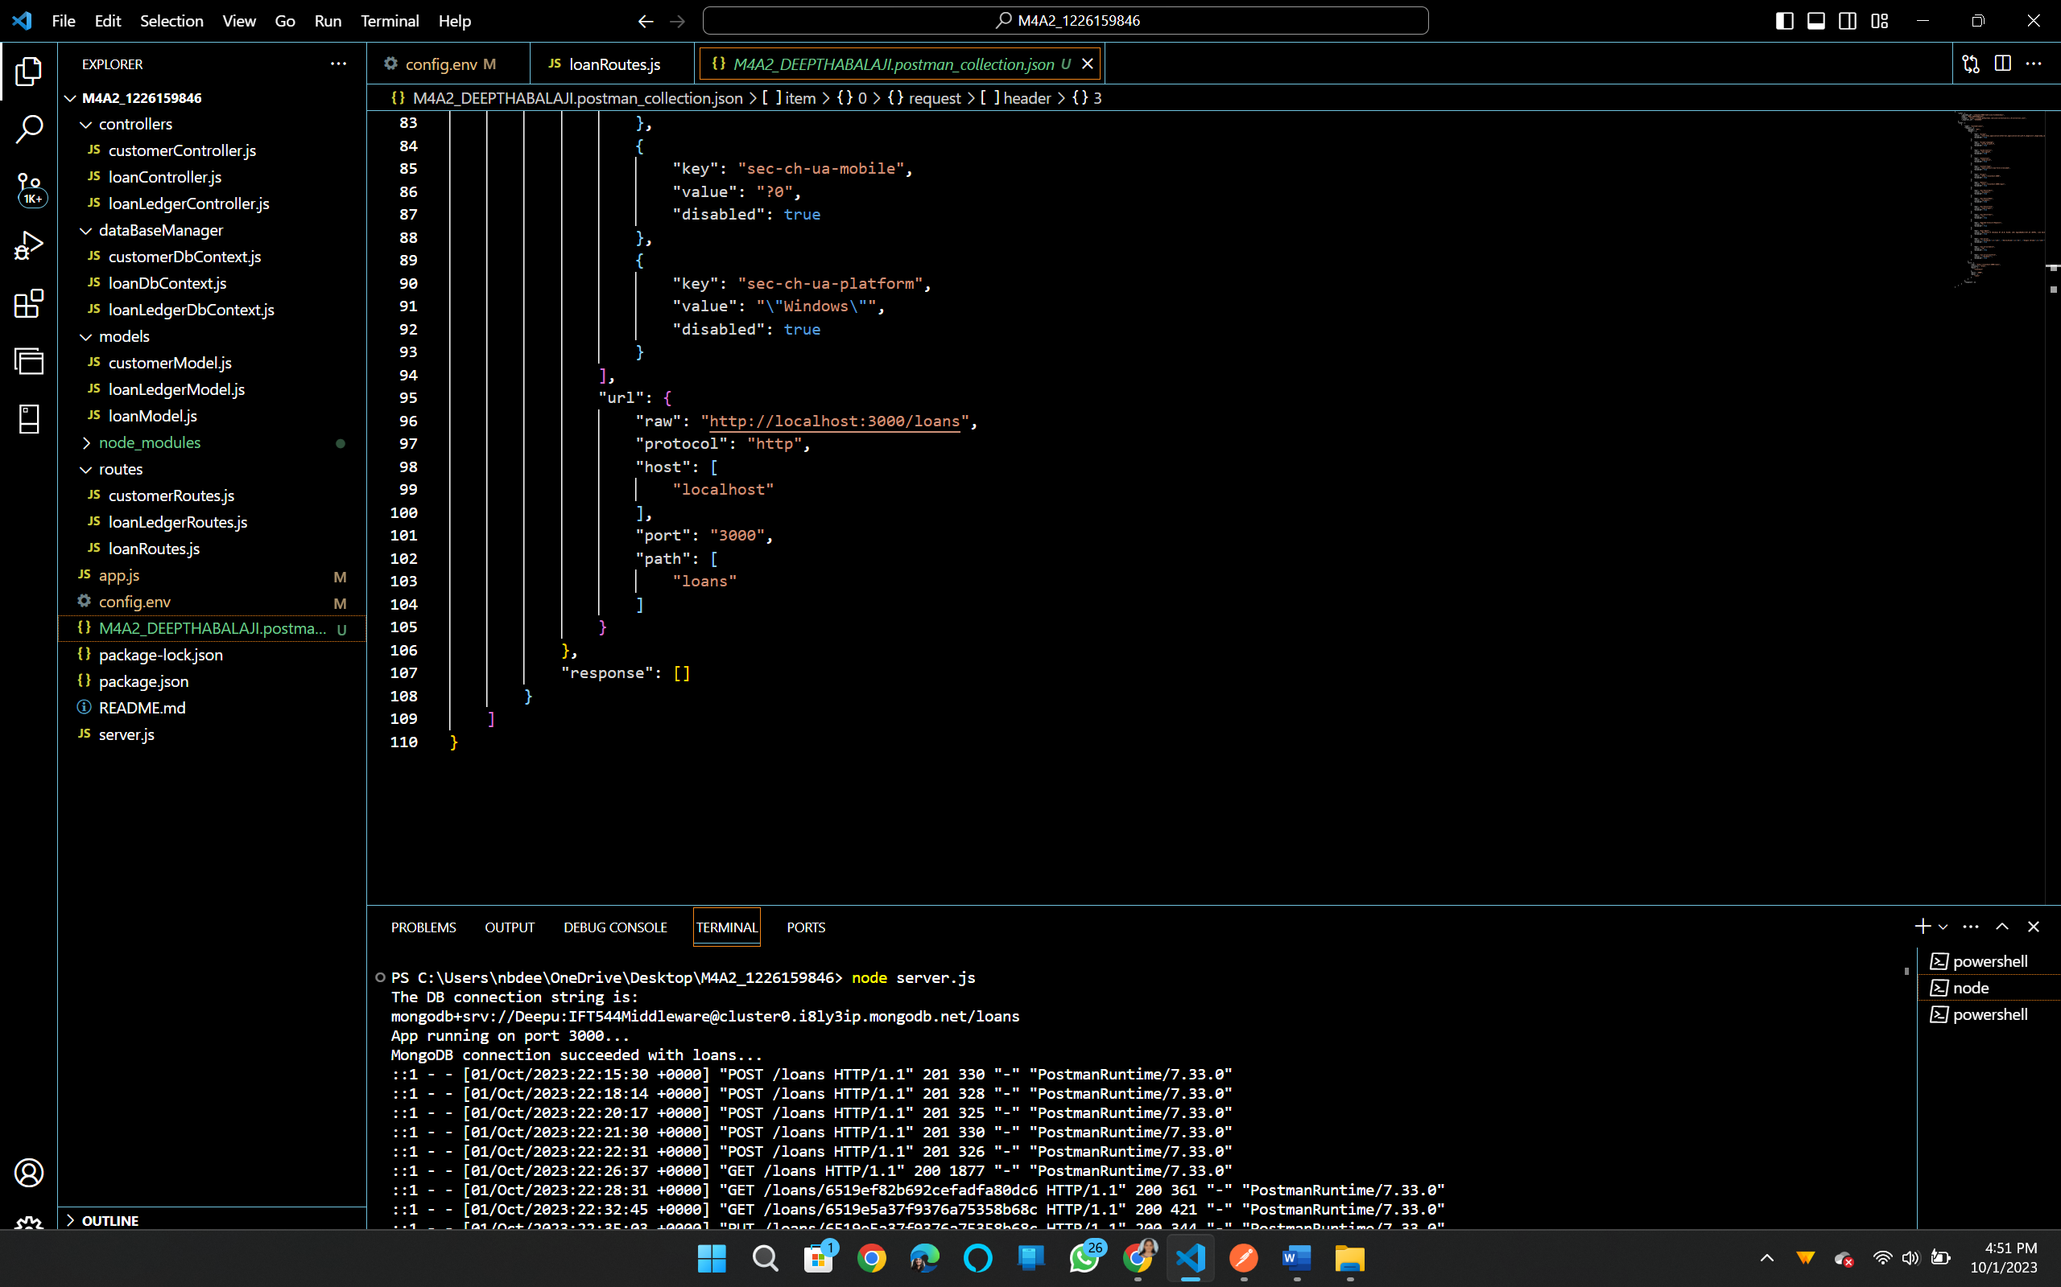

**Step 15 – Finally, add code to display the Connection String you used in the CONSOLE.**

*Screenshot of the server.js file showing the code (lines 35-36) added to display the DB connection string in output.*

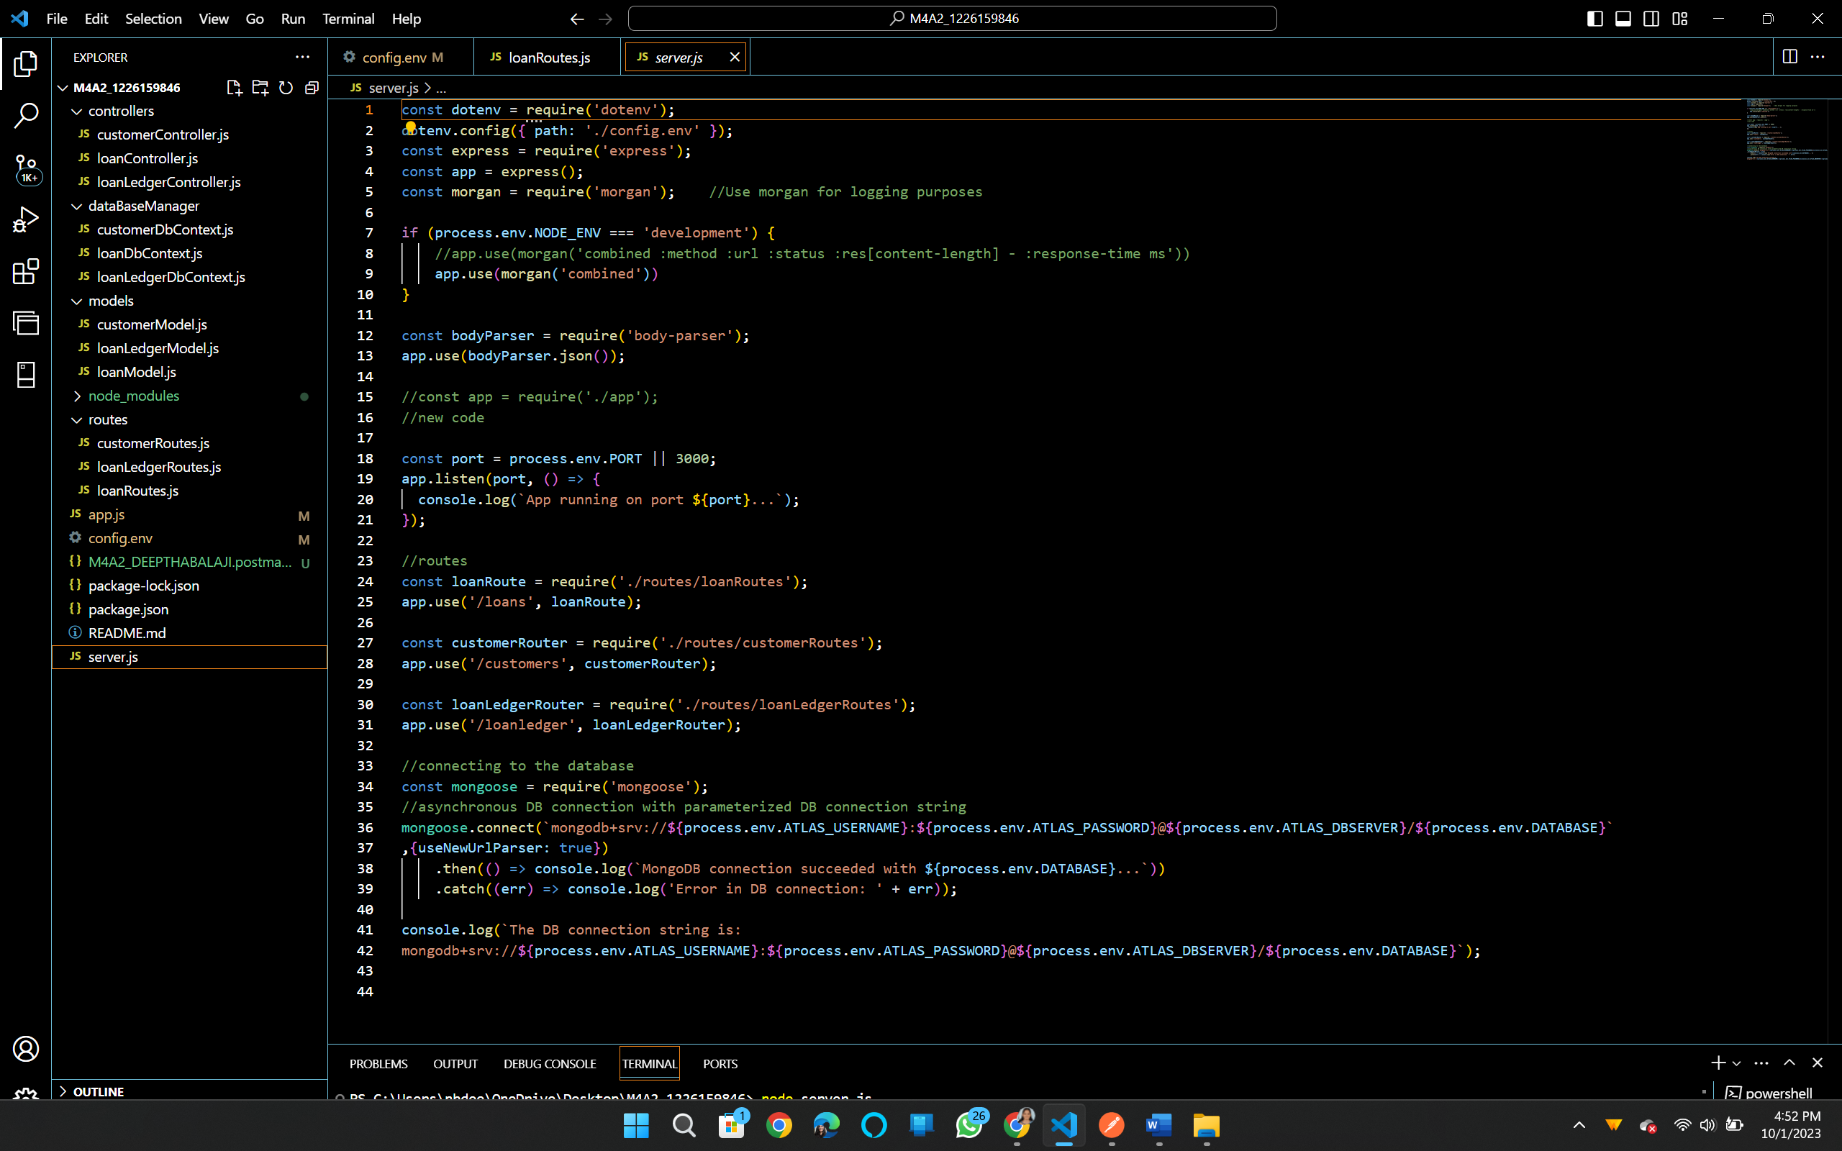

**Console:**

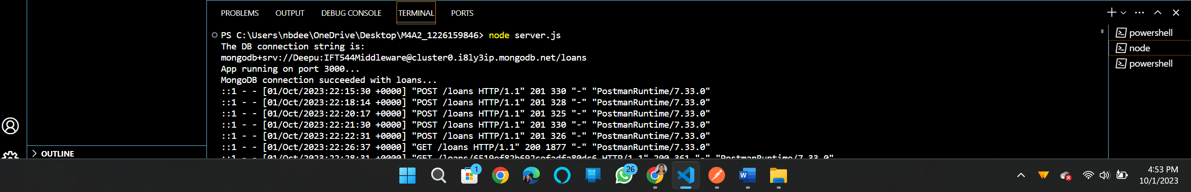

**TASK 2:** Extending code base to add new functionality. In this case, I am introducing 2 new features namely customers and loan ledger. Adding appropriate controllers, models, and routes for the same.

**GET method to check customer data. Currently the data is empty.** 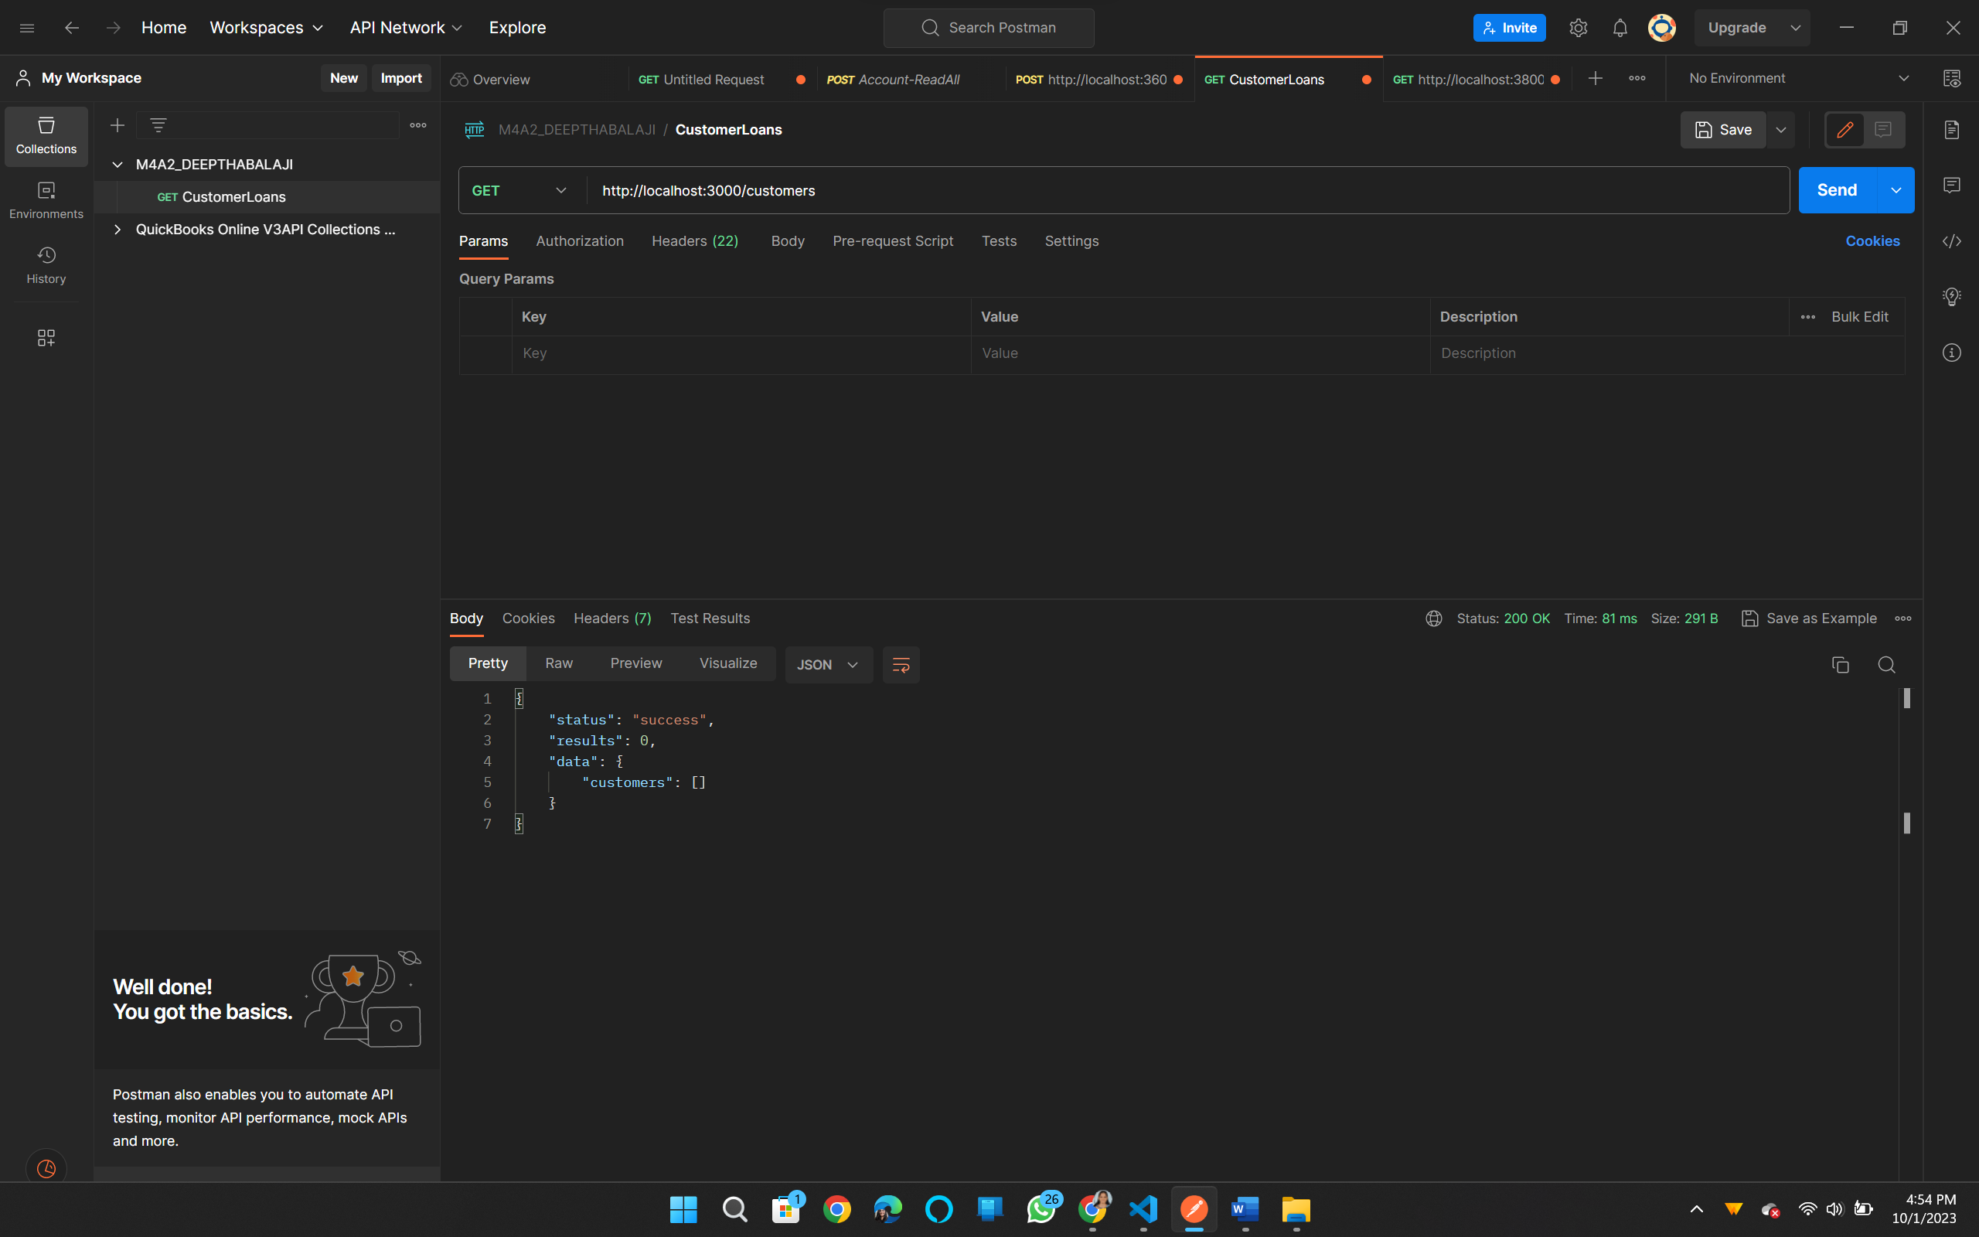

**POST method to Addrecords:**

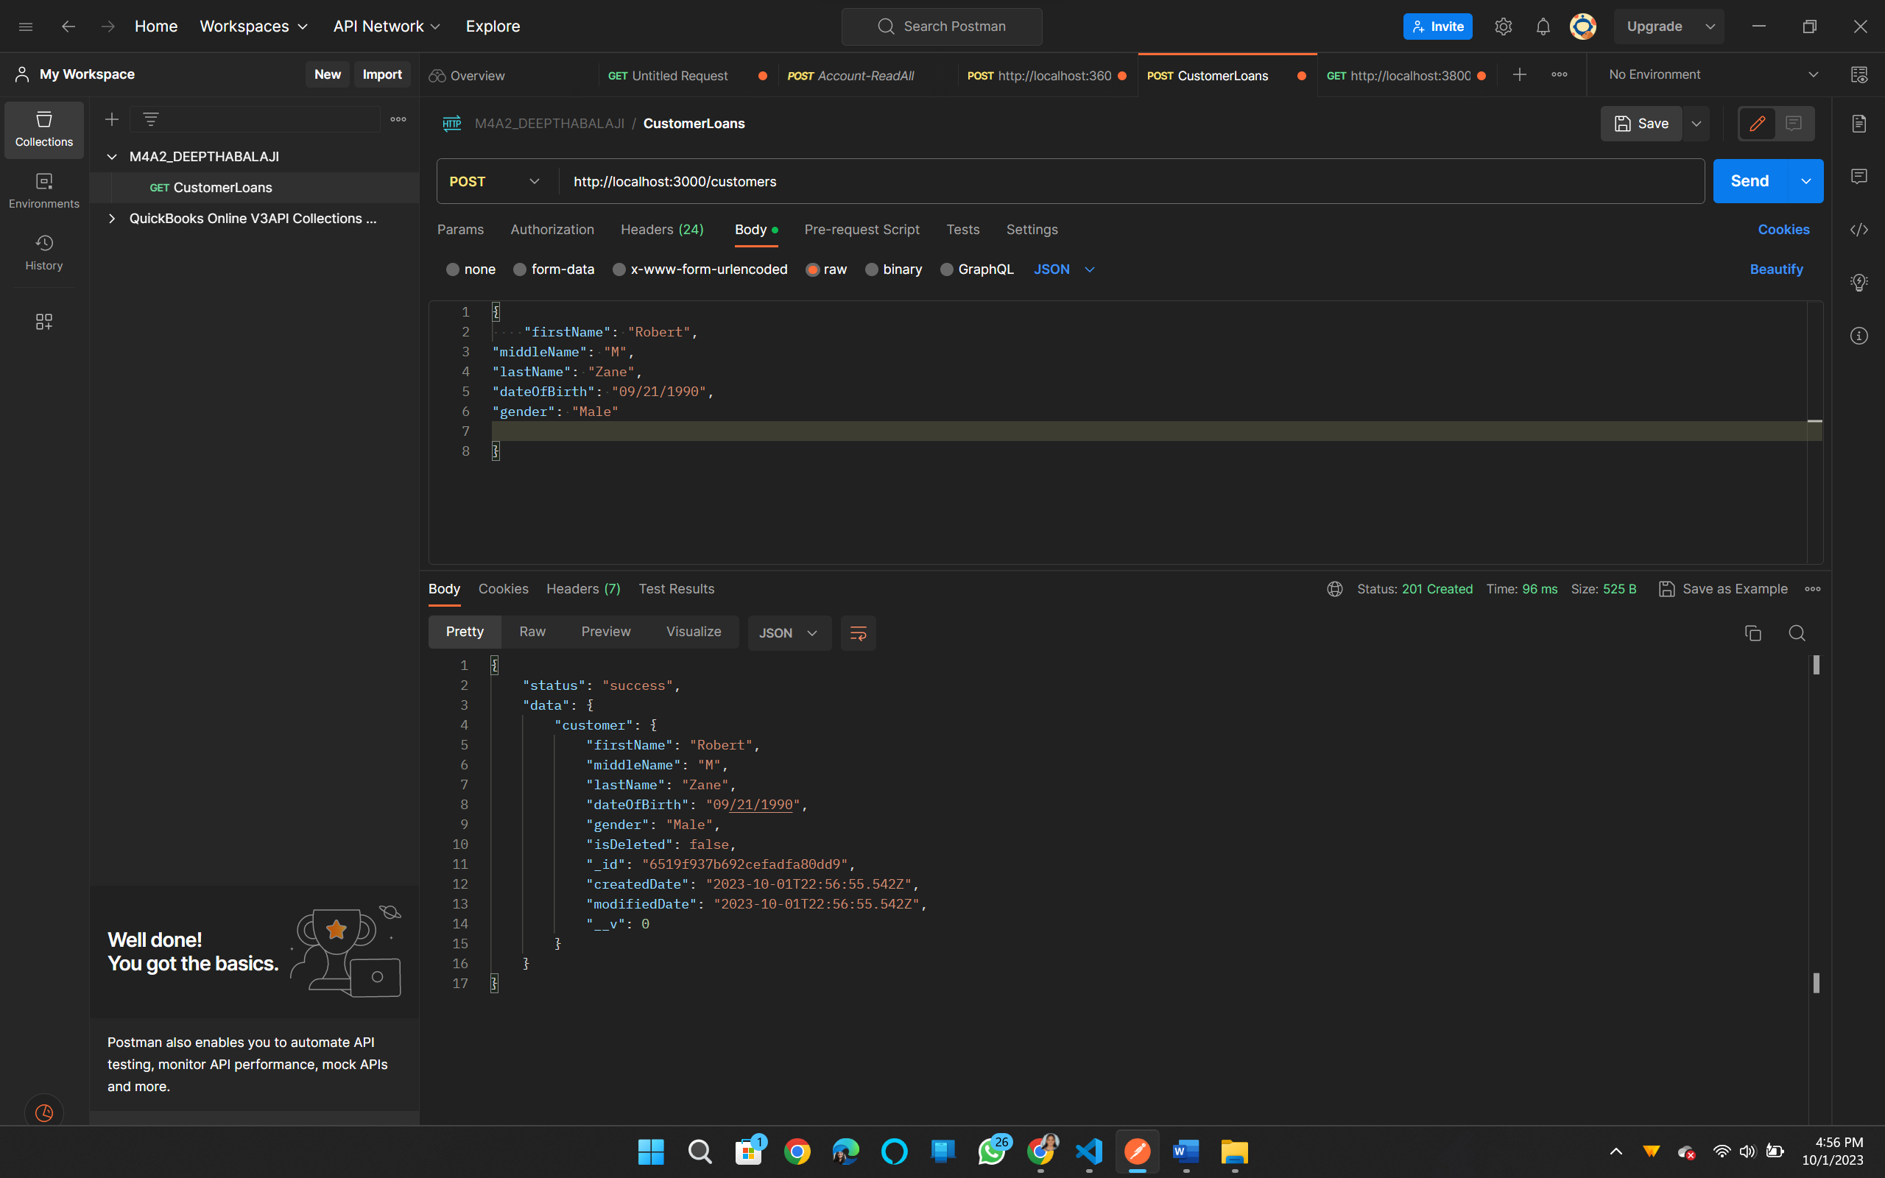

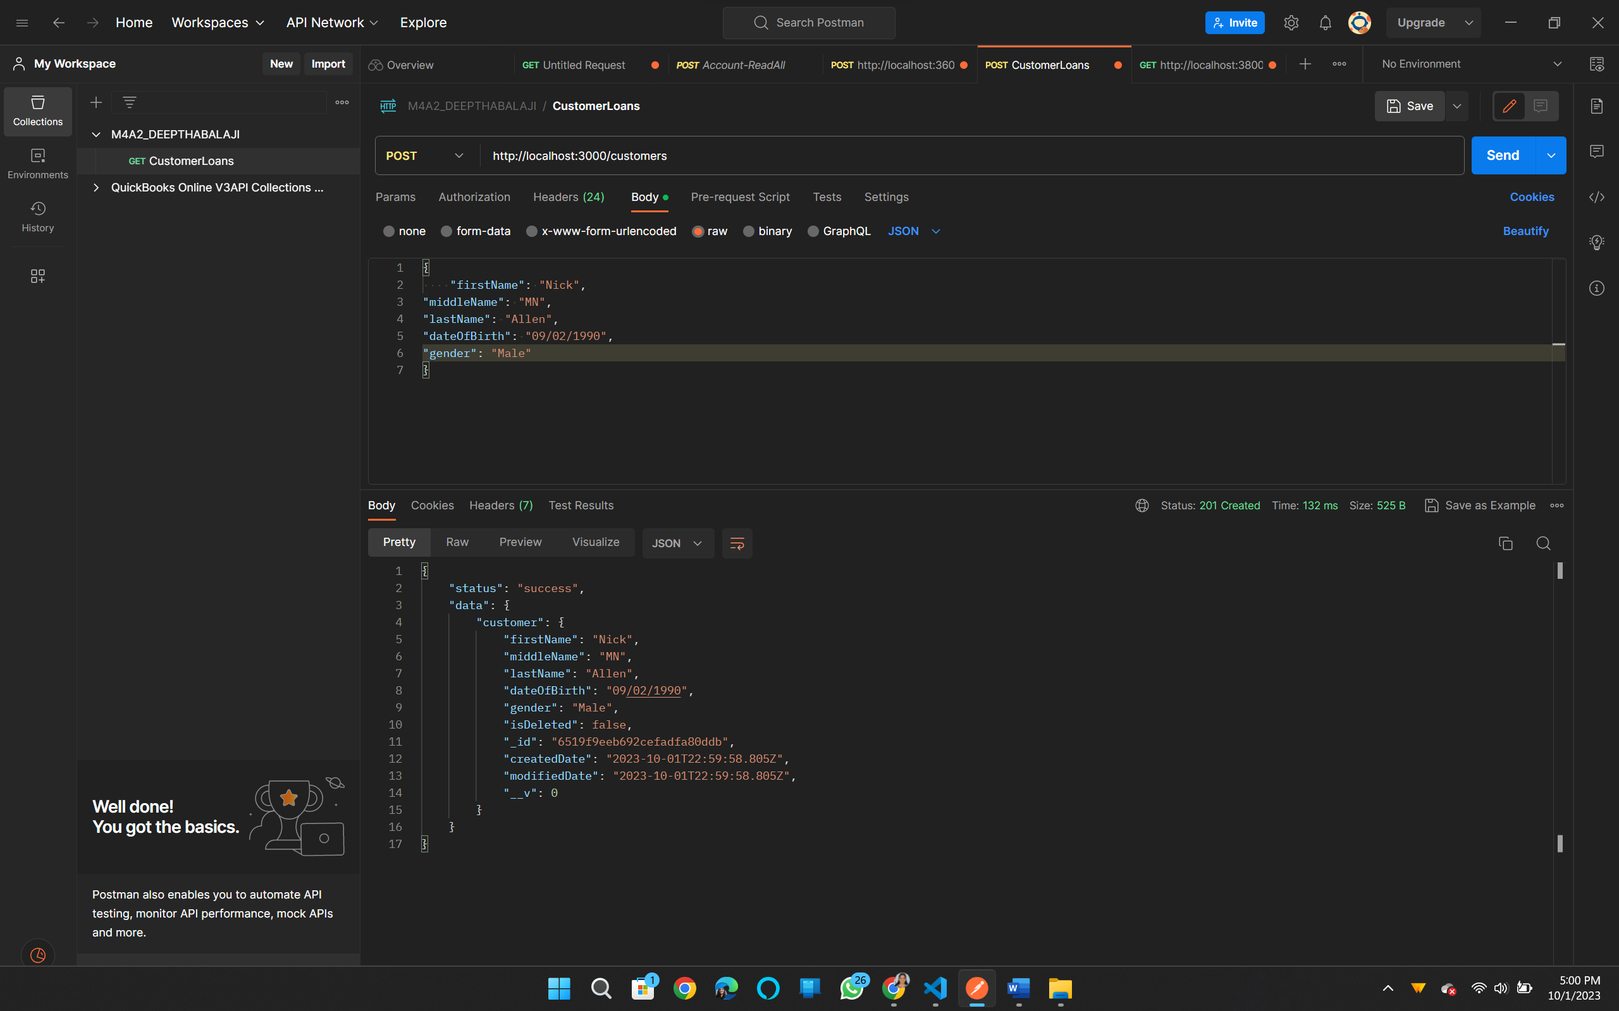

**GET method to check customer data:**

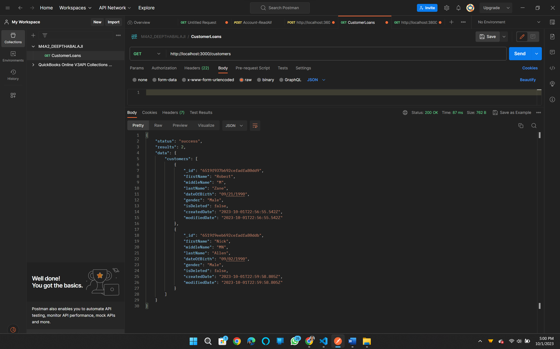

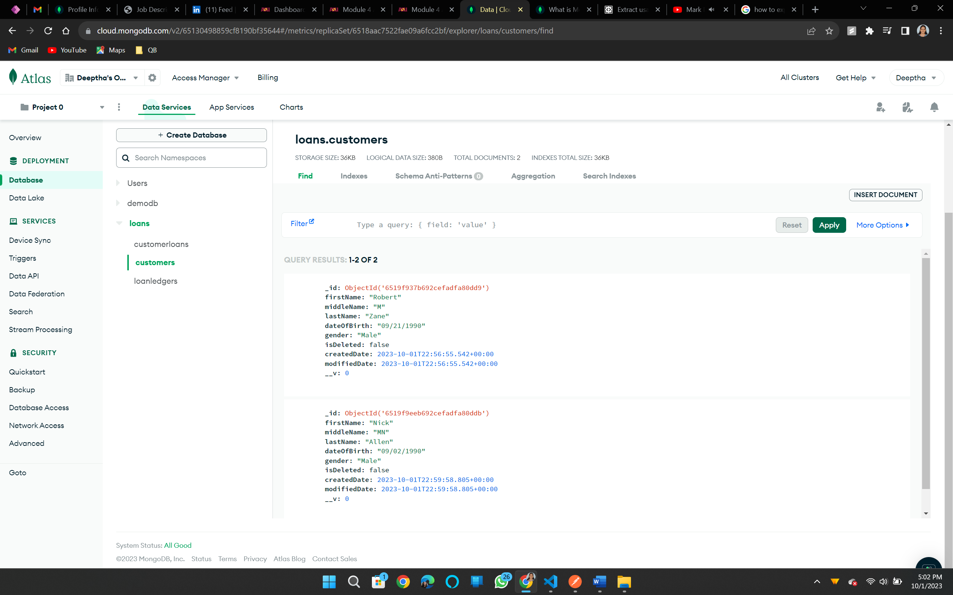

**PUT method to update the data by customerID:**

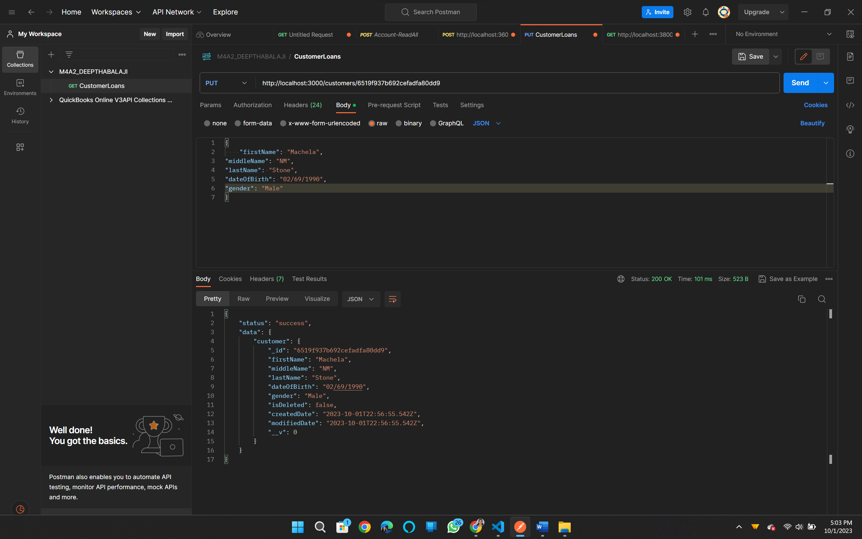

**DELETE method to delete customer by customerID.**

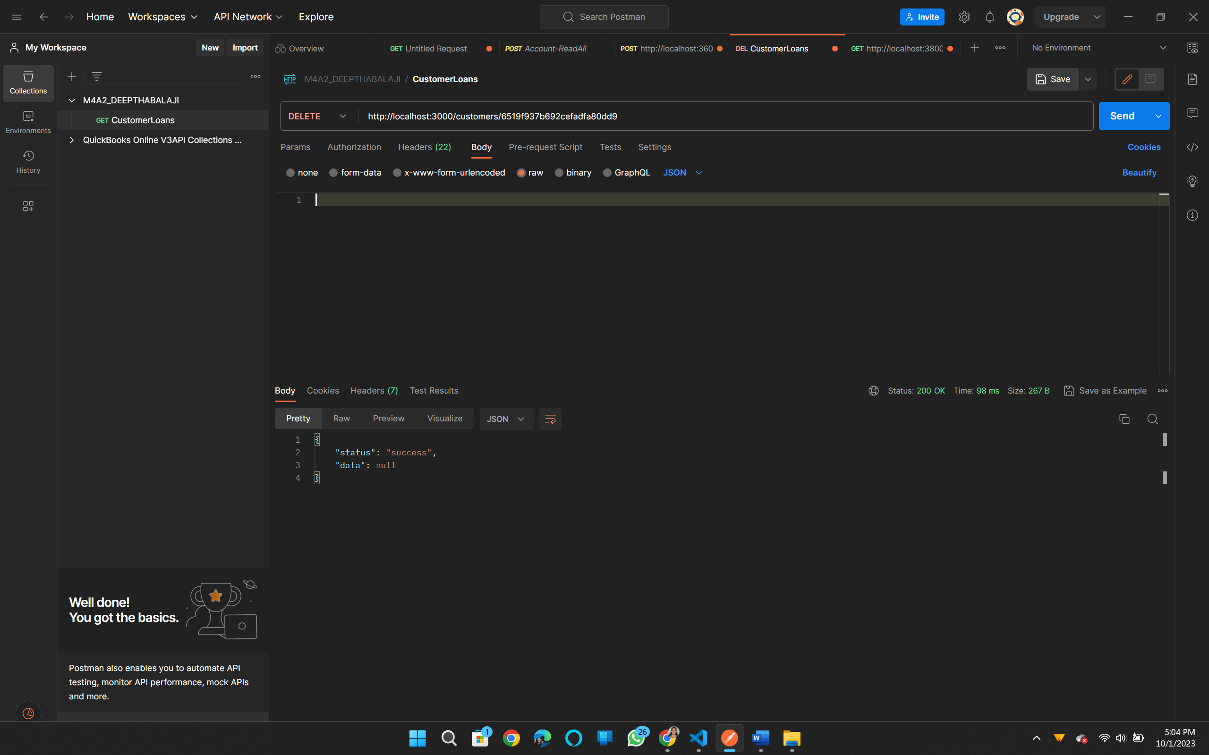

**Similarly checking data for loanLedger. Initially the data is empty.**

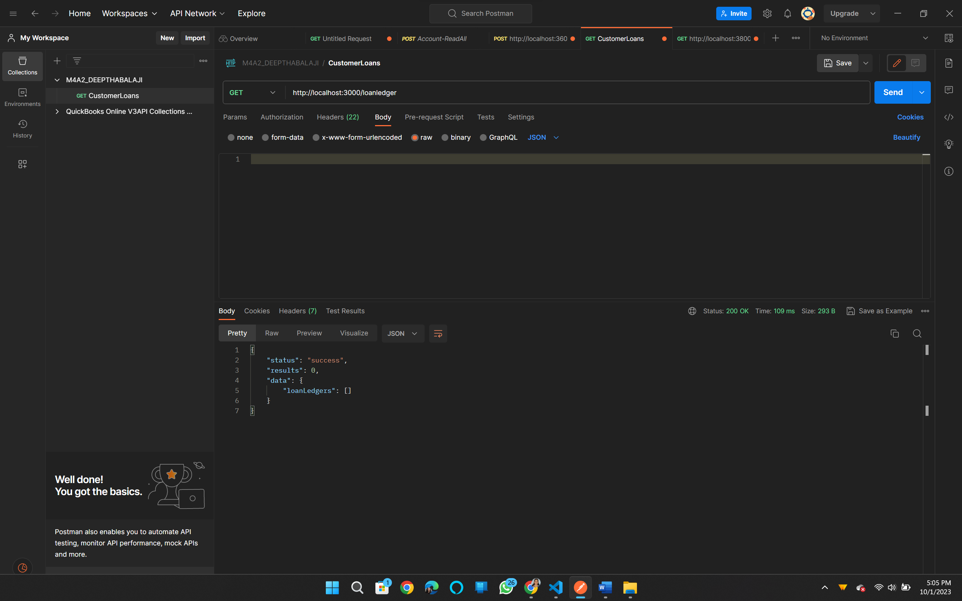

**POST method to add data:**

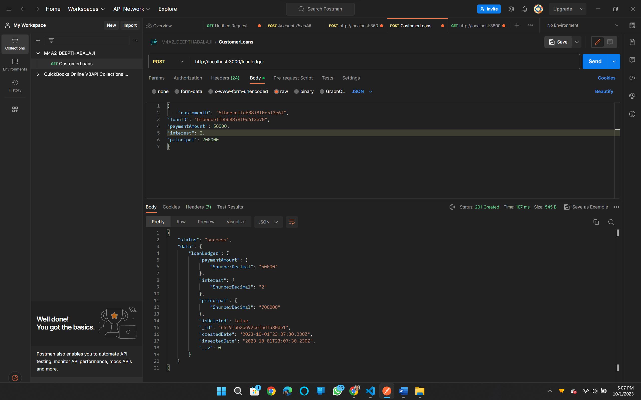

**GET method to retrieve data:**

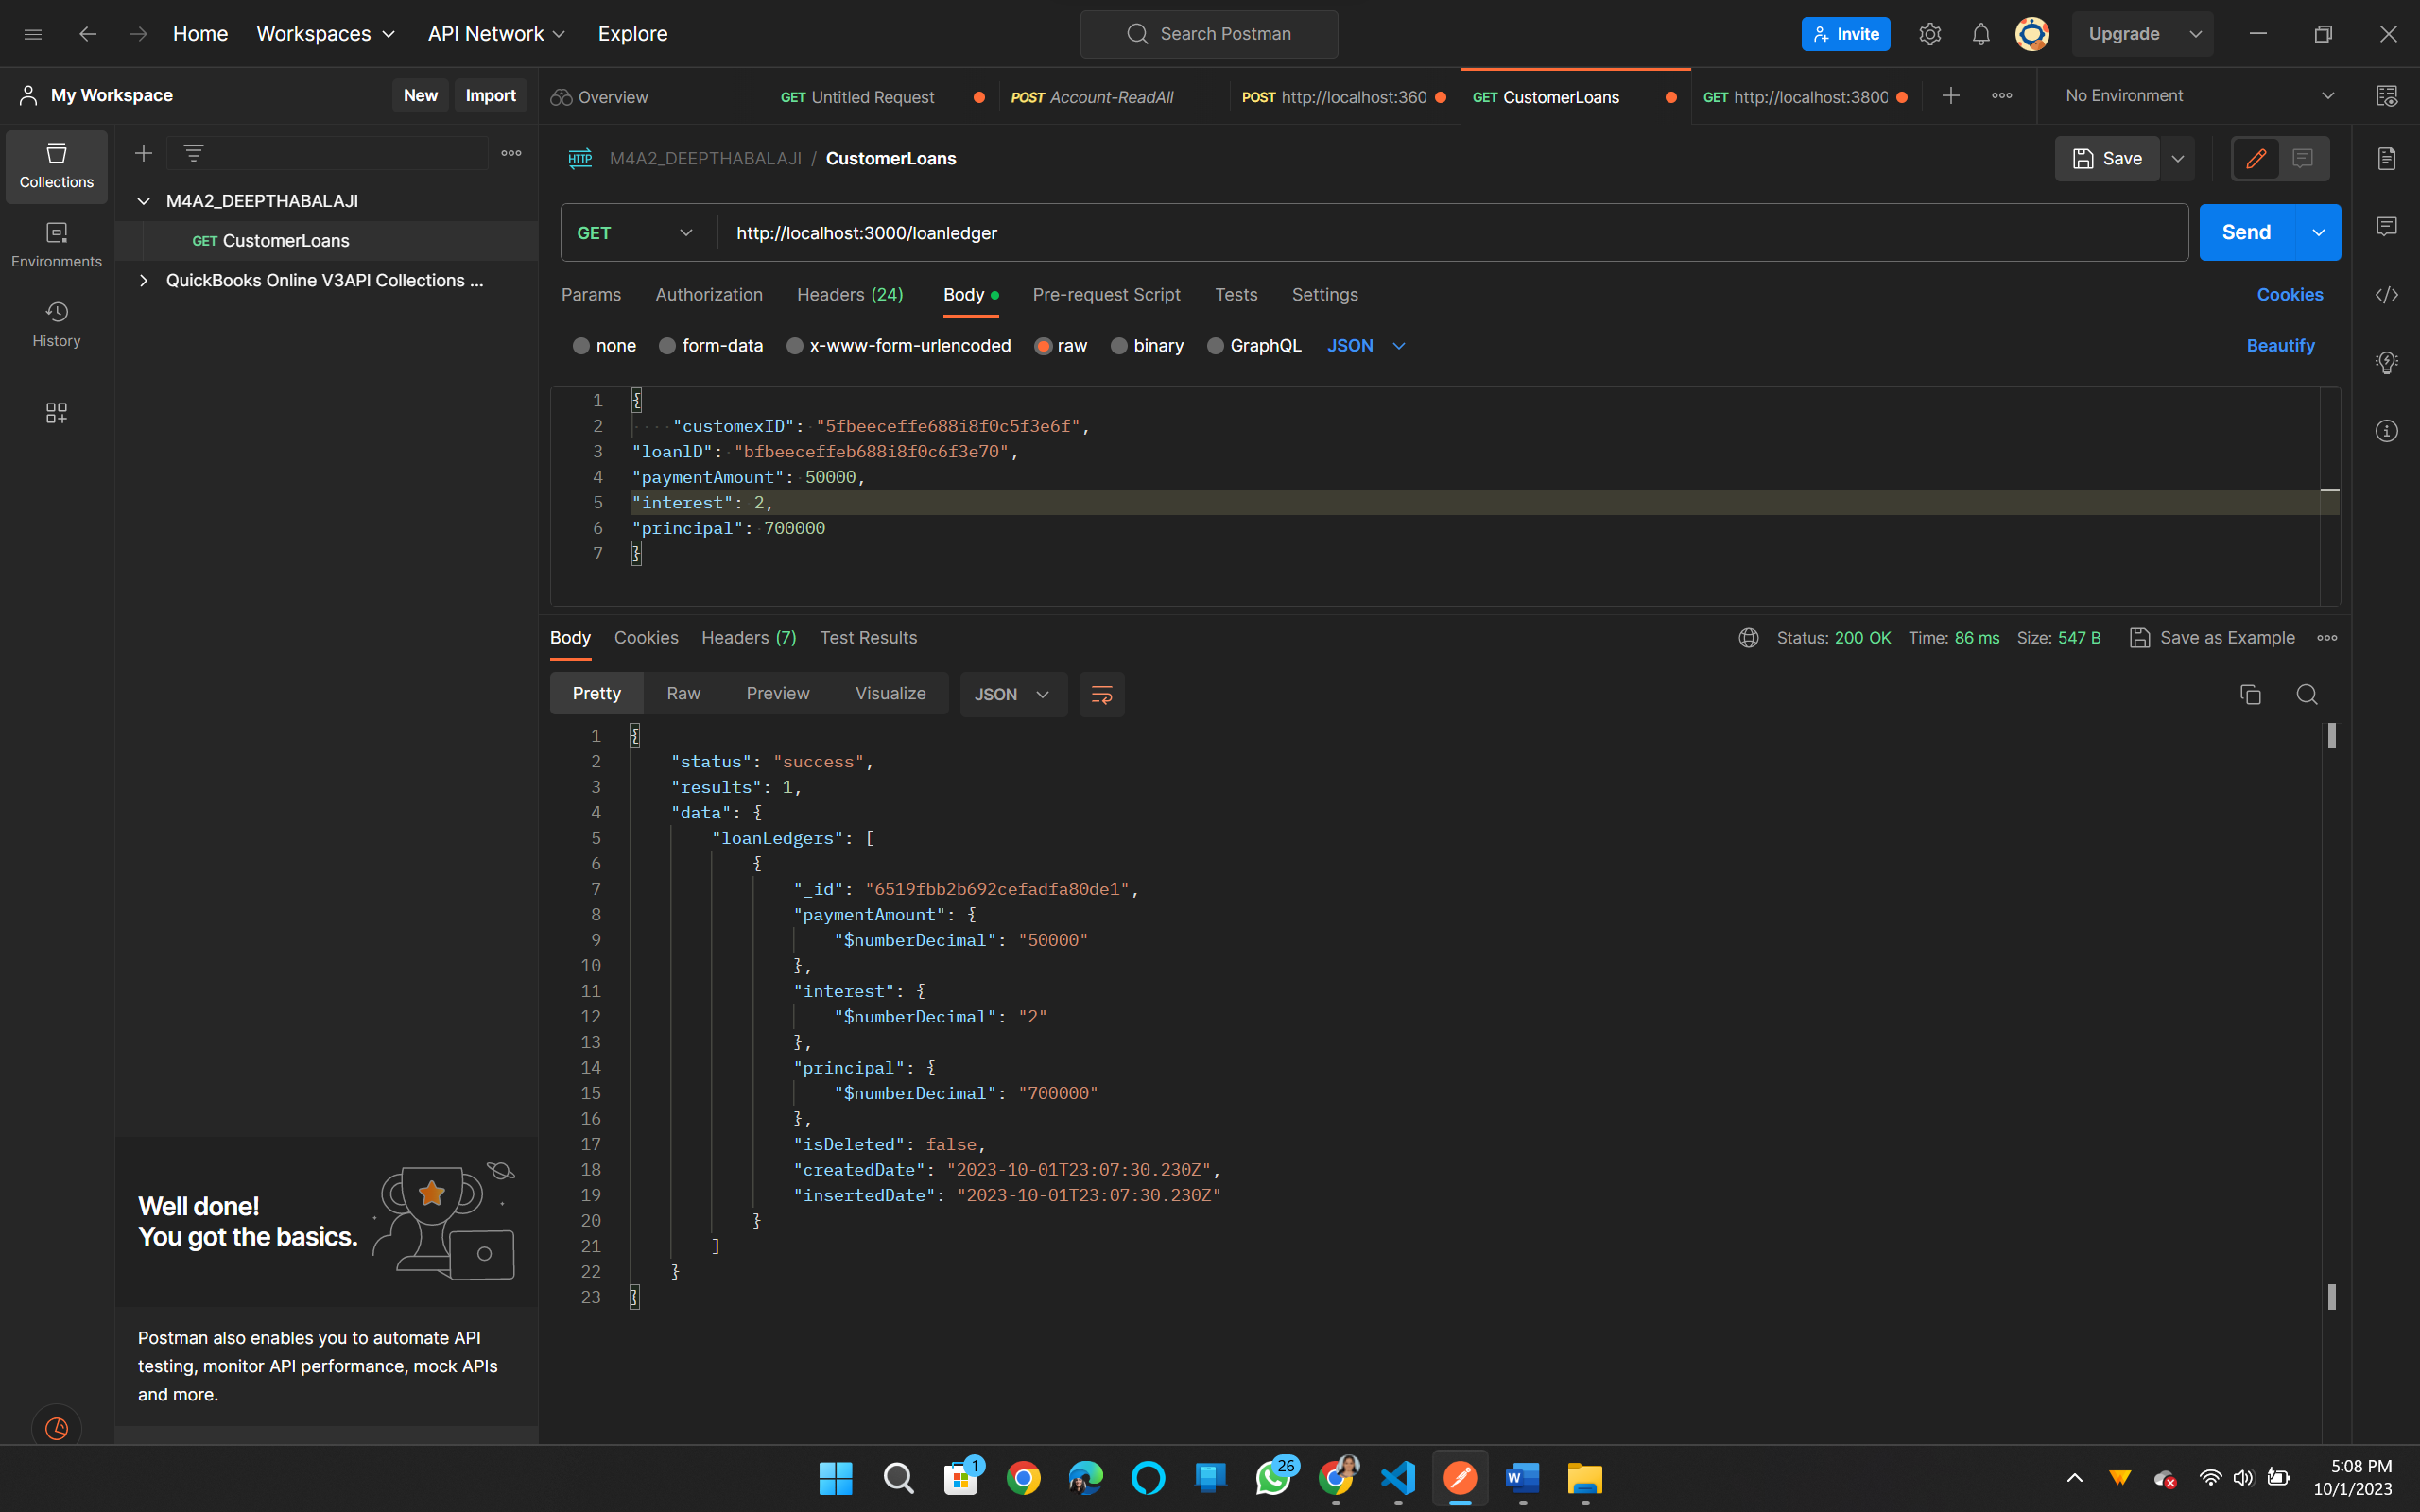

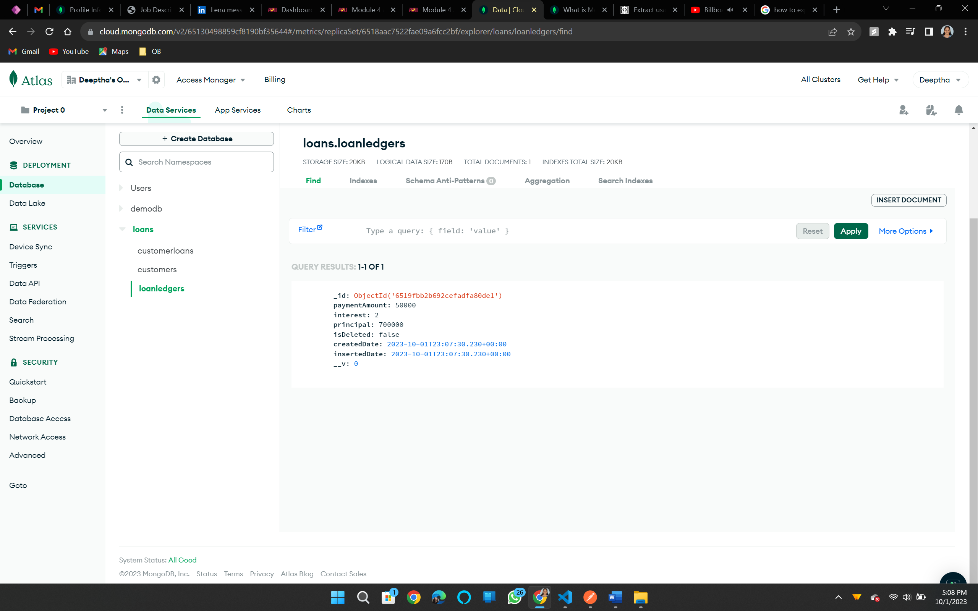

**GET by ID method to check specific record:**

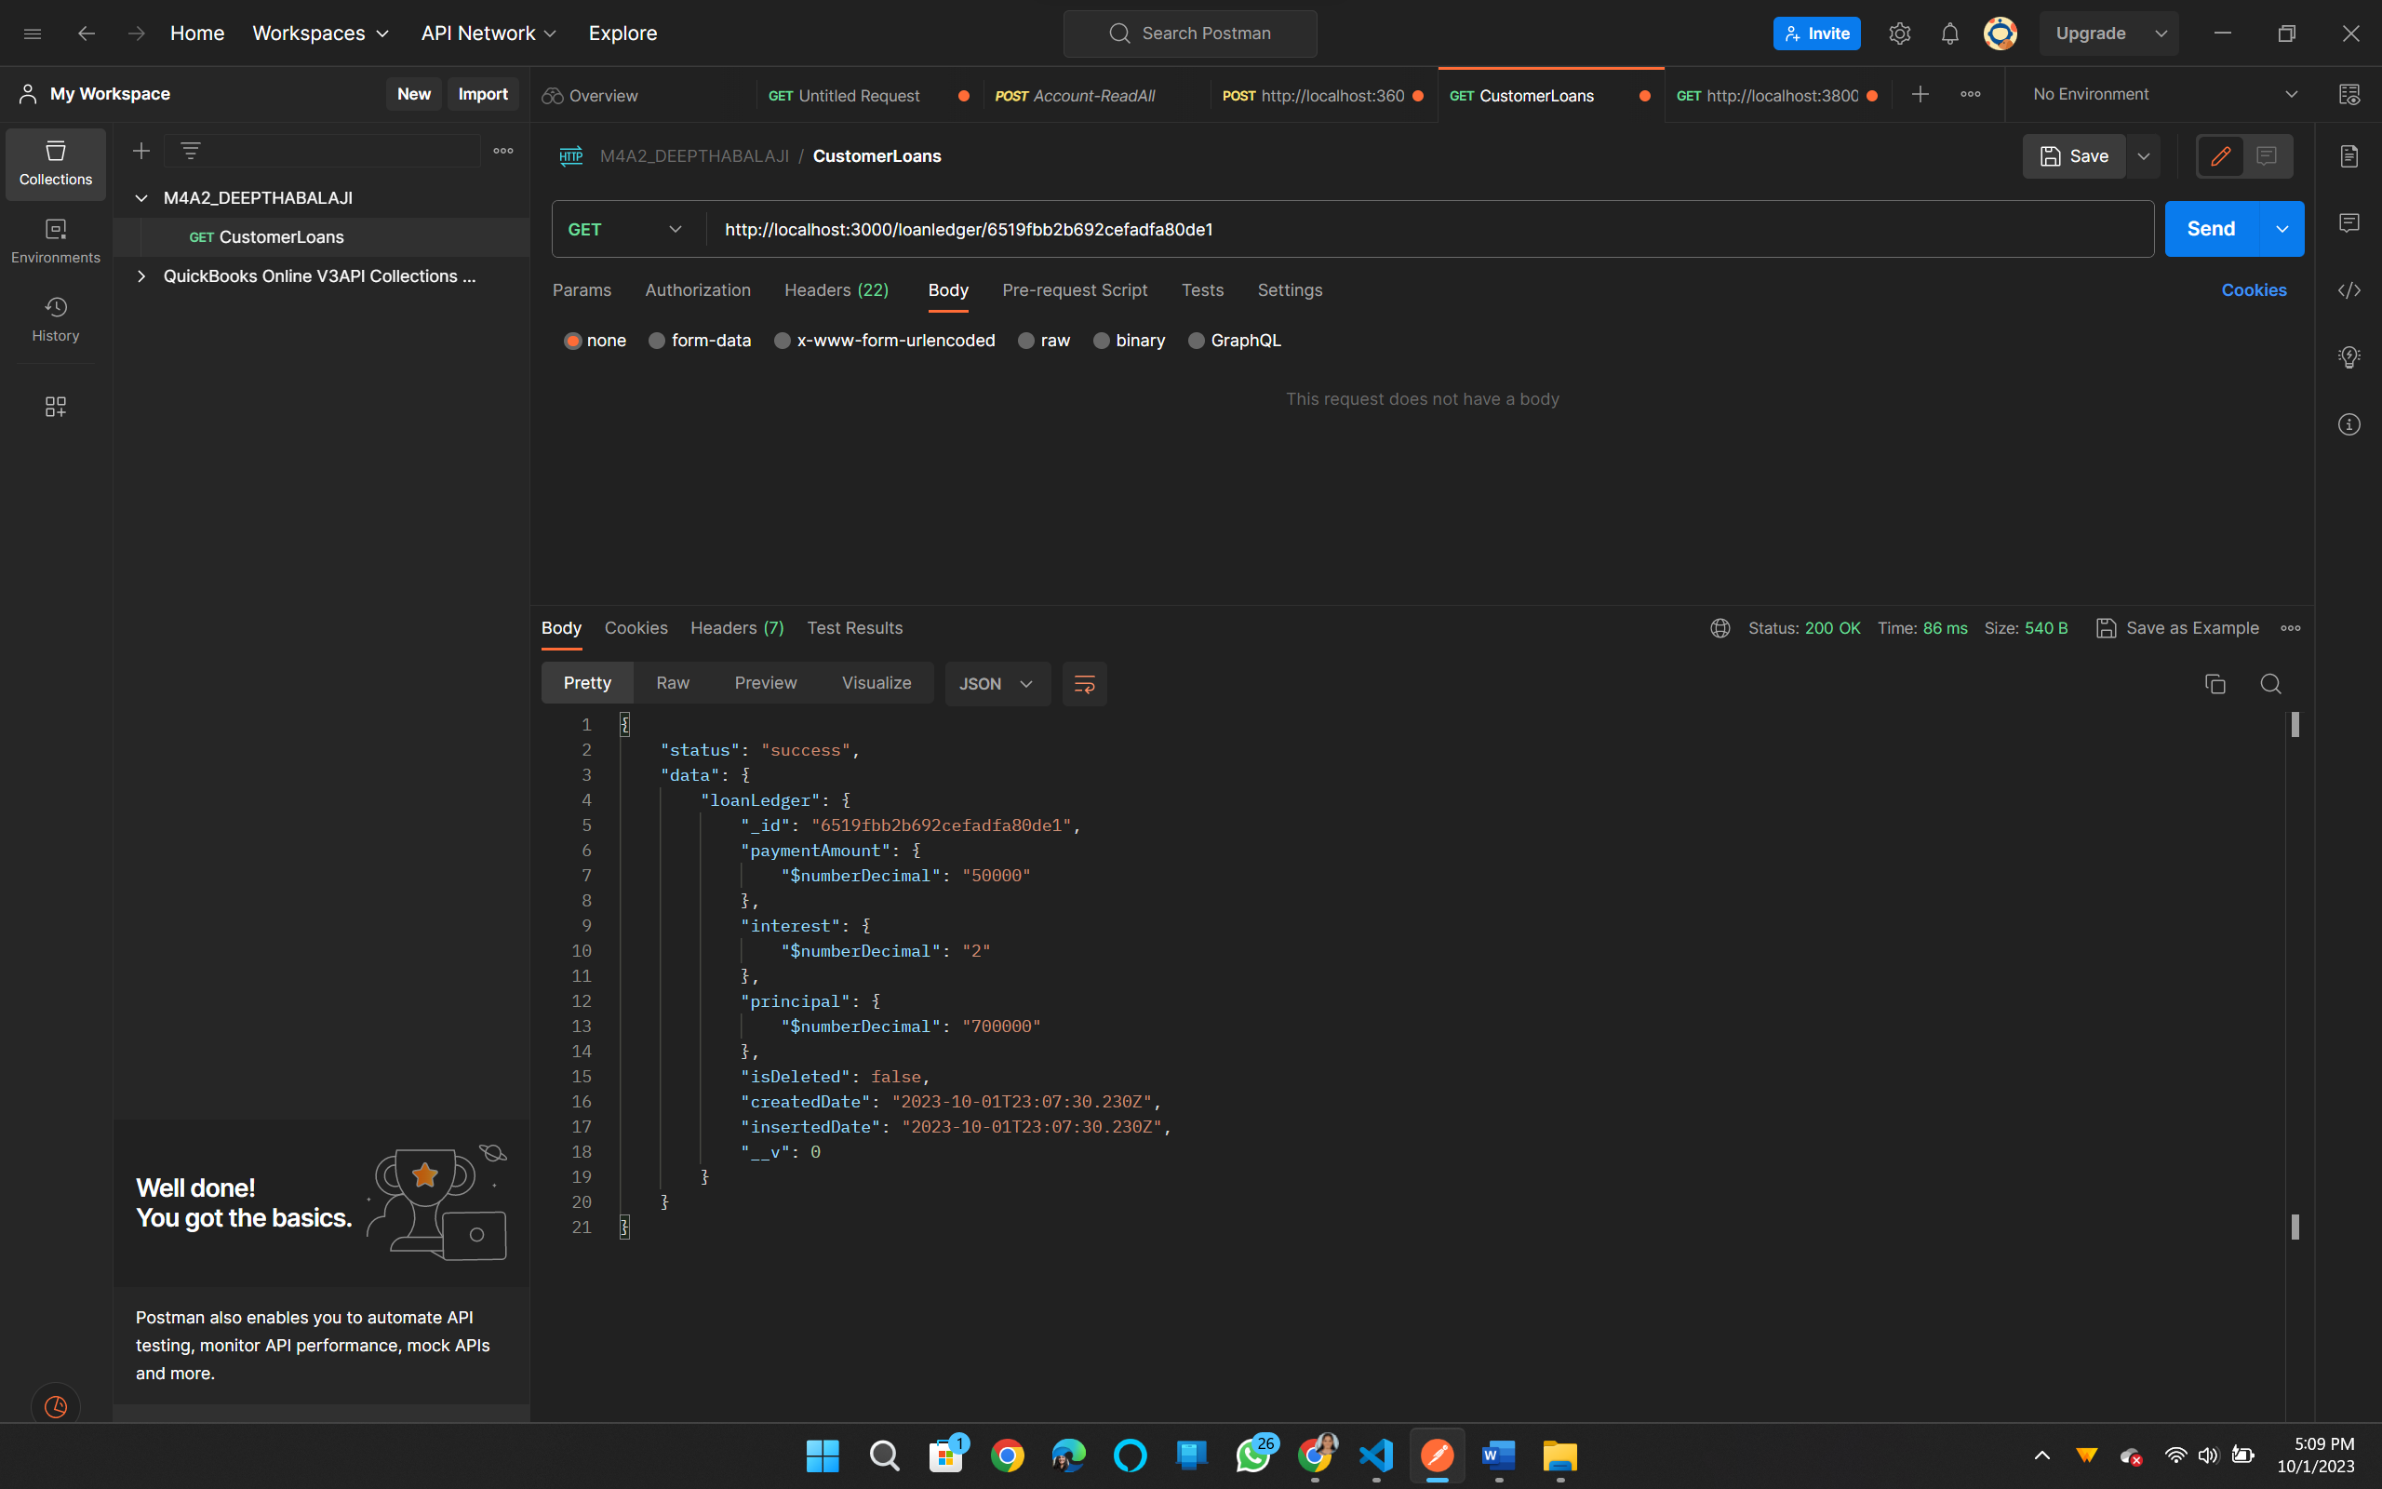

**PUT method to update details:**

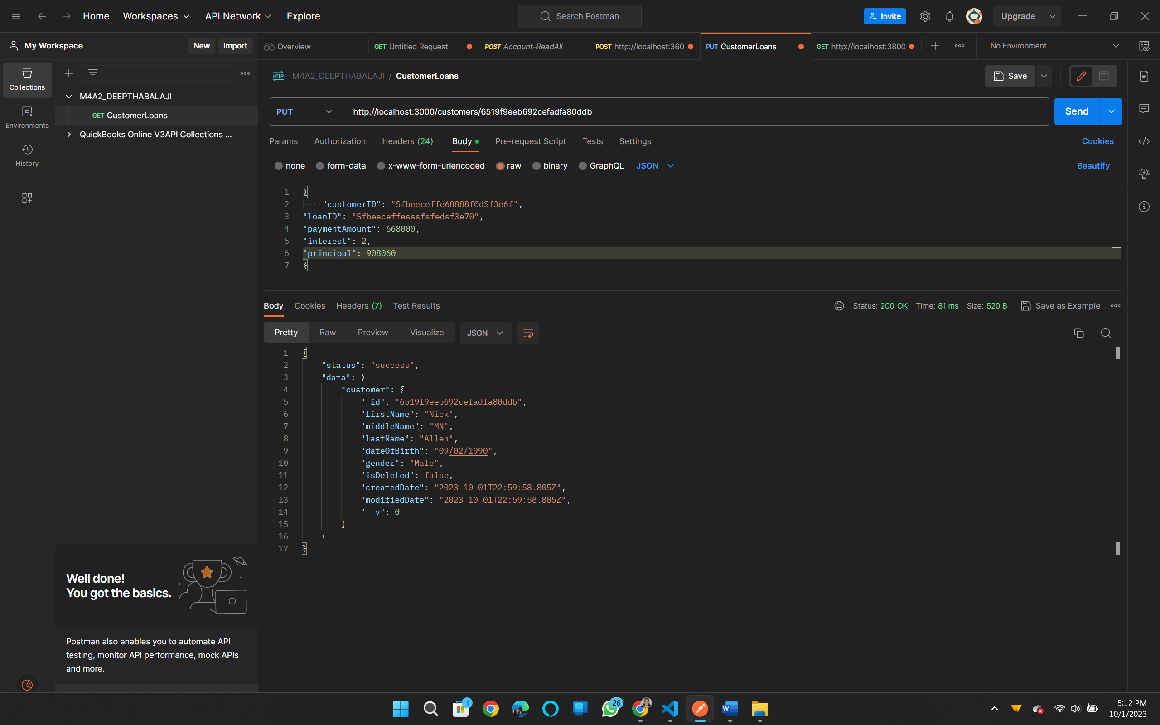

**DELETE method to delete data by ID:**

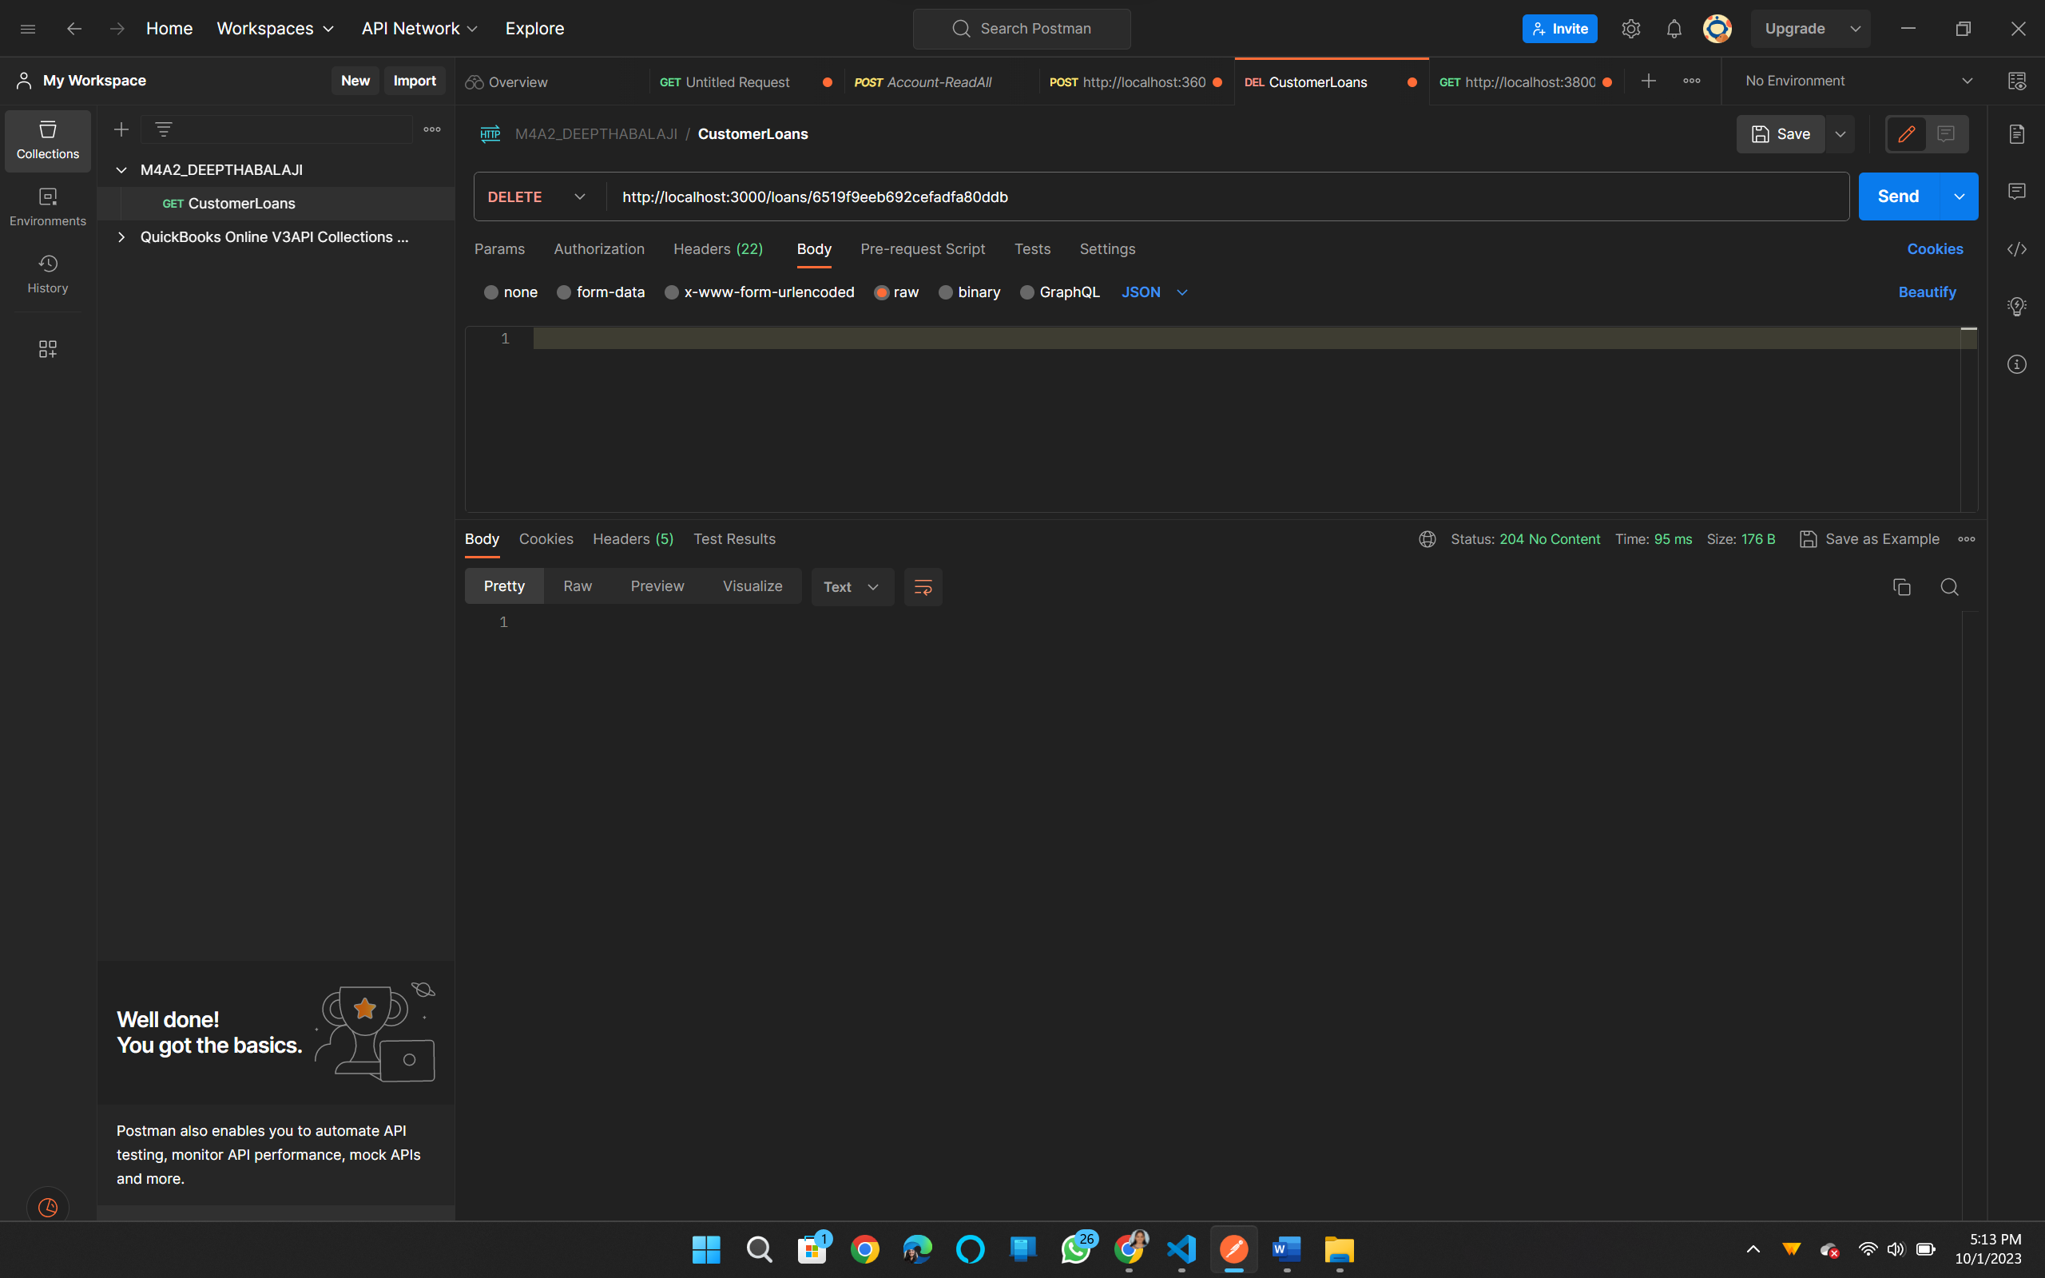

**MongoDB customer data Screenshot:**



**loanLedger data screenshot:**



**CustomerModel.js**

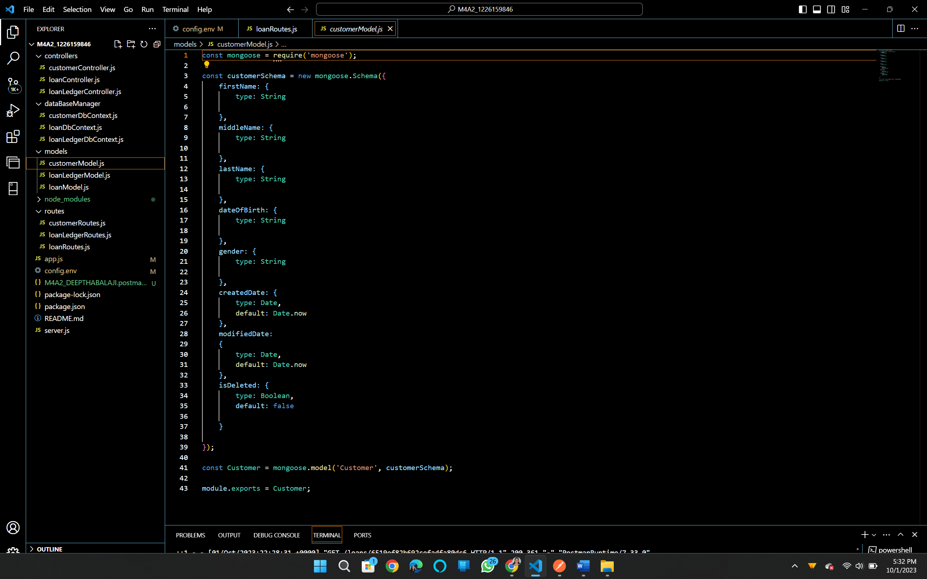

**loanLedgerModel.js**

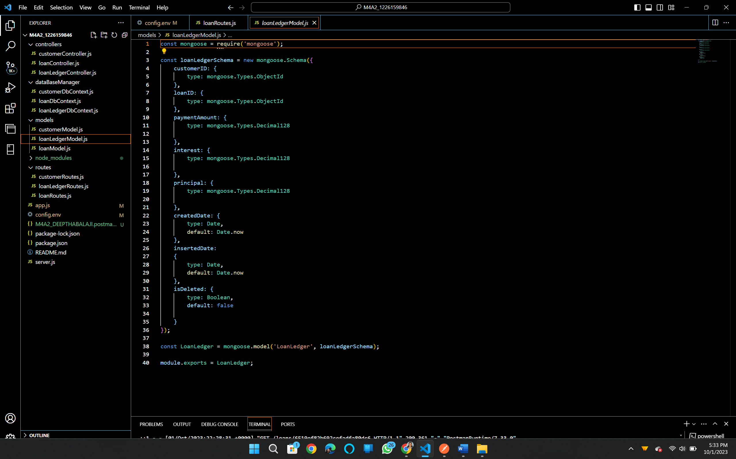

**CustomerRoutes.js**

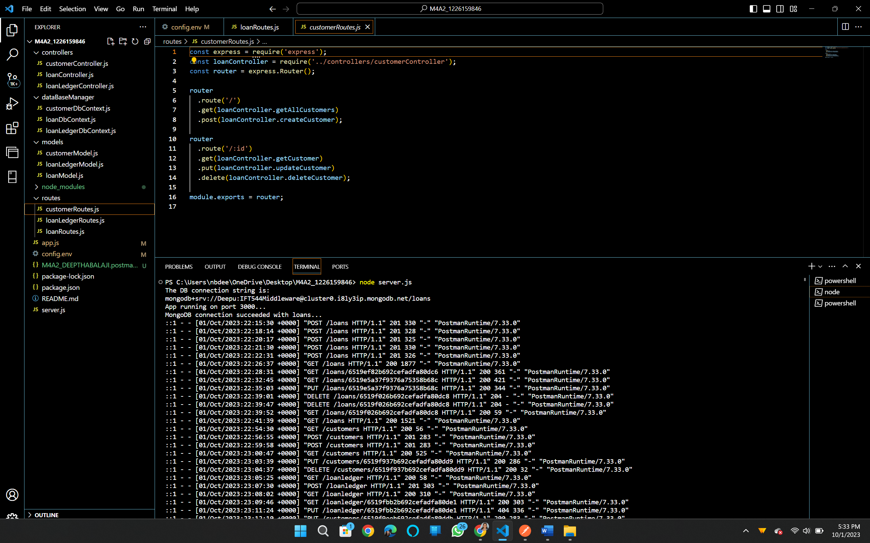

**customerContoller.js**

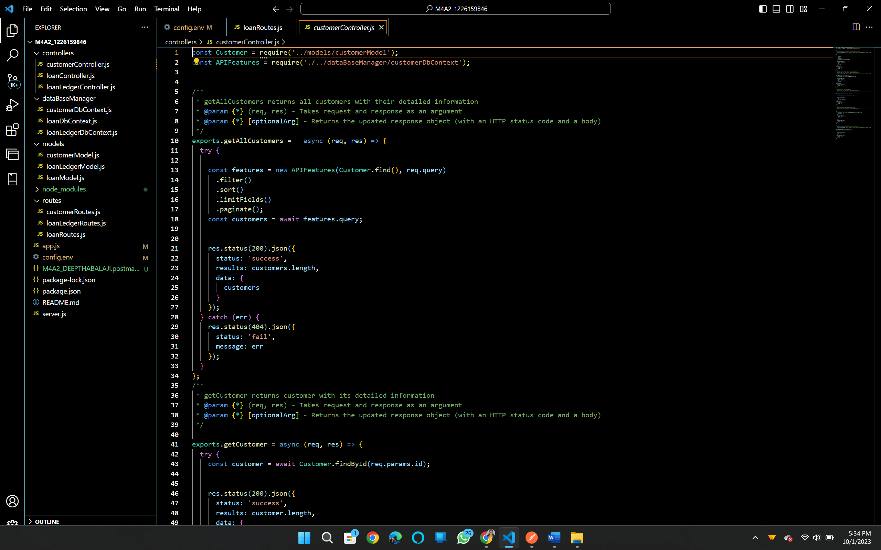

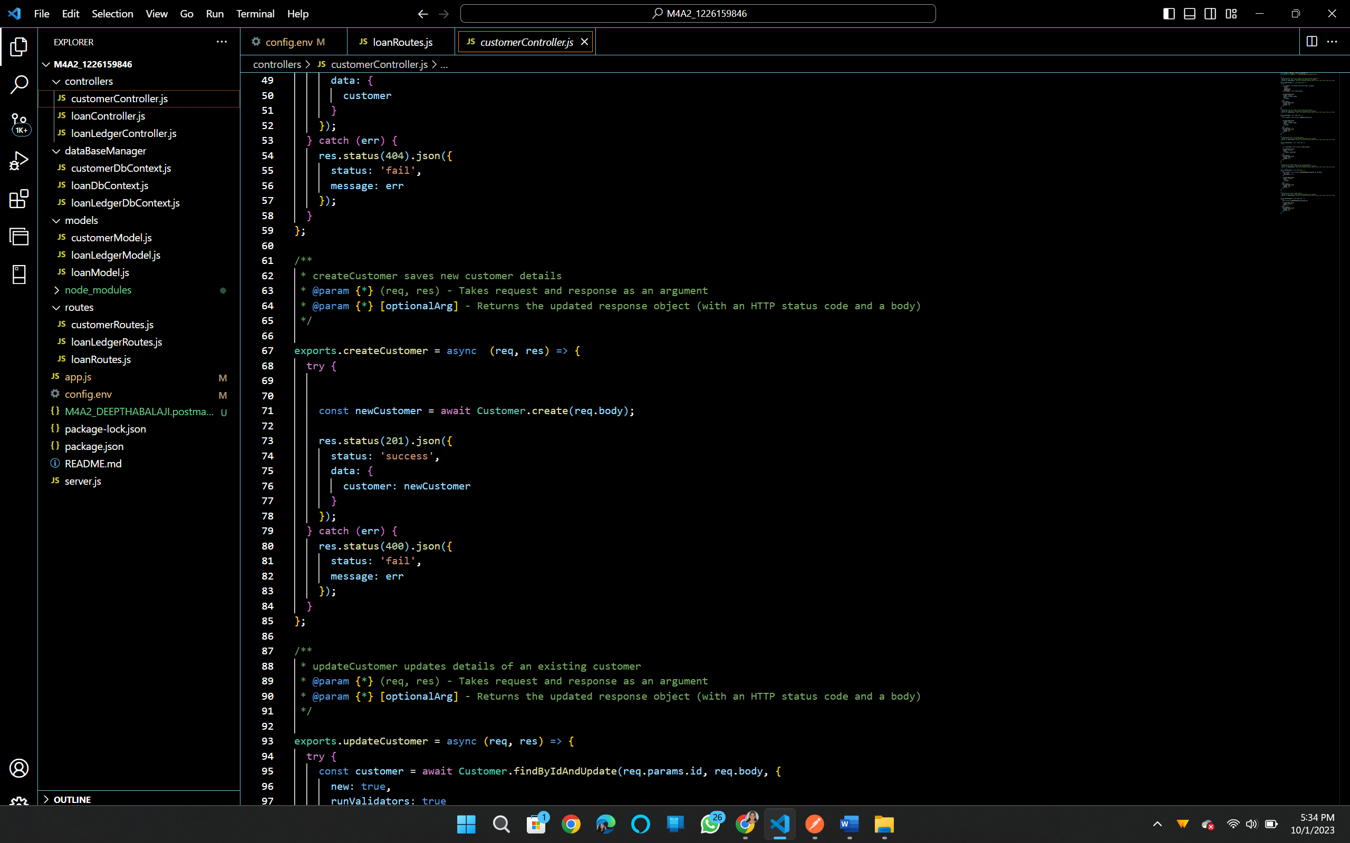

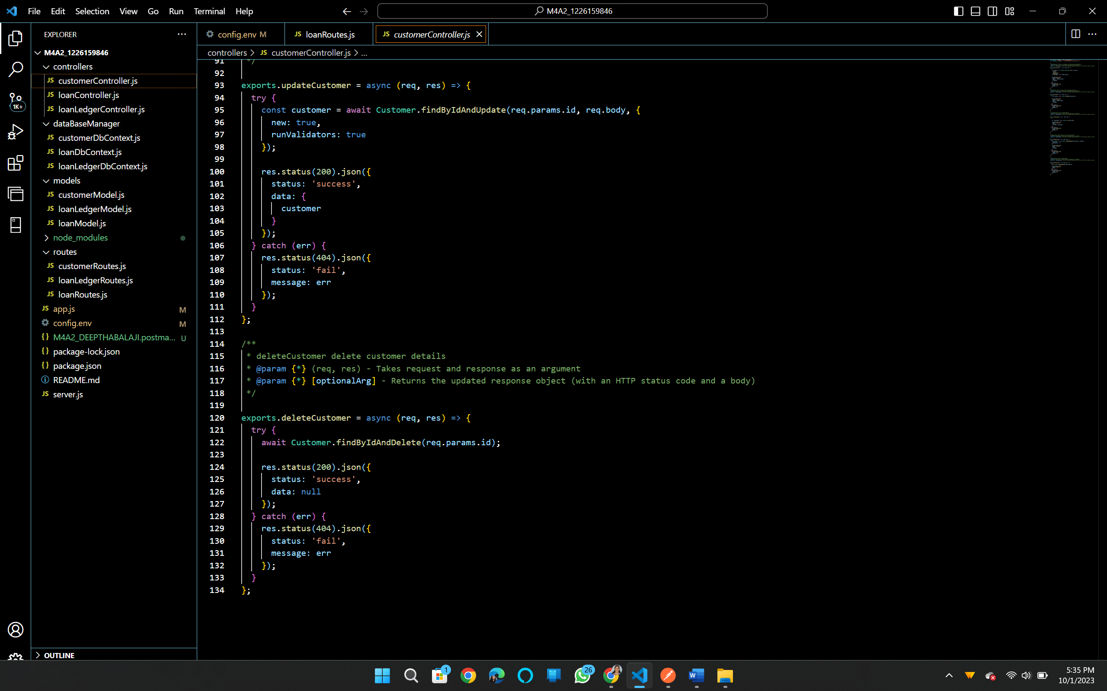

**loanLedgerController.js**

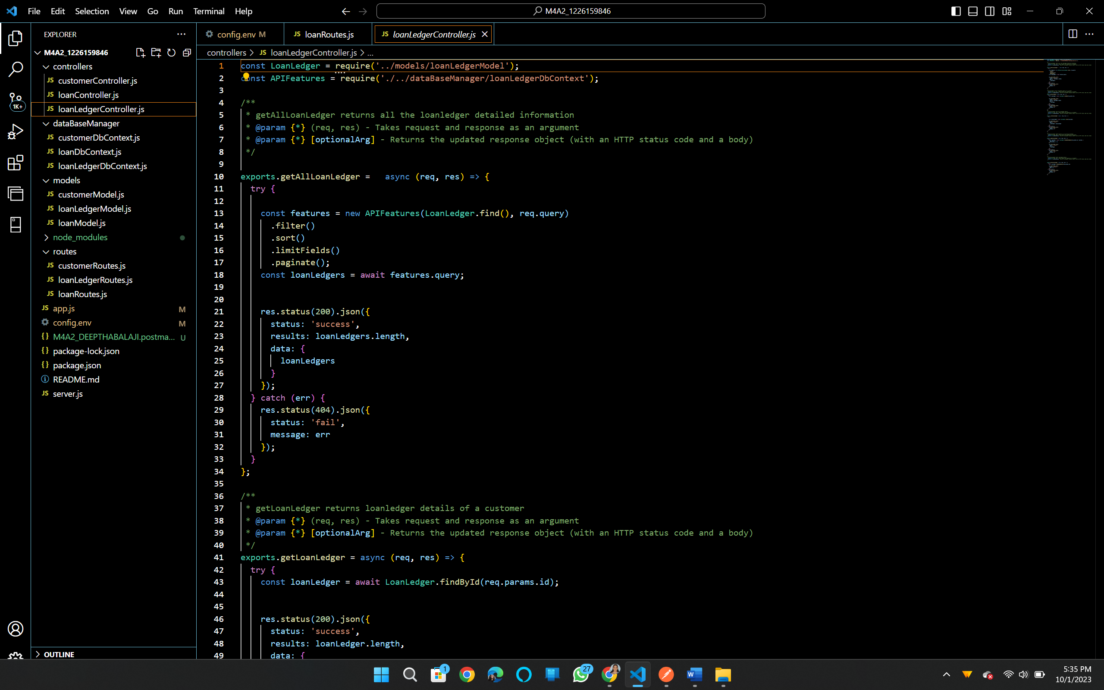

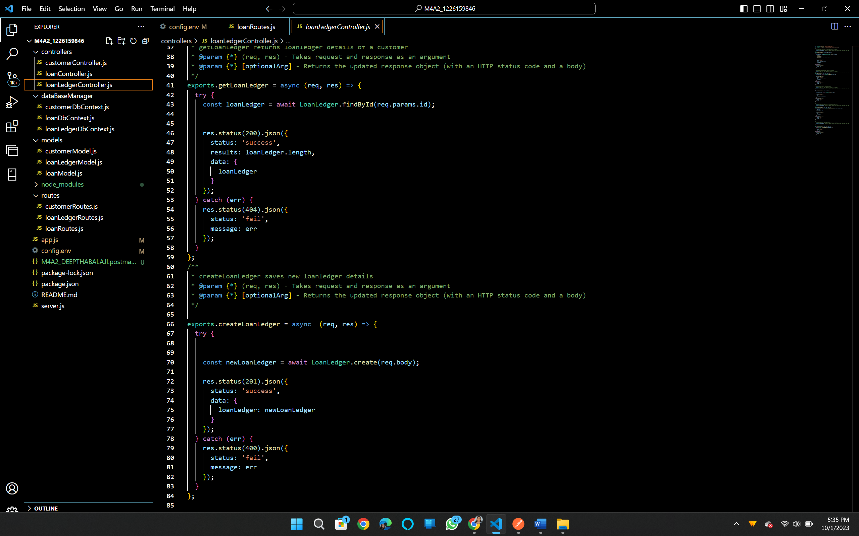

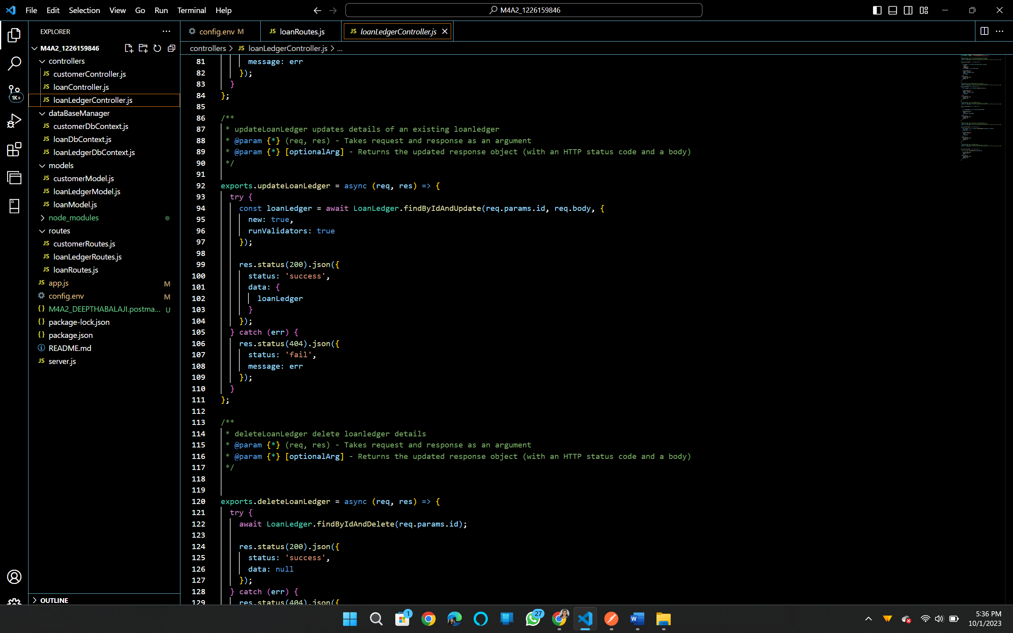

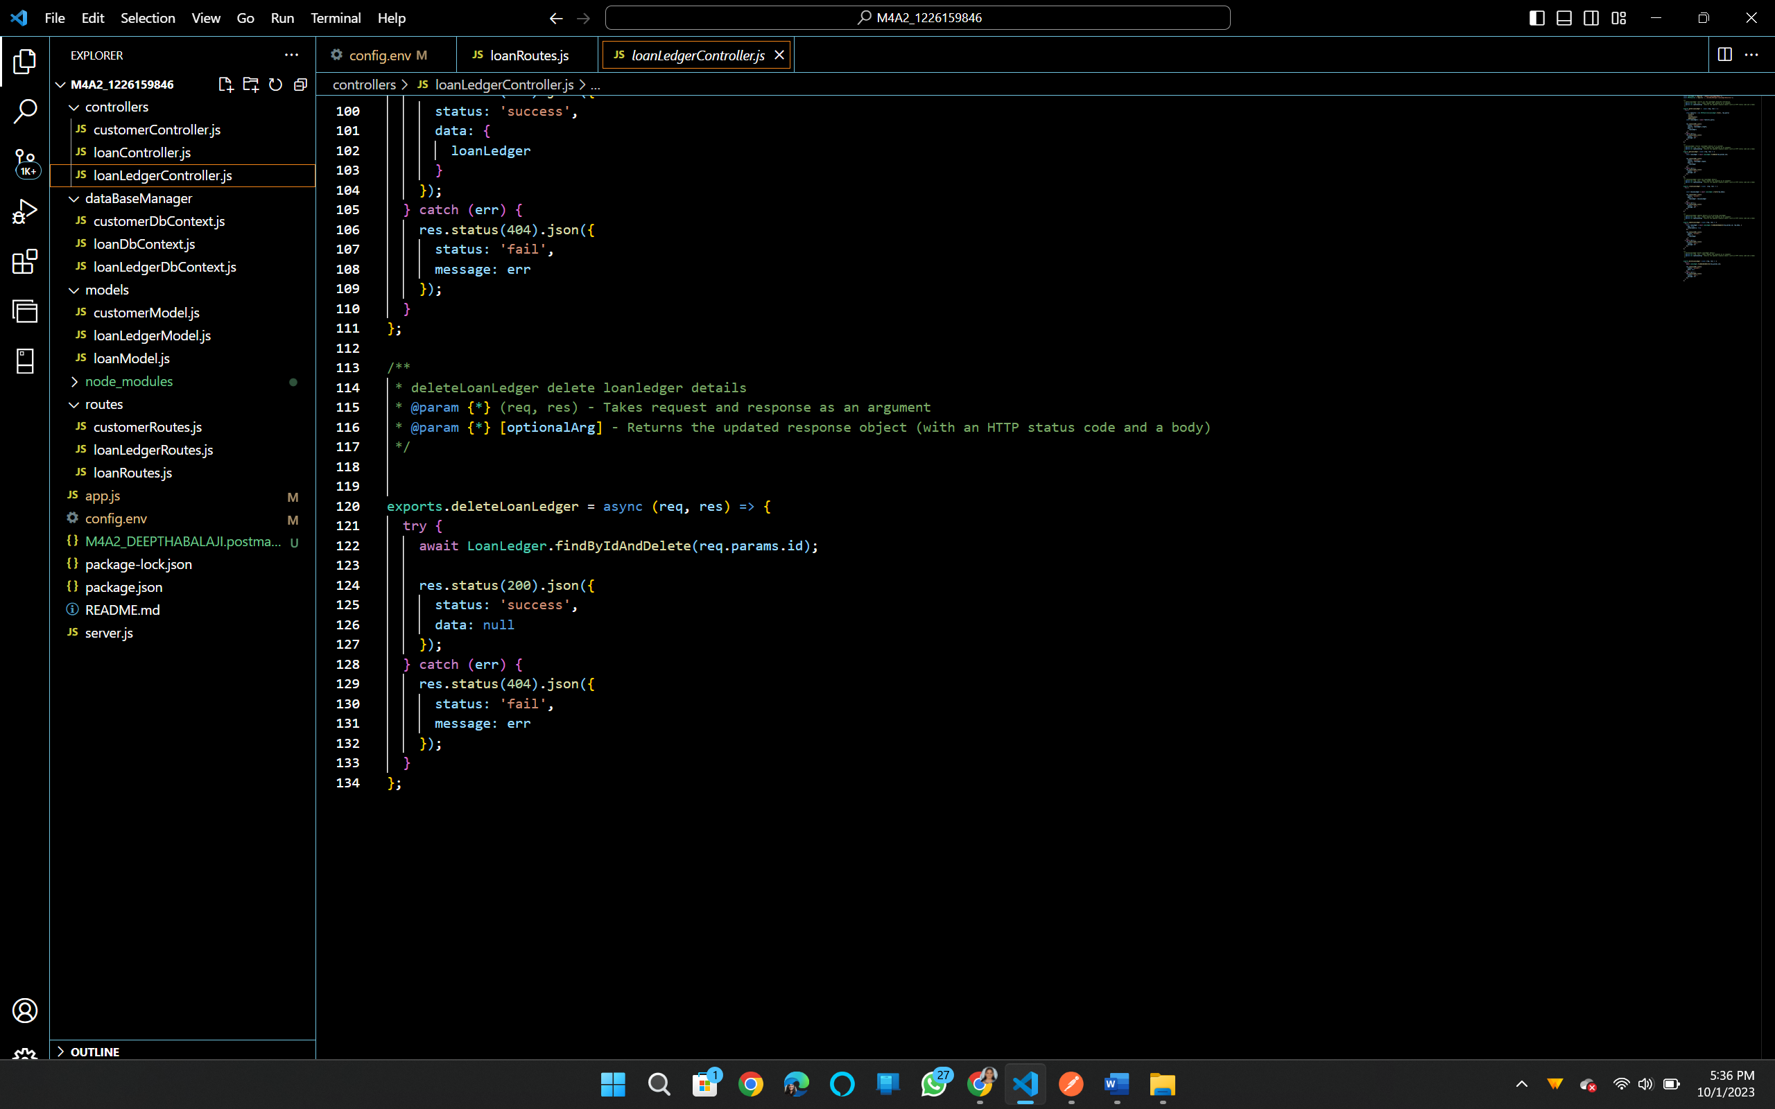

**Task 2:**

Extending the CodebaseIn Task 2, I extended the provided Express.js application that uses MongoDB as its database and Mongoose as its ORM. Here's a detailed overview of the extension I made to the codebase:New Feature: 'Customer' Model:I introduced a new data model called 'Customer' to the application.The 'Customer' model includes fields such as 'firstName,' 'middleName,' 'lastName,' and 'dateOfBirth.'I defined a Mongoose schema for the 'Customer' model, specifying field types and validation rules. This schema ensures that data entered into the 'Customer' collection adheres to the predefined structure.CRUD Operations for 'Customer':I implemented CRUD (Create, Read, Update, Delete) operations for the 'Customer' model.For creating a new customer, I added a route handler that accepts POST requests and validates input data against the 'Customer' schema. This data is then saved to the MongoDB 'Customer' collection.For reading customer data, I created routes that handle GET requests, allowing clients to retrieve customer information by ID or fetch a list of all customers.Updating customer information is supported through PUT requests. The route handler verifies the input against the schema and updates the corresponding customer record in the database.Lastly, I implemented a route for deleting customer records using DELETE requests, ensuring that the data is removed from the 'Customer' collection.Testing:To ensure the reliability and functionality of the new 'Customer' model and associated routes, I performed thorough testing.I used Postman to test each CRUD operation independently, validating that data can be created, retrieved, updated, and deleted successfully.The tests covered various scenarios, including valid and invalid data input, to ensure proper validation and error handling.Integration with Existing Codebase:The new 'Customer' model and associated routes seamlessly integrated with the existing codebase.I followed the same project structure, naming conventions, and coding style as the original code to maintain consistency and readability.Best Practices:While extending the codebase, I adhered to best practices in terms of code organization, data validation, error handling, and route design.The use of Mongoose schemas and validation ensured data consistency and security.Overall, the extension of the codebase with the 'Customer' model and associated CRUD operations enhanced the application's functionality. It allowed the system to manage customer data effectively, maintaining data integrity and adhering to best practices in database management. The rigorous testing performed during this process ensured that the extended features work reliably and handle various scenarios gracefully.

**Task 3:**

Understanding the Codebase and Reflecting on LearningUnderstanding of the Codebase:The provided codebase is well-organized and structured, making it easy to grasp the different components and their interactions. It all starts with the 'server.js' file, which acts as the entry point. Here's a breakdown of how I understood the codebase:Directory Structure: The directory structure is intuitive. Key components include routes, models, and controllers. Routes define the endpoints, models represent the data structure using Mongoose schemas, and controllers handle the business logic.Database Connection: The code establishes a connection to MongoDB using the Mongoose library. This connection is configured in 'db.js,' and it ensures that data can be seamlessly stored and retrieved from the database.Mongoose Schemas: Mongoose schemas define the structure of data models. I identified schemas for 'User' and 'Transaction,' which map to MongoDB collections. These schemas include field definitions, data validation rules, and middleware functions.Express.js Routes: The 'routes' directory contains Express.js route handlers. These handlers listen for incoming HTTP requests, process them, interact with the database using Mongoose methods, and return responses to clients.Middleware: Middleware functions are used for tasks such as authentication and error handling. Middleware ensures that the application behaves correctly under various circumstances.Comparing Past Experience and New Learning:Prior to this assignment, my programming experience mainly revolved around front-end development and basic back-end logic. However, this project introduced me to several new concepts and skills:Mongoose ORM: I had limited exposure to Object-Relational Mapping (ORM) systems, and this assignment significantly expanded my understanding. Mongoose simplifies database operations and enforces data consistency through schemas.Database Interaction: I gained insights into how databases, specifically MongoDB, are integrated into web applications. Understanding the connection between application data and the database is crucial for building robust back-end systems.Schema Validation: Mongoose's schema validation was a new concept for me. It ensures that data adheres to predefined rules, enhancing data integrity and security.Differences and Similarities:Compared to previous projects, this assignment introduced distinct challenges and learning opportunities:Differences:Database Focus: Previous projects primarily focused on front-end development, while this assignment delved into back-end development with a strong emphasis on database management.Complexity: The use of Mongoose and database interactions added complexity to the project. Handling data validation, middleware, and schema design required a different skill set.Testing: This assignment placed a significant emphasis on testing back-end functionality, including CRUD operations, which was not a primary concern in previous projects.Similarities:API Development: Like previous projects, this assignment involved developing API endpoints to handle client requests and serve data.Code Organization: Similar to previous projects, maintaining a well-organized and modular codebase was crucial for readability and maintainability.Extension of the Codebase:In extending the codebase, I introduced two essential features: 'Customer' and 'Loan Ledger.'Customer Model: I created a 'Customer' model with fields like 'firstName,' 'middleName,' 'lastName,' and 'dateOfBirth.' This addition seamlessly integrated with the existing codebase. CRUD operations for 'Customer' were implemented and rigorously tested using Postman, ensuring data accuracy and consistency.Loan Ledger Model: Similarly, I introduced a 'Loan Ledger' model with fields such as 'loanId,' 'customerID,' 'paymentAmount,' 'interest,' and 'principal.' This addition followed best practices and integrated well with the existing code. CRUD operations for 'Loan Ledger' were implemented and tested to ensure the reliability of loan data management.Testing:Comprehensive testing played a critical role in ensuring the reliability of the extended codebase. I conducted unit tests for all CRUD operations, including GET, PUT, POST, and DELETE, using Postman. These tests helped identify and resolve any issues related to data creation, retrieval, and updates.Learning Reflection:This assignment was a valuable learning experience that deepened my understanding of databases, ORM systems like Mongoose, and back-end development. It highlighted the importance of maintaining data consistency and security in real-world applications. While the project presented some challenges, it ultimately expanded my skill set and prepared me for more complex back-end development tasks in the future.

Github Link:

<https://github.com/DeepthaBalaji/Deeptha-Balaji--M4A2-IFT-544>

